**Placement cell**

The university has a full-fledged Placement Cell under the Dean Students Welfare to arrange campus interviews for placement of graduate and postgraduate students. The placement cell has been successfully organizing campus interviews with the collaboration of various reputed companies, State Bank of India and State Bank of Indore, Union Bank of India, Axis Bank, etc. seed companies, IIL, HDFC Bank, Beej Nigam, and other NGOs. The cell also provided the counseling to students on the availability of scholarships and avenues for higher studies. A step forward in the development of software, which would keep track of the student profiles in a database. Thus, simplifying the access to the student profiles

Objectives

The cell is responsible for arranging campus interviews with the employer organization for the selection of our pre-final/final year students.

1. To identify network and liaison with the prospective employer and arrange on- campus interviews for pre-final and final year students of University.
2. To maintain a computerized database of students and employers as a ready reckon for both its job seekers and its job provider.
3. To guide and counsel students to make the right carrier choice.
4. To provide socially inclusive opportunities to academically weaker students to improve their academic performance and personality.
5. To undertake personal enrichment activities to improve personality, communication skills, and professional competency of students.

**Facilities Available**

1. Exclusive and spacious interview rooms.
2. Air-conditioned room equipped with a projector for pre-placement talks and group discussions.
3. Smart T.V. with video conferencing facility with high-speed internet connectivity for Online Campus interview / examinations

**Employment profile of graduates**

|  |
| --- |
|  |
| **(i) Students placement records for last Six years:**   |  |  |  |  |  |  |  |  | | --- | --- | --- | --- | --- | --- | --- | --- | |  | Department | Year-wise number of students | | | | | | | 2014-15 | 2015-16 | 2016-17 | 2017-18 | 2018-19 | 2019-20 | |  | University | 9 | 21 | 25 | 35 | 11 | 03 | |  | Agriculture | 24 | 36 | 56 | 32 | 9 | 03 | |  | ATMA | 19 | 17 | 21 | 00 | 0 | - | |  | Seed Corporation | 35 | 31 | 29 | 00 | 10 | 02 | |  | Seed Certification | 0 | 12 | 52 | 00 | 0 | - | |  | Forest Ranger | 8 | 14 | 19 | 02 | 0 | - | |  | Sub Inspector | 3 | 0 | 0 | 21 | 0 | - | |  | Fertilizer Corporation | 0 | 0 | 0 | 0 | 25 | - | |  | Kisan Call Centre | 0 | 0 | 0 | 0 | 27 | - | |  | Nationalized Bank | 0 | 0 | 0 | 0 | 12 | 09 | |  | Private sector |  |  |  |  |  | 56 |  |  | | --- | | C:\Users\D.S.W\Desktop\photo web\01.jpeg | | Online campus interview by Madhya Pradesh Farm & Beej Vikas Nigam Bhopal During lockdown period | | C:\Users\D.S.W\Desktop\photo web\04.jpeg | | C:\Users\D.S.W\Documents\DSW Achievement 2017-18\Photo Placement 2017-18\8 .5.17\IMG_8269 copy.jpg | |

|  |  |
| --- | --- |
| C:\Users\DSW34\Desktop\21.10.19 FINAL WEBSITES MATTER\PHOTO FOR WEB AKN\IMG-20191021-WA0019.jpg | C:\Users\DSW34\Desktop\21.10.19 FINAL WEBSITES MATTER\PHOTO FOR WEB AKN\IMG-20191021-WA0020.jpg |
| Well equiped Interview chamber of Placement Cell | |
| C:\Users\DSW34\Desktop\21.10.19 FINAL WEBSITES MATTER\PHOTO FOR WEB AKN\IMG-20191021-WA0018.jpg | C:\Users\DSW34\Desktop\21.10.19 FINAL WEBSITES MATTER\PHOTO FOR WEB AKN\IMG-20191021-WA0017.jpg |
| Well equipped smart classroom for campus activities of Placement Cell | |

**Registration for placement & Counseling Cell : link to be provided**

**Tutorial Cell**

* As per the directive of Hon’ble Vice-Chancellor Tutorial Cell for students of Jawaharlal Nehru Krishi Vishwa Vidyalaya has been started for preparation of ADA JRF/SRF/NET/GATE and other competitive Examination. Students registered under Tutorial Cell.

Carrier opportunities programmes

* The carrier opportunity programme was held on 05.04.2019 at Vivekanand Hall, College of Agriculture, Jabalpur by T.I.M.E. for multiple carrier options for U.G.P.G. & Ph.D. students. Experts of this institute time management tips for solving the question of various kinds at the time of different competitive examinations.
* One day lecture programme on a positive lifestyle for students, employees & officers was organized on 28.05.2019. On this occasion International Motivational speaker Shri B.K. Shivlal Bhai Ji expressed his views.
* One day workshop "Introduction to Study falcon" was organized on 02.12.2019 to provide exposure to students and faculty for the preparation of various competitive exams.

**A total of 150 students** from 10 campuses have been offered one month free excess of learning through falcon web portal for preparation of competitive examinations.

|  |
| --- |
| C:\Users\D.S.W\Desktop\STUDY FALCON-1.JPG |
| V.V. authorities in the unauguration of Study Falcon Workshop |
| C:\Users\D.S.W\Desktop\DESKTOP 07.11.2019\FALCON STUDY\DSW--2-12-19\IMG_9528.JPG |
| Lecture session during the Study Falcon Workshop |

* One day workshop on Introduction to **Nipa Genx Electronic Resources and Solution Pvt. Ltd, New Delhi** an online study platform to provide exposure to students for preparation of JRF/SRF/NET/GATE examinations.

A total number of 200 students from 10 campuses of the university have been offered one-month free access to Nipa Genx Electronic Resources and Solution Pvt. Ltd, New Delhi web portal for preparation of competitive examinations.

|  |  |
| --- | --- |
| F:\19-12-2019   NIPA WORKSHOP\photo NIPA 19.12.19\NIPA DSW--19-12-19\IMG_0112.JPG | F:\19-12-2019   NIPA WORKSHOP\photo NIPA 19.12.19\NIPA DSW--19-12-19\IMG_0139.JPG |
|  | |
| F:\19-12-2019   NIPA WORKSHOP\photo NIPA 19.12.19\NIPA DSW--19-12-19\IMG_0129.JPG | F:\19-12-2019   NIPA WORKSHOP\photo NIPA 19.12.19\NIPA DSW--19-12-19\IMG_0128.JPG |
| lecture session during the nipa genx. Workshop | |

* Special classes were organized with the help of meritorious Ph.D. scholars for the preparation of the JRF examination. Monthly examination was also conducted with the help of Model papers for the students, who attended these classes for preparation of JRF examinations.

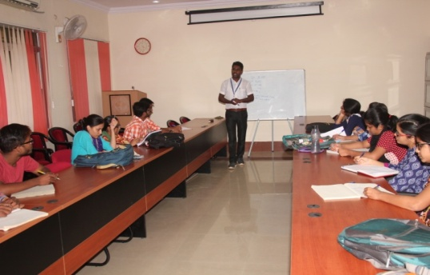

* Dean Student Welfare visited College of Agriculture, Khurai & Krishi Vigyan Kendra Sagar on 22 & 23 Nov. 2019 to organize a motivational session for students of under graduate classes. In this session, Dean Student Welfare interacted with students and staff of the college of Agriculture, Khurai.

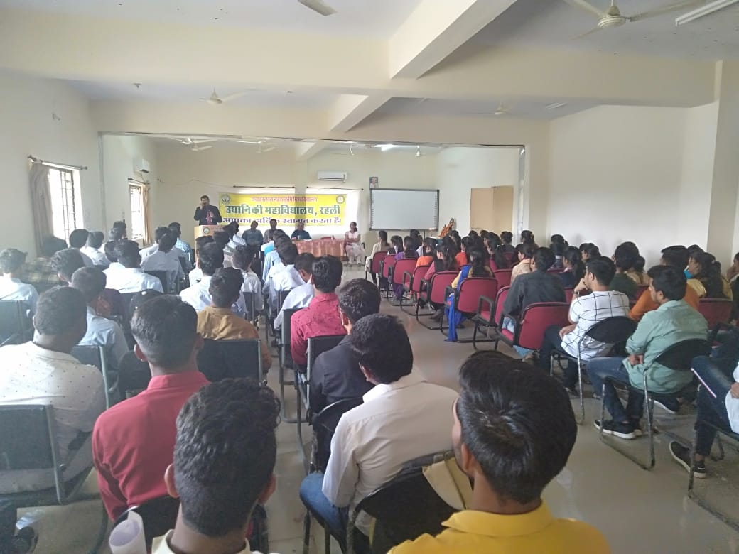.

* Dean Student Welfare visited the college of Horticulture Chhindwara, and College of Agriculture, Balaghat from 17 to 18 Dec. 2019. During the visit Dean Student Welfare also interacted with students and staff of colleges.

|  |
| --- |
| **F:\ALL DOCUMENTS APRIL 2020 TO MARCH 21\IMAGES\mesume photo\mesume photo all\DSW VISIT\BALAGHAT.jpeg** |
|  |

|  |
| --- |
| F:\ALL DOCUMENTS APRIL 2020 TO MARCH 21\IMAGES\mesume photo\mesume photo all\DSW VISIT\CHHIND-2.jpeg |
|  |

* Dean Student Welfare office organized a webinar on “How to Excel in Competitive Examination AIEEA (PG) JRF, All India Competitive AICE-JRF/SRF (Ph.D.) and GATE on 6 and 7 June 2020 for creating a positive learning environment and enlightening the students even during the corona virus outbreak. Various learned speakers from IARI and other National institute delivered their lectures regarding the preparedness for competitive exams.

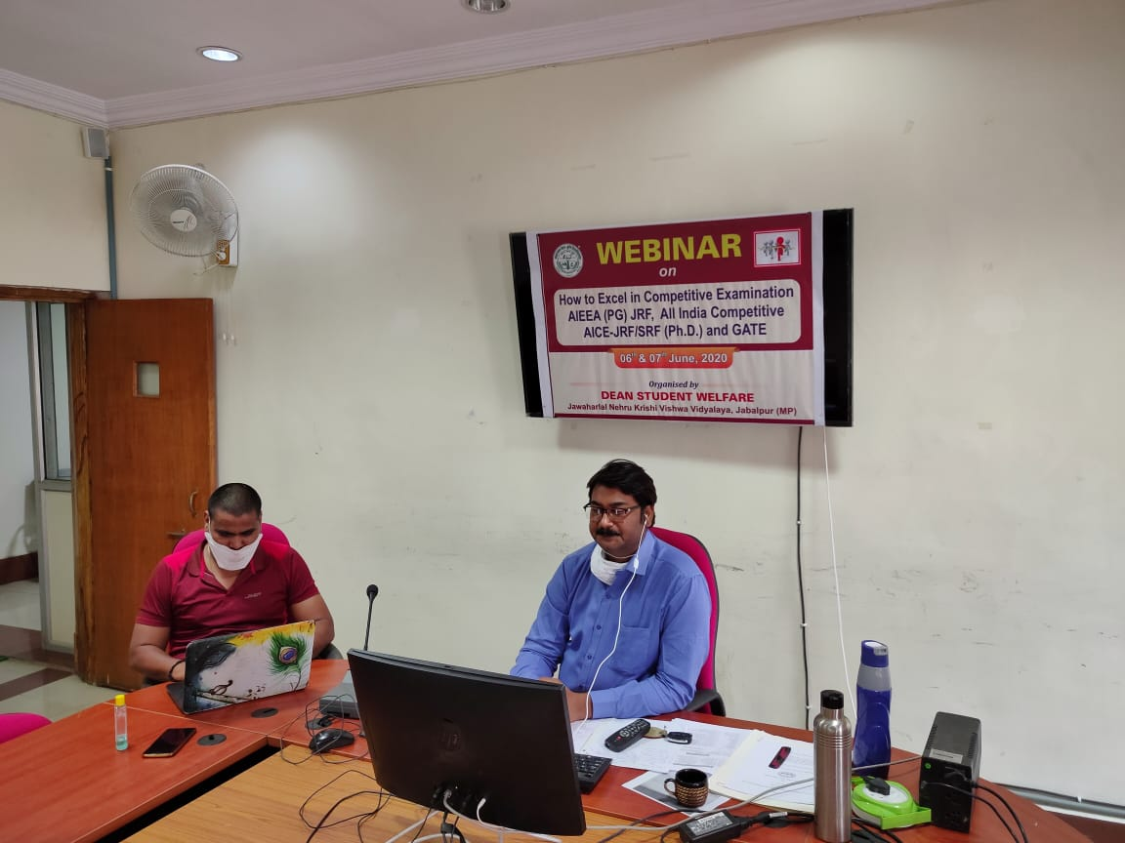

* Dean Student Welfare office organized webinar on “Strengthening Students’ English for Professional Growth” on 17 July 2020 on the topic of ‘Communication Skills for Professional Development’ & ‘What Makes Listening / Speaking Hard?’ for students of UG, PG, and Ph.D. A total of 1600 students from different universities of 16 states including the 1600 students of JNKVV participated in this webinar.

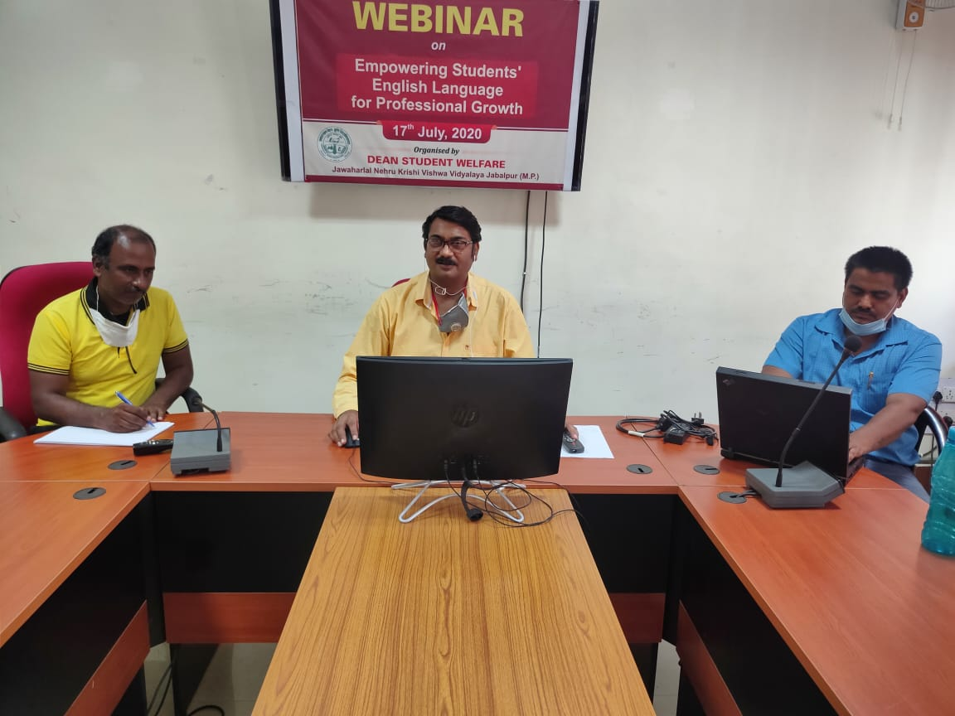

**Achievement in GATE**

Thirty-three students of College of Agril. Engineering, JNKVV, Jabalpur have qualified gate examination for post graduate courses at Indian Institute of Technology.

22 boys and 11 girls have qualified GATE. At the national level, JNKVV 's Harsh Rusia secured the second position, while two students secured 10th position and 13 students got position under 50. While rest 22 students are amongst the top 100 qualifiers and the rest are under 200 top position holders.

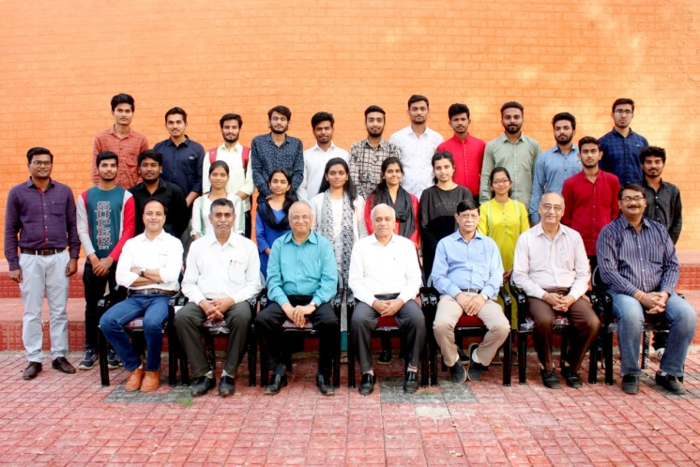

**Achievement in NET**

Twenty-nine students of College of Agriculture, JNKVV, Jabalpur have qualified the NET examination.

The selection of students from JNKVV in this big number is a historic achievement. The students brought laurels under the able leadership of Vice-Chancellor honorableProf. Pradeep Kumar Bisen.

