National Cadet Corps (NCC)
The NCC activities have been conducted at the College of Agriculture, Jabalpur. Since 1966-67, under 1MP Battalion, Jabalpur, now it is running by 1MP Arty Battalion, Jabalpur. NCC Officer, Lt. Rahul Dongre looks after overall the work of NCC. NCC Girls wing has been running since 2007. The in-charge of the Girls NCC battalion is CTO Dr. Rajnee Sharma.
Under the banner of NCC the cadets are being provided with the elementary military training with the main emphasis on subject viz : foot drill, arms drill, weapon training with a rifle, (LMG,CMG,SLR,), etc. self defense, civil defense, first aid besides participation in adventure activities viz : gliding, parasailing para-jumping, boat pulling and social activities viz : tree plantation, blood donation, traffic control on several occasions, help the people during natural calamities etc. Cadets qualify 'B' and 'C' certificate after an examination. The cadets holding NCC 'C' Certificates are exempted from appearing in the written examinations to get commissions in defense forces under the “NCC Special Entry Scheme”.

Details of NCC Officers of various campuses
S. No. | Name of the College where NCC is running | Name of ANO/ CTO | Contact No. | Email ID | No. of Seats | Available For Boys / Girls | Battalion
1. | College of Agriculture, Jabalpur | Lt. (Dr.) Rahul Dongre | + 91 94070 67241 | dongre.jnau@gmail.com | 53 | Boys | 1MP Arty Battalion, Jabalpur
2. | College of Agriculture, Jabalpur | Dr. Rajnee Sharma | 9158072679  7649802659 | rajinisharma5886@jnkvv.org | 53 | Girls | 2 MP Girls Battalion, Jabalpur
3. | College of Agriculture, Rewa | Dr. R. K Tiwari | + 91 83191 85360 | rktkvkrewa@rediffmail.com | 53 | Boys | 3 MP Battalion, Rewa
4. | College of Agriculture, Ganjbasoda | Capt. (Dr.) Satish Sharma | + 91 93009 79361 | er.satishsharma@rediffmail.com | 53 | Boys | 14 MP Battalion, Vidisha
5. | College of Agriculture, Powarkheda | Dr. Shakshi Singh | + 91 62602 57985 | singh.bhu683@gmail.com | 53 | Girls | 5 MP Girls battalion, Hoshangabad,

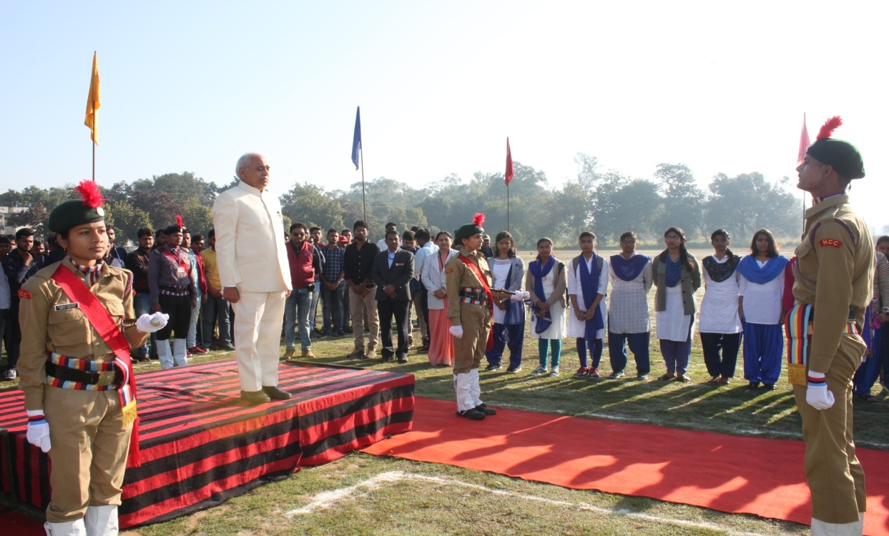
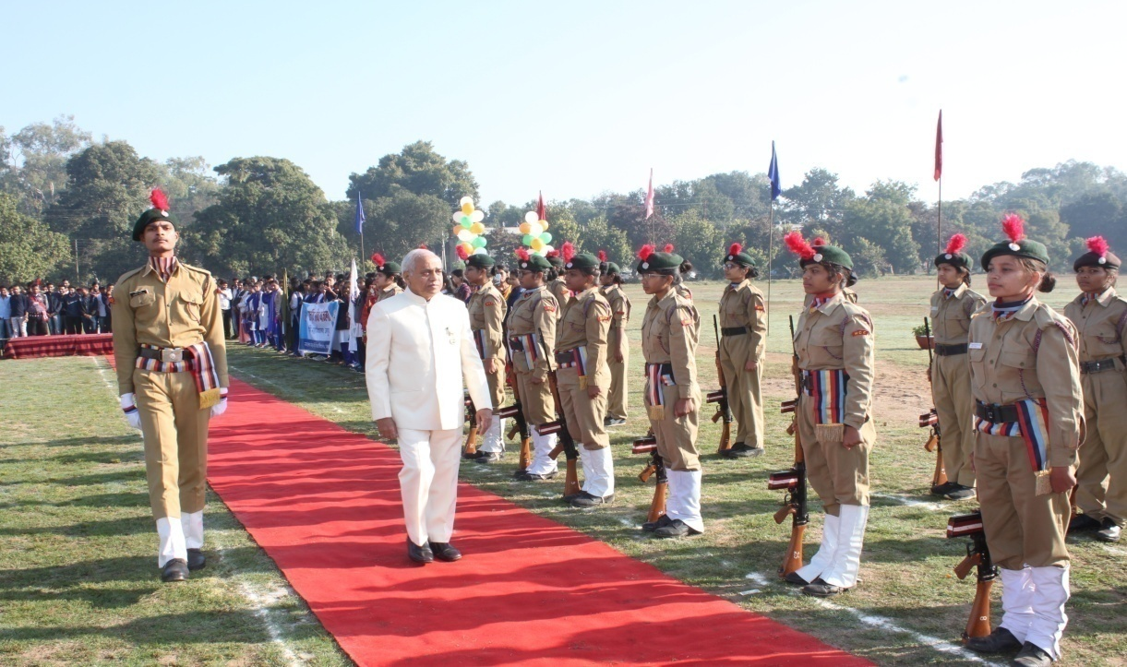
Guard of honour to Hon'ble Vice-Chancellor Prof. P.K. Bisen during republic day celebration-2020
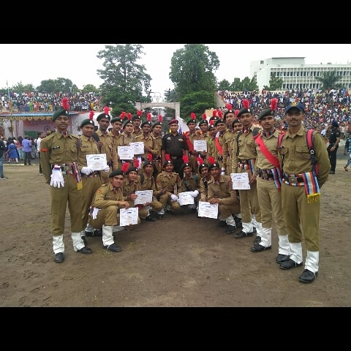
NCC certificate award ceremony

