Curriculum Vitae
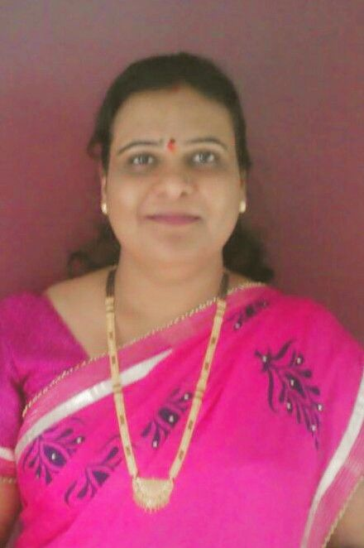

- Name: Dr. (Mrs.) Seema Naberia
- Designation: Assistant Professor/Scientist
- Category: General
- Date of Birth: 13-06-1975
- Name of Institution: Jawaharlal Nehru Krishi Vishva Vidhyalaya, Jabalpur
- Mailing Address:
Assistant Professor
Department of Extension Education
College of Agriculture, JNKVV, Jabalpur (M.P.) PIN 482004
Mobile:+91-9424325641, email: seemanaberia@jnkvv.org/ seemanaberia@gmail.com

- Educational Qualification (starting from Bachelors Degree onwards)
Degree | Year of passing | Institution
Ph.D. (Agril Extension Education) | 2012 | M.G. Chitrakoot Gramodaya Vishwa Vidyalaya, Chitrakoot, Satna (M.P.)
M.Sc. (Agril Extension) | 2000 | Jawaharlal Nehru Krishi Vishwa Vidyalaya, Jabalpur (M.P.)
B.Sc. (Agriculture) | 1997 | Jawaharlal Nehru Krishi Vishwa Vidyalaya, Jabalpur (M.P.)
NET | 2000 | Qualified in Agricultural Extension Conducted by ASRB, New Delhi

- Details of Employment
Designation | Duration |  | Institution | Nature of work
Designation | From | To | Institution | Nature of work
Senior Research Fellow | Dec-02 | Dec-04 | Zonal Project Directorate, Zone-VII, ICAR, Jabalpur | Research & Extension
Senior Research Fellow | Jun-06 | Jan-07 | College of Agril Engg, JNKVV, Jabalpur | Research & Extension
Programme Assistant | Jan-07 | May-08 | KVK, Narsinghpur | Research & Extension
Assistant Professor | May-08 | Till date | College of Agriculture, JNKVV, Jabalpur | Teaching & Extension

- Professional Recognition/ Awards/Prizes/Certificates etc.

- Conferred with the “Best Teacher Award 2023” by Jawaharlal Nehru Krishi Vishwa Vidyalaya (JNKVV), Jabalpur, on its 60th Foundation Day.
- Got ISEE Fellow Award-2021 for Outstanding Contribution in the Field of Extension Education by Indian Society of Extension Education, IARI New Delhi, in ISEE National Seminar on Transforming Indian Agriculture through Pluralistic and Innovative Extension Approaches for Self-Reliant India during 4-6 October 2021 at BHU, Varanasi.
- Got Young Scientist Award by Indian Society of Extension Education in the ISEE, National Seminar 2017 on “Doubling farmers’ Income and Farm Production through Skill Development and Technology Application” held at Bihar Agriculture University, Sabour, Bhagalpur (Bihar) during 28-30 November 2017.
- Received the “Scientist of the Year Award” in National Conference on Recent Trends and New Frontiers in Biotechnology, Agriculture, Science and Environment NCRTNFBASE-2020, organized by Academy for Environment and Life Sciences, Agra and Department of Botany, St. John’s College, Agra during 22-23 February 2020.
- Contested for the position of Executive Councilor (Central Zone) of Indian Society of Extension Education, IARI, New Delhi for the period of 2020-2023.
- Got Best Poster Presentation Award by Indian Society of Extension Education, New Delhi in National Seminar on Extension Innovations and Methodologies for Market-led Agricultural Growth and Development during February 26-28, 2015 at RVSKVV, Gwalior (M.P.)
- Got Best Poster Presentation Award by Society of Extension Education, Agra in 4th National Extension Education Congress during 2007 at JNKVV, Jabalpur (M.P.).

- Details of Professional Training
Participation in Summer School/Winter school/Orientation programme
S.N. | Particular | Title of the training | Duration | Organizing institute
 | Winter School Programme | Techno-preneurship Opportunities in Agricultural Mechanization | 20 Nov-10 Dec. 2012 | CIAE, Bhopal (M.P.)
 | Winter School Programme | Participatory Extension Research and Management | 2-22 Dec. 2014 | MPUAT Udaipur (Rajasthan)
 | Winter School Programme | Changing Dimensions of higher education in India | 5-24 Dec.2016 | HRDC, RDVV, Jabalpur
 | Orientation Programme | Orientation Programme | 5-29 July 2017 | HRDC, RDVV, Jabalpur
 | Online training programme | Innovative Practices in Extension Research & Evaluation | 8-28 Sept. 2020 | ICAR-NAARM, Hyderabad
 | National Level higher training | Sustainable Development of Secondary Agriculture: Economical, Food Nutritional and Livelihood Perspective | 16Jan.-5 Feb. 2021 | CAST, Navsari Agricultural University, Navsari, Gujrat under NAHEP of ICAR, New Delhi
 | Hands on training programme | Hands on training on Remote sensing & Georeferencing | 29 July -19 August 2021 | JNKVV, Jabalpur under NAHEP of ICAR, New Delhi
 | National workshop | National workshop on Psychometric Scale construction techniques: Basic to Advances | November 24-28, 2020 | Dairy Extension Division, ICAR-National Dairy Research Institute, Karnal, Haryana
 | Online training | Research Support Tools: Effective E learning with smart tools & Techniques | May 28-30, 2020 | College of Agriculture, Powarkheda, Hoshangabad (M.P.)
 | Online training | Awareness and Sensitization for Sexual Harassment | 5 Nov. 2020 | College of Agriculture (JNKVV), Tikamgarh
 | Online training | Social-Media in Agriculture Extension. | 18 May 2020 | Department of Extension Education, College of Agriculture, JNKVV, Jabalpur (M.P.)
 | Online training | Adult learning and its principles | 19 May 2020
 | Online training | Effective communication for public speaking | 20 May 2020
 | National Webinar | National Webinar on ‘Experimental Research in Social Science’ | 13 July 2020 | Bihar Agricultural University, Sabour, Bhagalpur (Bihar)
 | International workshop | International workshop on Nurturing Physical. Mental and Social Health: During and Post COVID 19 | May 16,2020 | Institute of Home Science, Dr. Bhimrao Ambedkar University, Agra
 | National Webinar | Two days National Webinar on ‘Role of ICT in Agriculture and Extension in Present Scenario of Covid-19’ | 11-12 June, 2020 | Department of Extension Education and Communication Management, College of Community and Applied Sciences, MPUAT, Udaipur
 | Online training | Soft Skills and Personality Development | 24-25 March, 2021 | Mahatma Phule Krishi Vidyapeeth (MPKV) Rahuri, Dist. Ahmednagar (M.S.)
 | Successfully completed Six-week agMOOCs online course on E-Extension with distinction during 03 December 2019.

12. Publications:
- More than 85 research papers published in National & International Journals.
- Popular Articles: 25, Bulletin: 7, Book Chapter: 5
13. Research:
Guidance to Ph.D. and P.G. students as Chairman of the Advisory Committee
Particular | Major Advisor | Member Advisory Committee
Ph.D. Students | 03 | 05
M.Sc. Students | 28 | 25

14. Membership of Society/Journal:
- Life Membership of Indian Society of Extension Education (ISEE), IARI, Delhi
- Life membership of Society of Extension Education Gujarat.
- Society of Extension Education Agra
- MOBILIZATION Society (The Society for Community Mobilization for Sustainable Development, IARI, New Delhi
- Member of Editorial Board of Krishak Suraksha magazine published monthly from Bhopal (M.P.).

