Credential of the Teachers
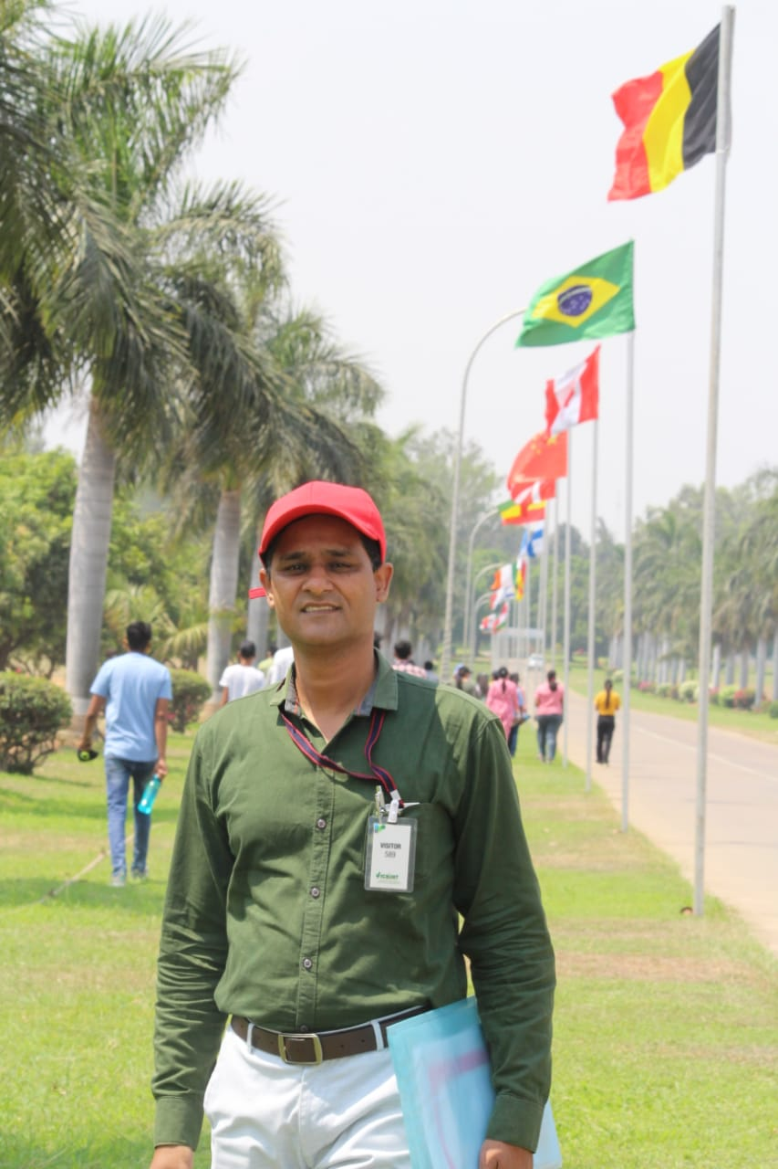
Name: Suneel kumar Rajak
Date of birth: 01/07/1975
Designation: Assistant Professor
Office address: College of Agriculture, Balaghat
Home address: Ward No. 05, Health club, Waraseoni, Distt. Balaghat, M.P.
Mobile number : 9179176849 e mail: suneeldamohcoa@gmail.com
Date of joining
Post | Assistant Professor | Associate Professor | Professor
Date of joining | 24/03/2015
Experience in year | 7 years
Qualification
Examination | Years of passing |  | Subject (s) |  | University/ Institute |  | Any distinction
Bachelor’s | 2098-99 |  | Agriculture |  | JNKVV, Jabalpur
Master’s | 2000-01 |  | Ag.Economics |  | JNKVV, Jabalpur
Title of MSc thesis | Evaluation of Regional Rural Bank of damoh District of Madhya Pradesh
Doctorate | 2007 |  | Economics |  | RDVV, Jabalpur
Title of Ph D thesis | “Production and Marketing of Safed Musli a Study of Malwa Region of Madhya Pradesh”
Post doctoral
Any Other
Details of participation in 21 day training programme
Title |  | From -to |  | Duration |  | Institute | Specialization
Technological and Policy Options for Enhancing Farmers Income 23 September to 13 October |  | 23.09.2017 |  | 13.10.2017 |  | CAFT center, New Dehli | Ag. Economics
Innovative Approaches and Strategies for Higher Profitability and Sustainability in Organic Production System |  | 01.06.2018 |  | 21.06.2018 |  | CAFT center, MPUAT, Udaipur | Organic Farming
“Analytical Techniques for Decision Making in Agriculture” during 2-25  Feb, 2022 |  | 02.02.2022 |  | 25.02.2022 |  | ICAR-NIAP,New Dehli | Ag.Economics
Experience in teaching
Degree | Bachelor | Master | Doctorate
Year | 7 years
Number of courses taught and year of experience
Sr | Degree | Title of the course taught | Year of experience for the course | Course Learning Outcomes | details Specialization for the course  (PD/Training/orientation)
1 | Bachelor | Fundamentals of Ag. Economics | 7 years
2 |  | Agricultural Finance and Co-Operation | 7 years
3 |  | Agricultural Marketing Trade & Prices | 7 years
4 |  | Farm Management, Production & Resource Economics | 3 years
5 |  | Agribusiness Management | 2 year
6 |  | Village Survey (RAWE) | 7 years
 |  | Physical Education and Yoga Practice | 5 years
7 | Master | NA
8
9 | Doctorate | NA
10
11
Guided for curricular research guided

Degree | Master | Doctorate | Total
Number | 2
Field of expertise | Survey

Accomplishment in teaching
Professional licensure and certification

Honours and awards |  |  | Young Scientist Awardby AEDS, Rampur  Excellence in Teaching Award by SSDAT, Meerut
Continuous documented excellence in teaching

Other demonstrated competencies and achievements that contribute to excellence in teaching and student learning outcomes |  |  | All type of sports activity for the students (I/C Sports) Regularly conducted ICAR-JRF classes
Number of research paper as per NAAS rating published so far |  |  | 4.00-5.00 | 5.01-6.00 |  | 6.01-7.00 |  |  | >7.00
 |  |  | 2 | 4
Published books with ISBN /ISSN

Details of International exposure
Post | Organization | Field of Assignment |  |  | From |  | To | Duration

