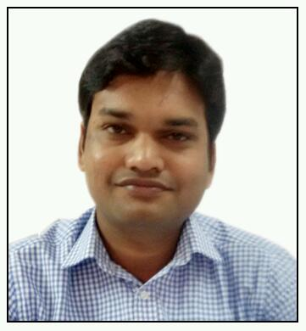
Credential of the Teachers

Passport si ze recent photograph
Name Dr. Ramkrishna Singh Solanki
Date of birth 05-June-1985
Designation Assistant Professor
Office address College of Agriculture Balaghat, Murjhad Farm Waraseoni
Home address College of Agriculture Balaghat, Murjhad Farm Waraseoni
Mobile number 9826026464 e mail rsolankisolanki_stat@jnkvv.org
Date of joining
Post | Assistant Professor | Associate Professor | Professor
Date of joining | 26-March-2015 | Nil | Nil
Experience in year | 07
Qualification
Examination | Years of passing |  | Subject (s) |  | University/ Institute |  | Any distinction
Bachelor’s | 2007 |  | Statistics |  | D.A.V.V. Indore
Master’s | 2009 |  | Statistics |  | D.A.V.V. Indore
Title of MSc thesis | Nil
Doctorate | 2013 |  | Statistics |  | Vikram University Ujjain
Title of Ph D thesis | Contributions to the Theory of Estimation of Population Parameters Using Supplementary Information in Sample Surveys
Post doctoral | Nil
M.Phil. | 2010 |  | Statistics |  | Vikram University Ujjain
Details of participation in 21 day training programme
Title |  | From -to |  | Duration |  | Institute | Specialization
“Recent Developments in Statistical Modeling and Forecasting in Agriculture” |  | 28/12/2017 to 17/12/2018 |  | 21 Days |  | ICAR-IASRI, New Delhi
“Recent Trends in Data Analytics and Knowledge Management” during |  | 06/09/2018 to 26/09/2018 |  | 21 Days |  | ICAR-IASRI, New Delhi
“Hands on Training on Remote Sensing and GIS using QGIS” |  | 25/08/2021 to 15/09/2021 |  | 21 Days |  | JNKVV, Jabalpur
Experience in teaching
Degree | Bachelor | Master | Doctorate
Year | 07 | NIL | NIL
Number of courses taught and year of experience
Sr | Degree | Title of the course taught | Year of experience for the course | Course Learning Outcomes | details Specialization for the course  (PD/Training/orientation)
1 | Bachelor | Elementary Mathematics | 06 | Enhance basic knowledge of mathematics
2 |  | Statistical Methods | 07 | Students will learn and apply the fundamental tools of statistics
3
4
5 | Master | Nil
6
7
8
9 | Doctorate | Nil
10
11
Guided for curricular research guided

Degree | Master | Doctorate | Total
Number | Nil | Nil | Nil
Field of expertise

Accomplishment in teaching
Professional licensure and certification |  |  | Nil
Honours and awards |  |  | Nil
Continuous documented excellence in teaching |  |  | Nil
Other demonstrated competencies and achievements that contribute to excellence in teaching and student learning outcomes |  |  | Nil
Number of research paper as per NAAS rating published so far |  |  | 4.00-5.00 | 5.01-6.00 |  | 6.01-7.00 |  |  | >7.00
 |  |  | 0 | 02 |  | 10 |  |  | 01
Published books with ISBN /ISSN |  |  | Nil
Details of International exposure
Post | Organization | Field of Assignment |  |  | From |  | To | Duration
Nil

