Fellowship and Scholarship
Scholarship/Stipend
Achievements in the National level Agricultural Competitive exam.
SN | Year | JRF | SRF | NET | ARS | GATE | Remarks
 | 2015-16 | 56 | 02 | 20 | 02 | 14 | Qualified JRF Examination
 | 2016-17 | 34 | - | - | - | 13
 | 2017-18 | 30 | 06 | 48 | 22 | 18
 | 2018-19 | 44 | 09 | 17 | Nil | 12
 | 2019-20 | 56 | 12 | 29 | - | 33

Fellowships/Scholarships coordinated from Dean Student Welfare Office
Name of Scholarship / Fellowship | Eligibility | Funding Agency | Amount /month
Senior Research Fellowship (SRF) | Ph.D. | ICAR | 31000=00  Contingency  10,000=00 /year  (Separate )
Junior Research Fellowship (JRF) | M.Sc.(Ag.) | ICAR | 12640=00  Contingency  6,000=00 /year  (Separate )
National Talent Scholarship (NTS)  (Non-JRF) PG | M.Sc.(Ag.) | ICAR | 5000=00
National Talent Scholarship (NTS) | B.Sc.(Ag.) | ICAR | 3000=00
Merit-Cum-Means (M-C-M) | B.Sc.(Ag.) | ICAR | 500=00
Merit- Scholarship (M.S.) | B.Sc.(Ag.) &  M.Sc.(Ag) | V.V. | 100=00  125=00
P. D Gadkari Scholarship | B.Sc.(Ag.) | V.V. | 500=00
Dr. P. K Nigam sports Scholarship | B.Sc.(Ag.)/ M.Sc. (Ag.) | V.V. | 100=00
Anand Foundation Scholarship,  New Delhi | M.Sc.(Ag.) | Anand Foundation  New Delhi | 2500=00
Environmental Planning &  Coordination Organization  (EPCO), Bhopal | Ph.D. | M.P. Govt. | 25000=00  Contingency  50,000=00 /year  (Separate )
Dhanuka Agri-Tech. Scholarship  New Delhi | M.Sc.(Ag.)  Entomology | Dhanuka Agri-Tech.  New Delhi | 10,000=00  Contingency  25,000=00 /year 2  (Separate )
Dhanuka Agri-Tech. Scholarship  New Delhi | Ph.D  Plant Pathology | Dhanuka Agri-Tech.  New Delhi | 10,000=00  Contingency  25,000=00 /year 2  (Separate )

Student Insurance
University has implemented an Accidental Insurance Policy for the students of the university from the academic year 2009-10. In the insurance policy, there is a provision of Rs. 2, 00,000*/_ for the accidental death of students and parents.
Anti Ragging Cell

- Each college of the V.V. has constituted the Anti-ragging committee, Anti-ragging squad & Anti-ragging cell with the involvement of senior professor, Assistant Student Welfare Officer, wardens, and students for frequent monitoring in college premises.
- At entry-level new students are supervised by a professor from time to time as a student advisor.
- All wardens/class advisor & professors are instructed to keep strict vigilance in a place where first-year students generally assemble.
- Posters and helpline numbers are also displayed in the library, hostels, colleges, common rooms and many other places where students gathered in off time.
- Information about anti-ragging helpline numbers is also displayed in all the notice board colleges, hostels, notice boards as well as on the V.V. website.
- frequent inspections are undertaken usually by the concerned anti-ragging committee at hostels, canteen, recreational rooms, toilet and important place
HEALTH FACILITY

- A full-fledged University dispensary with a chief medical officer is functional under the supervision of Dean Student Welfare. Presently 02 doctors and 01 Male surgeon are available to the students, staff members, and their families.
- There is one ambulance available for all around the 24 x 7.

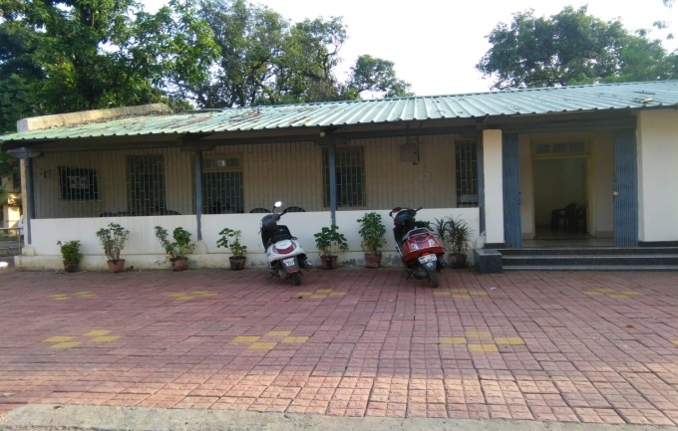 | 