Practical Chapter - ESTIMATION OF WATER STATUS OF PLANTS THROUGH RELATIVE WATER CONTENT (RWC) AND WATER SATURATION DEFICIT (WSD).
Dr. Sunil Kumar Pandey, Assistant Prof. (Plant Physiology),
College of Agriculture, Powarkheda, Hoshangabad , Madhya Pradesh

Objective: To find out the estimation of relative water content (RWC %) and water saturation deficit (WSD %) from leaves tissue in control (Normal) and water deficit (Stress) condition.

Principal of RWC (%): In principle, to obtain the initial and turgid water contents it is necessary merely to weigh freshly sampled leaf tissue (disks punched with a cork-borer are most convenient), to reweigh the same sample after it has been floated on water to full turgidity and finally to subtract from each of these values the weight of the sample after oven drying (Weatherley, 1950).
Materials Required:
S.No. | Name of items use in experiment | Image
1. | Leaves tissue of sample , | Selection of fully developed and expanded leaves in control and water deficit (Stress) condition :  Control  Water Deficit
2. | Polythene bag, (Zip lock air tight) | 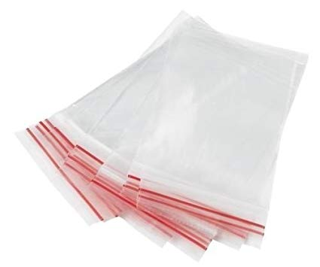
3. | Cooler bag (10⁰C-15⁰C), | 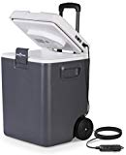
4. | Petri-dish (With cover) | 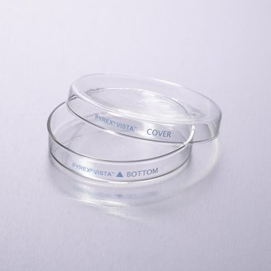
5. | Lab refrigerator (about 10⁰C) | 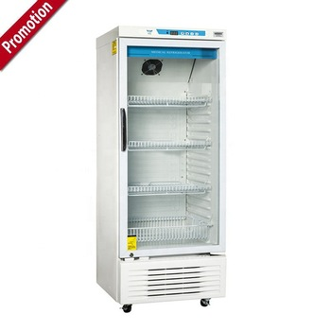
6. | Tween 20 (Detergent Class: Nonionic polyoxyethylene surfactant) if the leaf surface is waxy than use.  TWEEN 20 used in pre- extraction of membranes to remove peripheral proteins (used at 2% for extraction of membrane- bound proteins | 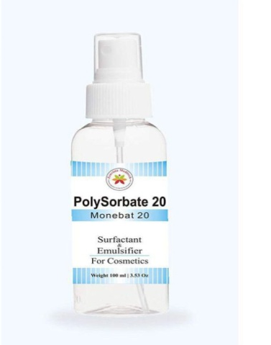
7. | Filter paper | 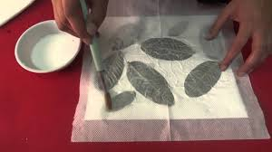  But in this experiment need cut leaf tissue in pieces a before turgid weight slightly use filter paper for surface moisture removal.
8. | Electronic balance | 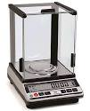
9. | Small envelop size
10. | De-ionized water  (Distil water ) | Distil water unit
11. | Stainless steel strainer /Sieve | 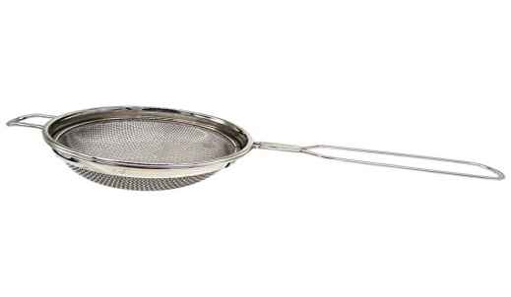
12. | Beaker (Small and Big)  Capacity (250ml to1L) | 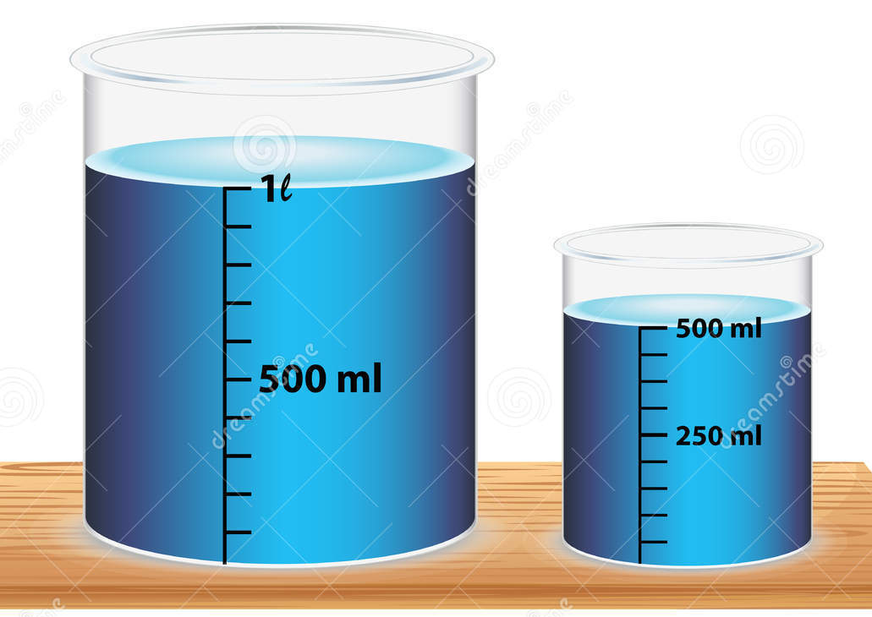
13. | Hot Air Oven | 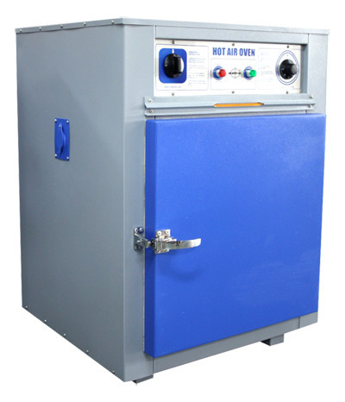

Procedure:
Relative Water Content is express in percentage (%). The technique consists essentially in comparing the water content of leaf tissue when freshly sampled with the fully turgid water content and appropriate water status in plant tissue in term of physiological consequences of cellular water deficit (Barrs and Weatherley, 1962). Which is power full mechanism for conserving cellular hydration in water deficit condition, however water stress express the effect of osmotic adjustment (OA).
Following step is used for estimation of relative water content (RWC %) from leaves tissues viz., soybean or wheat leaves or other crops etc.
- Collect the leaf sample from fully develop and expended topmost is preferable
- Best suitable time for sampling is 11AM-12 Noon.
- For minimize the water loss from leaves tissue kept in Polythene bag, (Zip lock air tight).
- Tissue with Polythene bag, immediately kept in Cooler bag (10⁰C-15⁰C), and quickly reaches at laboratory.
- Leaf tissues cut in fine pieces cut about (5-10 cm) length or 5-10 leaf discs around 1.5 cm diameter.
- Smaller or composite leaves having several leaflets cut in small pieces used 5-10 leaf discs.
- Careful cut of the leaves in small pieces and avoid large veins and mid-ribe.
- Quickly weigh of fresh leaves tissue sample with the help of electronic balance.
- Value recorded as fresh weight(g) in observation sheet.
- After recorded fresh weight leaf tissue sample (g) transfer in petri-dish plate with presence of de-ionized water and cover with petri-dish cap.
- In leaf tissue petri-dish with water, kept in Lab refrigerator (about 10⁰C) or at normal room temperature and light for 4hour.
- Hydrated and full turgid leaf tissue after 4 hour remove from petri-dish with the help stainless steel strainer /Sieve and pour out in filter paper and remove excess moisture.
- Again hydrated turgid leaves weight (g) will measure by electronic balance and value recorded in observation sheet column (Turgid Weight (g)).
- If the leaves tissues or surface is waxy than use add 0.01% Tween 20.
- Turgid leaves tissues kept in small size envelope and kept in hot air oven at 80ºC for 24 hours (h).
- Leaves tissues after proper drying (Till the weight become constant) again the measure dry weight of tissues and value recorded in observation sheet column (dry weight (g)).
- With the value of observation sheet calculate the RWC (%) from the leaves tissue under normal and water deficit condition.
RWC (%) = | (Leaves Fresh Weight - Leave Dry Weight) | X 100
 | (Leaves Turgid Weight - Leaves Dry Weight)
Observation Sheet:
S.No. | Condition | Fresh Weight in Leaves Tissue (g) (A) | Turgid Weight in Leaves Tissue (g) (B) | Dry Weight in Leaves Tissue (g) (C) | RWC (%) =  [(A-C)/(B-C)]X100
1. | Control | 0.80 | 0.90 | 0.40 | 80.00
2. | Water Deficit  (Stress) | 0.75 | 0.90 | 0.35 | 72.72

Water Saturation Deficit (WSD %): Calculate the WSD with help of RWC(%) value

WSD ( %)= 100- RWC(%)

Control Condition

WSD ( %)= 100-80.00

= 20 %

Water Deficit (Stress)
WSD ( %)= 100-72.72
= 27.28 %

Precaution:
- Fully develop and expanded top most leaves selection.
- Sample size does not have to be the same for all samples.
- Avoid large veins and mid-rib from leaves sample.

References:
- Weatherley, P. E. (1950). Studies in the water relations of the cotton plant. 1. The field measurement of water deficits in leaves. New Phytol. 49: 81-97.
- Barrs HD and Weatherly PE. (1962). A re-examination of relative turgidity technique for estimating water deficits in leaves. Australian Journal of Biological Science 15: 413- 428.

