Lecture no. 11
Modification and wing coupling apparatus
Modifications of insect Wing
- Tegmina : (Singular : Tegmen) Wings are leathery or parchment like. They are protective in function. They are not used for flight. e.g. Forewings of cockroach and grasshopper.
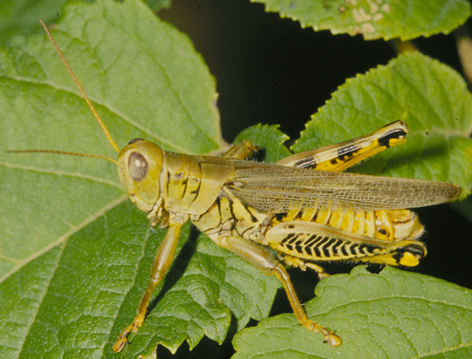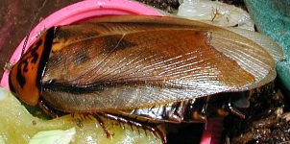
- Elytra : (Sigular : Elytron) The wing is heavily sclerotised. Wing venation is lost. Wing is tough and it is protective in function. It protects hind wings and abdomen. It is not used during flight. But during flight they are kept at an angle allowing free movement of hind wings. e.g. Fore wings of beetles and weevils.
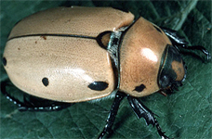
- Hemelytra : (Singular : Hemelytron) The basal half of the wing is thick and leathery and distal half is membranous. They are not involved in flight and are protective in function. e.g. Fore wing of heteropteran bugs.
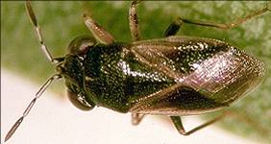
- Halteres: (Singular : Haltere) In true flies the hind wings are modified into small knobbed vibrating organs called haltere. Each haltere is a slender rod clubbed at the free end (capitellum) and enlarged at the base (scabellum). On the basal part two large group of sensory bodies forming the smaller hick's papillae and the large set of scapel plate. They act as balancing organs and provide the needed stability during flight. e.g. true flies, mosquito, male scale insect.
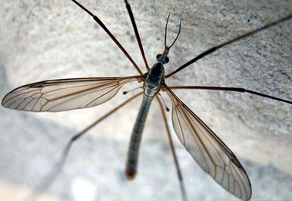
- Fringed wings: Wings are usually reduced in size. Wing margins are fringed with long setae. These insects literally swim through the air. e.g. Thrips.
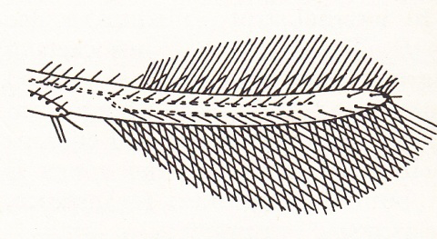
- Scaly wings: Wings of butterfly and moths are covered with small coloured scales. Scales are unicellular flattened outgrowth of body wall. Scales are inclined to the wing surface and overlap each other to form a complete covering. Scales are responsible for colour. They are important in smoothing the air flow over wings and body.
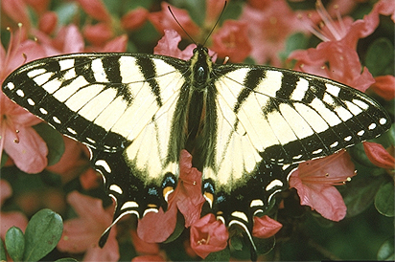
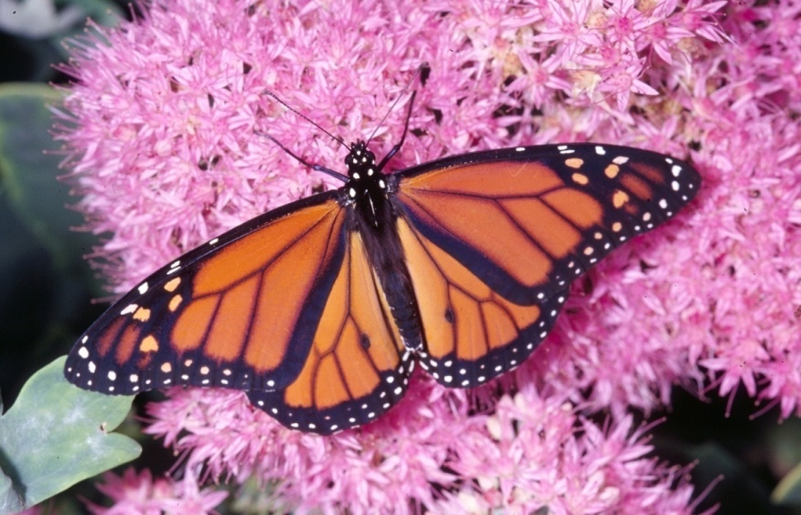
- Membranous wings: They are thin, transparent wings and supported by a system of tubular veins. In many insects either forewings (true flies) or hind wings (grass hopper, cockroach, beetles and earwig) or both fore wings and hind wings (wasp, bees, dragonfly and damselfly) are membranous. They are useful in flight.
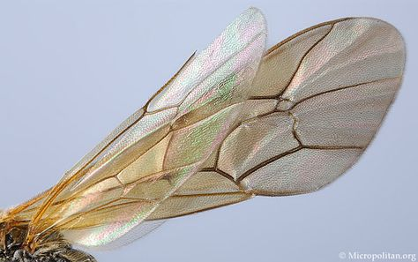
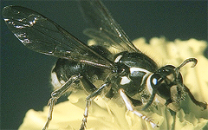
Wing coupling
- Hamulate : A row of small hooks is present on the coastal margin of the hind wing which is known as hamuli. These engage the folded posterior edge of fore wing. e.g. bees.
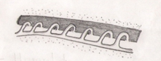
- Amplexiform : It is the simplest form of wing coupling. A linking structure is absent. Coupling is achieved by broad overlapping of adjacent margins. e.g. butterflies.
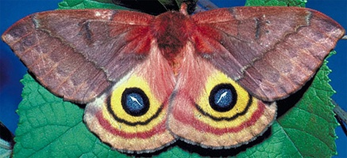
- Frenate : There are two sub types. e.g. Fruit sucking moth.
  - Male frenate : Hindwing bears near the base of the coastal margin a stout bristle called frenulum which is normally held by a curved process, retinaculum arising from the subcostal vein found on the surface of the forewing.
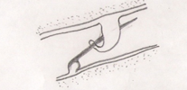

  - Female frenate : Hindwing bears near the base of the costal margin a group of stout bristle (frenulum) which lies beneath extended forewing and engages there in a retinaculum formed by a patch of hairs near cubitus.
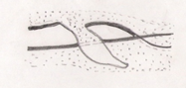
- Jugate : Jugam of the forewings are lobe like and it is locked to the coastalmargin of the hindwings. e.g. Hepialid moths.
