**Lecture no. 10**

**Structure and modifications of insect legs**

**Structure**

In almost all insects all the three thoracic segments *viz*., pro-, meso- and metathorax bear a pair of segmented legs. Each leg consists of five segments viz., coxa, trochanter, femur, tibia and tarsus.

**Coxa** : (Pl. coxae) It is the first or proximal leg segment. It articulates with thecup like depression on the thoracic pleuron. It is generally freely movable.

**Trochanter**: It is the second leg segment. It is usually small and singlesegmented. Trochanter seems to be two segmented in dragonfly, dameselfy and ichneumonid wasp. The apparent second trochanter is in fact a part of femur, which is called trochantellus.

**Femur**: (Pl. femora) It is the largest and stoutest part of the leg and is closelyattached to the trochanter.

**Tibia**: (Pl. tibiae) It is usually long and provided with downward projectingspines which aid in climbing and footing. Tibia of many insects is armed with large movable spur near the apex.

**Tarsus**: (Pl. tarsi) It is further sub-divided. The sub segment of the tarsus iscalled tarsomere. The number of tarsomeres vary from one to five. The basal tarsal segment is often larger than others and is named as basitarsus.

**Pretarsus**: Beyound the tarsus there are several structure collectively known aspretarsus. Tarsus terminates in a pair of strongly curved claws with one or two pads of cushions at their base between them. A median pad between the claws is usually known as arolium and a pair of pads, at their base are called pulvilli (Pulvillus-singular). Leg pads are useful while walking on smooth surface and claws give needed grip while walking on rough surface. When one structure is used, the other is bent upwards.



**Types or modifications**

Legs are modified in to several types based on the habitat and food habit of insect and used for a wide variety of functions.

1. **Ambulatorial** (Ambulate - to walk; Walking leg) e.g. Fore leg and middle legof grasshopper. Femur and tibia are long. Legs are suited for walking.

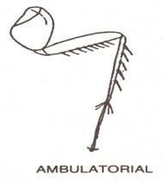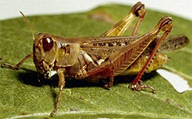

1. **Cursorial**: (Cursorial = adapted for running : Running leg) e.g.All the threepairs of legs of cockroach. Legs are suited for running. Femur is not swollen.

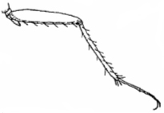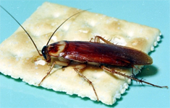

1. **Saltatorial:** (Salatorial = Leaping : Jumping Leg) e.g. hind leg of grasshopper.

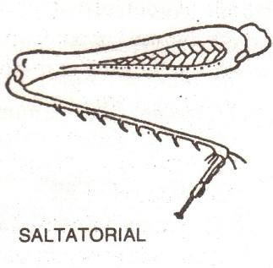

1. **Scansorial**: (Scansorial = Climbing; climbing or clinging leg) e.g. all the threepairs of legs of head louse.



1. **Fossorial**: (Forrorial = Digging; Burrowing leg) e.g. Fore legs of mole cricket.

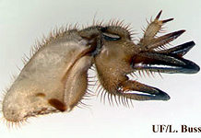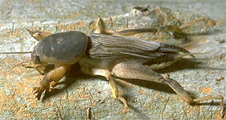

1. **Raptorial**: (Raptorial = predatory ; Grasping leg) e.g. Forelegs of preyingmantis.

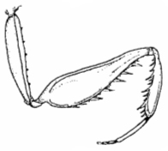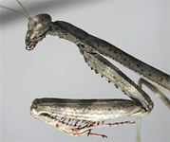

1. **Natatorial**: (Natatorial = pertaining to swimming; Swimming leg) e.g. hinglegs of water bug and water beetle.

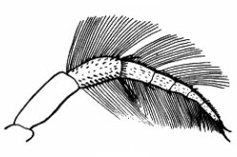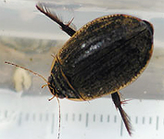

1. **Sticking leg**: e.g. all the three pairs of legs of house fly.

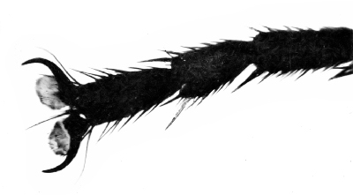 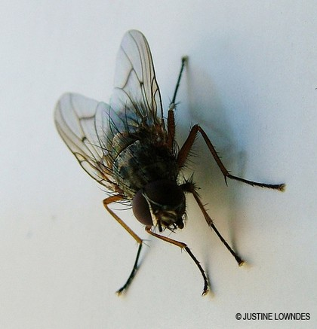

1. **Basket like leg:** e.g. Legs of dragonfly and damselfly.



1. **Clasping leg**: e.g. Forelegs of male water beetle.

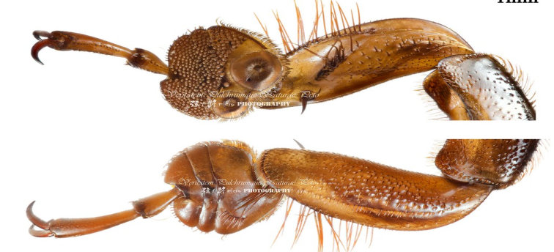

1. **Foragial leg**: (Forage = to collect food material) e.g. Legs of honey bee.

**i. Forelegs** : The foreleg has three important structures

a. Eye brush

1. Antenna cleaner or strigillis:
2. Pollen brush:

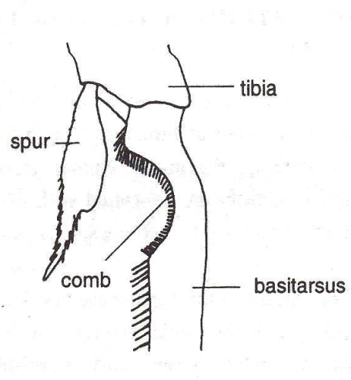

ii. **Middle legs** : It has two important structures.

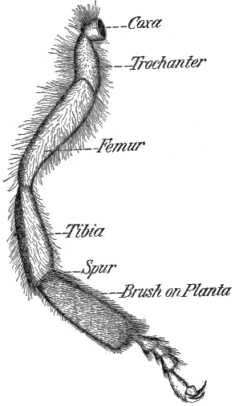

1. **Pollen brush**: Stiff hairs on basitarsus form pollen brush which is useful tocollect pollen from middle part of their body.
2. **Tibial spar**: At the distal end of the tibia, a movable spur is present which isuseful to loosen the pellets of pollen from the pollen basket of hind legs and to clean wings and spiracles.
3. **Hind legs**: It has three important structures viz., pollen basket, pollen packerand pollen comb.
4. **Pollen basket**: It is also called corbicula. The outer surface of the hind tibiacontains a shallow cavity. The edges of the cavity are fringed with long hairs. The pollen basket enables the bee to carry a larger load of pollen and propolis from the field to the hive.

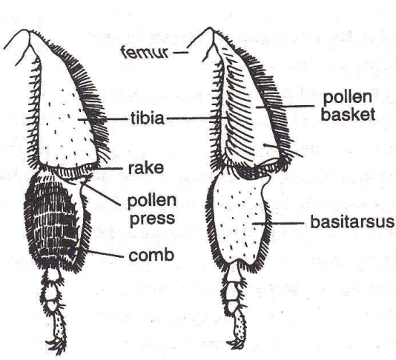

1. **Pollen packer**: It is also called pollen press. It consists of pecten and auricle.Pecten is a row of stout bristles at the distal end of tibia. Auricle is a small plate fringed with hairs at the basal end of basitarsus. Pollen packer is useful to load pollen in corbicula.

c. **Pollen comb**: About ten rows of stiff spines are present on the inner side of hind basitarsus. The pollen comb is used to collect pollen from middle legs and from posterior part of the body.

12. **Prolegs** or **False legs** or **Pseudolegs**: e.g. abdominal legs of caterpillar. There are two to five pairs of abdominal legs termed prolegs in caterpillar. Prolegs are thick, fleshy and not segmented. They are shed with last larval moult. One pair of prolegs on the last abdominal segment are called anal prolegs or claspers. The tip of proleg is called planta upon which are borne hooks or claws known as crochets which are useful in crawling or clinging to surface.

