**Lecture no. 9**

**Structure, function and modifications of insect mouth parts: biting and chewing and piercing and sucking types ( bug type)**

The mouthparts are the organs concerned for the ingestion of different nature of food. The variation can be correlated with the methods of feeding and the techniques of insect pest management. The mouthparts have also taxonomic importance as it gives clues for the classification of insects. The mouth parts comprises:

* + - Labrum upper lip or in front,
    - the lower or ventral surface of which forms the epipharynx,
    - a tongue like hypopharynx behind the mouth,
    - one pair of jaws or mandibles,
    - one paired maxillae and
    - labium forming a lower lip.

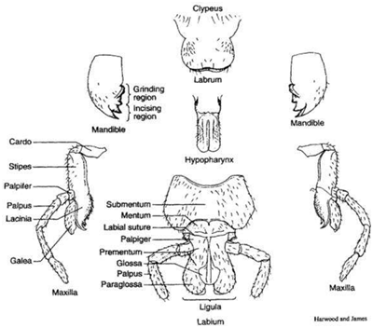

The mouthparts may include up to two pairs of sensory, feeler-like palps (labial palps or maxillary palps). Various pairs of glands (labial glands, mandibular glands, maxillary glands and thoracic glands) are also associated with the mouthparts. In insects, the mouthparts do not lie in a cavity of the head and the condition is called ectognathous. The mouth parts of Collembola, Diplura and Protura lie in a cavity of the head and the condition is called entognathous condition.

**Different parts of insect mouth**

**Labrum**: Labrum or upper lip is a broad lobe that covers the mandibles and closes the mouth cavity from the upper front.

**Function**: It helps to pull the food into mouth.

**Mandibles**: Mandibles are the anterior or the first pair of true jaw and lie directly behind the labrum as the appendages of the second post-oral segment. Generally the mandibles are hard and heavily sclerotized, have various sets of teeth and brushes. Mandibles move sideways.

**Function**: Bite off and chew food particles.

**Maxillae**: These lie directly behind the mandibles and are the appendages of the third post oral segment. The generalized type of maxillae is masticating structure which can be divided following well marked sclerites;

* Cardo: The triangular basal sclerite attached to the head capsule that serves as a hinge for the movement of the remainder of the maxillae.
* Stipes: It is the central portion of the body of the maxillae. It is somewhat rectangular in shape. The stipes is situated above the cardo and is the basis for the remaining of the maxillae.
* Galea: It is the outer or lateral lobe articulating at the end of the stipes. It is frequently developed as a sensory pad or bears a cap of sense organs.
* Lacinia: It is the inner or mesal lobe articulating at the apex of the stipes. It is usually mandible like in form with a series of spines or teeth along its mesal edge.
* Palpus: It is the antennae like segmented appendage which arises from the lateral side of the stipes. It is commonly five segmented and entirely sensory in function.

**Labium**: Labium or lower lip is a single structure lying posterior the maxillae and is formed by the fusion of a pair of appendages serially homologous with the maxillae. The labium is divided by a labial suture into two primary portions: a basal postmentum and distal prementum.

* Postmentum: It is the basal region of labium and hinges with the head membranes.
* Prementum: It is the apical region of the labium and includes various lobes and processes. The central portion is the prementum also called stipulae which bears a pair of labial palpi, one on each side of the prementum and each usually three segmented in generalized forms. The apical portion of prementum frequently forms a sort of tongue and is called ligula. The ligula varies greatly in structure but usually is divided into two pairs of lobes: the mesal glossa and lateral paraglossae parallel to glossae. In many groups the glossae are fused to form an alaglossa and in many others the glossa and paraglossa are fused to form totoglossa.

**Epypharynx**: On inner and posterior side of labrum a membranous median lobe, epipharynx is present. Epipharynx is a sensory area believed to contain end organs of taste.

**Hypopharynx**: Hypopharynx is a short tongue like structure located immediately above the labium and between the maxillae. It usually forms a project lobe or mould and is associated with the base of labium as to be considered a part of it. Unlike the other mouth parts, the hypopharynx is not an appendage but an un-segmented outgrowth of the ventral membranous floor of the head. In most insects, the ducts from salivary glands open on or near the hypopharynx. In a few primitive insects, a pair of lateral lobes occurs with the median lingua of hypopharynx and is called superlinguae.

**Modification of mouth parts**

Mouthparts vary greatly among insects of different orders, but basically the mouth parts

may be divided into two groups:

• Chewing and Biting type (considered as primitive) (*mandibulate)*

• Sucking type (*haustellate)*

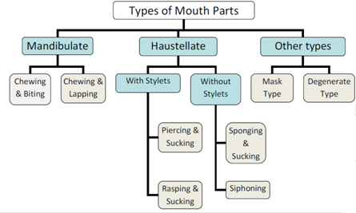

Chewing and Biting Type Grasshoppers, Cockroaches

Chewing and Lapping Type Honey Bee

Piercing and Sucking Type Aphids, Bugs, Mosquitoes, Lice

Rasping and Sucking Type or Thrips

Lacerating and Sucking Type

Sponging or Lapping and Sucking Type House fly

Siphoning Type Butter Flies, Moths

Mask Type Young ones (Naiads) of Dragon Fly

Degenerate Type Maggots

**CHEWING & BITING TYPE**

The generalized biting type of mouth parts are as follows and are present in nymphs and adults of grasshoppers, cockroaches, termites and beetles. Examples: Dragonflies and damselflies (order Odonata), termites (order Isoptera), adult lacewings (order Neuroptera), beetles (order Coleoptera), ants (order Hymenoptera), cockroaches (order Blattaria), grasshoppers, crickets and katydids (order Orthoptera), and caterpillars (order Lepidoptera). The biting and chewing type mouth parts comprises by following:

**Labrum**

* + It is a simple plate like structure situated below the clypeus, anterior side of the head.
  + It overlaps the bases of mandibles.
  + Its inner surface is usually provided with chemoreceptors and is produced into small
  + Lobe-like epipharynx in Hymenoptera.

**Mandibles**

* + Paired heavily sclerotized, un-segmented jaws lying immediately behind the labrum.
  + They articulate with the head capsule by means of two joints as dicondyle.
  + Mandibles possess two types of teeth: Incisors and molars. Incisors are useful for cutting and molars are useful for grinding.
  + The mandibles are adopted for cutting or crushing the food.
  + The mandibles are frequently used for defence also.



**Maxillae**

* + The paired structures lying behind the mandibles.
  + They are segmented and each maxilla bears a feeler like organ, the palpus which are useful to know the quality and taste of food.
  + The basal segment of the maxilla is the cardo and the second segment in the stipes. The palpus is borne on the lobe of stipes is called the palpifer (maxillary palpi).
  + The stipes bears at its apex two lobe like structures the lacinia, an elongate jaw like structure and the galea, a lobe like structure.
  + Lacinia is spined or toothed on its inner border. In some insects the stipes bears a single lobe called male. Functionally the maxillae are a pair of accessory jaws, their lacinia aiding the mandibles in holding the food when the later are extended as well as assisting in mastication.

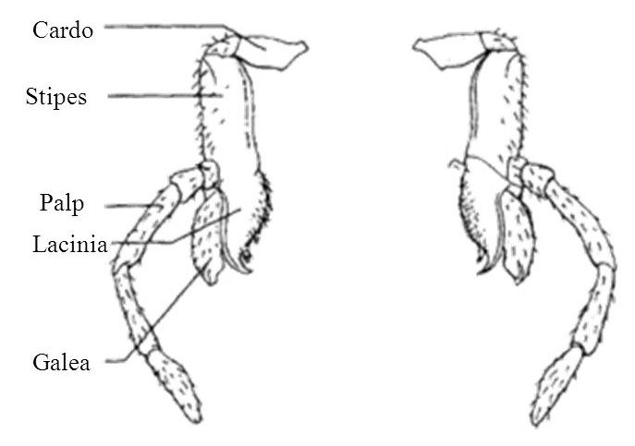

**Labium**

* + Lower lip lies behind the maxillae.
  + It is divided by a transverse suture (labial suture) into two portions a basal post-mentum and a distal pre-mentum.
  + Post mentum usually divides into basal sub-mentum and distal mentum.
  + The prementum bears a pair of palpi and a group of apical lobes which constitute the ligula. The labial palpi are borne on lateral lobes of the prementum, called palpiger.
  + The ligula consists of a pair of small lobes in the middle, the glossae and one pair of larger lobes laterally, the paraglossae.
  + Labial palpi functions as sense organs.



**Hypopharynx**

* + It is a short tongue like structure located above the labium and between the maxillae.
  + In most insects the ducts from the salivary glands open on or near the hypopharynx.



**PIERCING & SUCKING TYPE**

Example: Cicadas, aphids, and other plant bugs (order Hemiptera), sucking lice (order

Phthiraptera-Anoplura), stable flies and mosquitoes (order Diptera).



The mandible and maxillae are modified to form slender bristle like stylets which rest in the grooved labium.

* + Both pairs of stylets are hallowing sets–like structures capable of limited protrusion and retraction by means of muscular action.
  + The mandibular stylets form the anterior or outer pair. They are usually serrated with axe type edge, useful for piercing the skin.
  + The posterior or inner pair of stylets constitutes the maxillae. Maxillary palps absent. Each maxillary stylets tapers to a fine point and is grooved along its inner aspect the groove is divided in to two parallel channels by means of a longitudinal ridge which traverses the length of stylet.
  + When both the maxillary stylets come close together, they enclose two extremely fine tubes. 'Saliva' may be pumped down one of the tubes. This saliva makes the food into a liquid. The liquified food is sucked up the other tube.
  + The stylets themselves are enclosed in a sheath formed almost entirely by the labium which is dorsally grooved for their reception. At its base however the labial groove is wanting and in this region the sheath is roofed over the labrum. Usually labium is four segmented. Labial palps are wanting.
  + Labrum forms the cover over the grooved labium.
  + The hypopharynx is highly specialized and reduced either to form the floor of the cibarial sucking pump or to form mandibular plates.
  + The stylets are pierced inside the plant tissues and generally they suck plant sap from phloem vessels.