**UNIT- VI**

Biofertilizers- definition, classification, specifications, method of production and role in crop production.

**Biofertilizers**

'Biofertilizer' is a substance which contains living [microorganisms](http://en.wikipedia.org/wiki/Microorganism) which, when applied to seed, plant surfaces, or soil, colonizes the [rhizosphere](http://en.wikipedia.org/wiki/Rhizosphere) or the interior of the plant and promotes growth by increasing the supply or availability of primary nutrients to the host plant. Bio-fertilizers add nutrients through the natural processes of [Nitrogen fixation](http://en.wikipedia.org/wiki/Nitrogen_fixation), solubilizing [phosphorus](http://en.wikipedia.org/wiki/Phosphorus), and stimulating plant growth through the synthesis of growth promoting substances.

Bio-fertilizers can be expected to reduce the use of [chemical fertilizers](http://en.wikipedia.org/wiki/Chemical_fertilizers) and [pesticides](http://en.wikipedia.org/wiki/Pesticides). The microorganisms in bio-fertilizers restore the soil's natural nutrient cycle and build soil organic matter. Through the use of bio-fertilizers, healthy plants can be grown while enhancing the sustainability and the health of soil. Since they play several roles, a preferred scientific term for such beneficial bacteria is [plant-growth promoting rhizobacteria](http://en.wikipedia.org/wiki/Plant-growth_promoting_rhizobacteria) (PGPR). Therefore, they are extremely advantageous in enriching [soil fertility](http://en.wikipedia.org/wiki/Soil_fertility) and fulfilling plant nutrient requirements by supplying the organic nutrients through microorganism and their byproduct. Hence, bio-fertilizers do not contain any chemicals which are harmful to the living soil. Bio-fertilizers are Eco-friendly organic agro-input and more cost effective than [chemical fertilizers](http://en.wikipedia.org/wiki/Chemical_fertilizers). Bio-fertilizers like [*Rhizobium*](http://en.wikipedia.org/wiki/Rhizobium)*,* [*Azotobacter*](http://en.wikipedia.org/wiki/Azotobacter)*, Azospirillum* and [blue green algae](http://en.wikipedia.org/wiki/Blue_green_algae) (BGA) are in use since long time ago. [Rhizobium inoculant](http://en.wikipedia.org/wiki/Rhizobium) is used for leguminous crops. Different rhizobial cultures are used specifically for different cross inoculation groups of leguminous crops. [*Azotobacter*](http://en.wikipedia.org/wiki/Azotobacter) can be used with non-leguminous crops like [wheat](http://en.wikipedia.org/wiki/Wheat), [maize](http://en.wikipedia.org/wiki/Maize), [mustard](http://en.wikipedia.org/wiki/Mustard_plant), [cotton](http://en.wikipedia.org/wiki/Cotton), potato and other vegetable crops. [*Azospirillum*](http://en.wikipedia.org/w/index.php?title=Azospirillum&action=edit&redlink=1) inoculations are recommended mainly for [sorghum](http://en.wikipedia.org/wiki/Sorghum), [millets](http://en.wikipedia.org/wiki/Millets), [maize](http://en.wikipedia.org/wiki/Maize), [sugarcane](http://en.wikipedia.org/wiki/Sugarcane) and wheat. [Blue green algae](http://en.wikipedia.org/wiki/Blue_green_algae) belonging to general [*Nostoc*](http://en.wikipedia.org/wiki/Nostoc)*,* [*Anabaena*](http://en.wikipedia.org/wiki/Anabaena)*,* [*Tolypothrix*](http://en.wikipedia.org/w/index.php?title=Tolypothrix&action=edit&redlink=1)and[*Aulosira*](http://en.wikipedia.org/w/index.php?title=Aulosira&action=edit&redlink=1) fix atmospheric nitrogen and are used as inoculations for paddy crop grown both under upland and low land conditions. Other types of bacteria, so-called [phosphate solubilizing bacteria](http://en.wikipedia.org/wiki/Phosphate_solubilizing_bacteria) like [Pseudomonas fluorescence](http://en.wikipedia.org/wiki/Pseudomonas_putida)  are able to solubilize the [insoluble phosphate](http://en.wikipedia.org/w/index.php?title=Insoluble_phosphate&action=edit&redlink=1) from organic and [inorganic phosphate](http://en.wikipedia.org/wiki/Inorganic_phosphate) sources. In fact, due to immobilization of phosphate by mineral ions such as [Fe](http://en.wikipedia.org/wiki/Fe), [Al](http://en.wikipedia.org/wiki/Aluminium) and [Ca](http://en.wikipedia.org/wiki/Calcium) or [organic acids](http://en.wikipedia.org/wiki/Organic_acids), the rate of available phosphate (Pi) in soil is well below plant needs. In addition, chemical Pi fertilizers are also immobilized in the soil immediately so that less than 20 percent of added fertilizer is absorbed by plants. Therefore, reduction in Pi resources, on one hand, and environmental pollutions resulted from both production and applications of chemical Pi fertilizer, on the other hand, have already demanded the use of new generation of phosphate fertilizers globally known as [phosphate solubilizing bacteria](http://en.wikipedia.org/wiki/Phosphate_solubilizing_bacteria) or phosphate bio-fertilizers.

Blue-green algae cultured in specific media. Blue-green algae can be helpful in agriculture as they have the capability to fix atmospheric nitrogen to soil. This nitrogen is helpful to the crops. Hence, blue-green algae is used as a bio-fertilizer.

Biofertilizers are defined as preparations containing living cells or latent cells of efficient strains of microorganisms that help crop plants’ uptake of nutrients by their interactions in the rhizosphere when applied through seed or soil.  They accelerate certain microbial processes in the soil which augment the extent of availability of nutrients in a form easily assimilated by plants.

Very often microorganisms are not as efficient in natural surroundings as one would expect them to be and therefore artificially multiplied cultures of efficient selected microorganisms play a vital role in accelerating the microbial processes in soil.

Use of biofertilizers is one of the important components of integrated nutrient management, as they are cost effective and renewable source of plant nutrients to supplement the chemical fertilizers for sustainable agriculture. Several microorganisms and their association with crop plants are being exploited in the production of biofertilizers. They can be grouped in different ways based on their nature and function.

**Biofertilizers what does it contain ?**

Biofertilizers contain effective microorganisms (EM) isolated from local pedo-ecological system tested and screened under research unit of the VV. The EM strains are artificially nurtured and multiplied lavishly with ample supplement of nutrients under laboratory condition. The bioculture is then provided sustenance with a processed solid carrier base material like lignite, charcoal, sugarcane press mud. The microbes in carrier based culture are curried for further healthy multiplication upto 109 to 1010 cells/g. The biofertilizers are now ready to supply for agricultural use. The VV always provides freshly prepared biofertilizers, only after receiving supply orders.

**Attributes of carrier based Biofertilizers**

* Longer shelf life 6-12 months.
* No contamination if qualitatively tested.
* No loss of properties when stored at room temperature.
* Potentially competent to fight with native population.
* High populations can be maintained more than 108 cells/ml upto 6 months.
* Easy identification by typical fermented smell.
* Better survival on seeds, soil and other treated materials.
* Easy to procure directly from the source of manufacture.
* Very much easy to use by the farmer and good adhesion to seeds and other treated surface.
* Easy to treat on seeds, soil and planting materials.
* Application rates are very less.

**Benefits**

* Microorganism function is in long duration causing improvement of the soil fertility. It maintains the natural habitat of the soil.
* It increases crop yield by 20-30%, replaces chemical nitrogen and phosphorus by 25%, and stimulates plant growth. Hence it is supplementary to chemical fertilizers.
* It can also provide protection against drought and some soil-borne diseases (as assured in case of *Trichoderma* culture).
* Biofertilizers are cost effective relative to chemical fertilizers. They have lower manufacturing costs especially regarding nitrogen and phosphorus use.
* It is environmentally friendly in that it not only prevents damaging the natural source but also helps to some extent cleanse the plant from precipitated chemical fertilizer.
* Organic fertilizers have been known to improve biodiversity ([soil life](http://en.wikipedia.org/wiki/Soil_life)) and long-term productivity of soil, and may prove a large depository for excess [carbon dioxide](http://en.wikipedia.org/wiki/Carbon_dioxide).
* Organic nutrients increase the abundance of soil organisms such as fungal [mycorrhiza](http://en.wikipedia.org/wiki/Mycorrhiza), which aid plants in absorbing nutrients.
* Secrete certain growth promoting substances.
* Improve soil structure (porosity) and water holding capacity.
* Enhance seed germination.
* Increase soil fertility and fertilizer use efficiency and ultimately the yield of crops.

**Precautions in use of Biofertilizers**

The term 'Biofertilizer' itself denotes that, it is a 'Live Fertilizer'. The quality of Biofertilizers demand in-depth study of microbial characteristics, effectiveness, consistency, precautions and limitations not only at laboratory and production level but at field level too.

* 1. Store the packets of biofertilizers in cold place, away from direct sun or hot wind.
  2. Biofertilizers are very specific to be effective to the particular crop(s), please apply as recommended.
  3. Tear open the packets of biofertilizers only just before use, apply entire packet of biofertilizer in one application.
  4. Treat the seeds (seed coating) or seedling (dipping) under shade only.
  5. Avoid direct contact of chemical fertilizers and pesticides.
  6. In case of seed treatment with pesticides is essential, treat the seeds first with the pesticides followed by treatment of biofertilizer at the rate 2-3 time more of recommended dosage.
  7. Good quality biofertilizer is identified with the moisture content of 30-40%, as envisaged by formation of a clod in the fist.
  8. For convenience in application of biofertilizers, in case of soil application, admix recommended dose of biofertilizer with 50 kg pulverized soil or FYM and broadcast.
  9. Every biofertilizer responds better if soil is enriched with sufficient quantity of available phosphate (apply superphosphate), organic matter (apply FYM), soil of neutral pH (apply lime).
  10. To obtain best effect, treatment with biofertilizers is advised 3-4 hour before sowing.

**Classification of Biofertilizers**

**Biofertilizers**

**N fixers PSM VAM PGPR S solubilizing microbes**

*Bacillus Glomas* *phasiculatus* *Trichoderma viride Thiobacillus thiooxidans*

*Pseudomonas*

**Bacteria BGA Azolla**

*Rhizobium Anabaena Azolla filiculoides*

*Azotobacter Anabaenopsis Azolla rubra*

*Azospirillum Nostox*

*Mycobacterium Tolypothrix*

*Bacillus*

***Rhizobium* cultures**

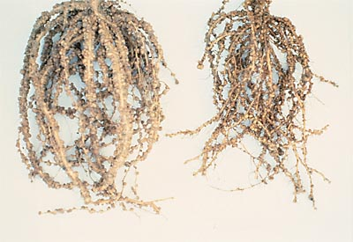

**Fig. Soybean root nodules, each containing billions of *Rhizobium* bacteria**

**Rhizobia** are [soil](http://en.wikipedia.org/wiki/Soil) [bacteria](http://en.wikipedia.org/wiki/Bacteria) that [fix](http://en.wikipedia.org/wiki/Nitrogen_fixation) [nitrogen](http://en.wikipedia.org/wiki/Nitrogen) ([diazotrophs](http://en.wikipedia.org/wiki/Diazotrophs" \o "Diazotrophs)) after becoming established inside [root nodules](http://en.wikipedia.org/wiki/Root_nodule) of legumes. Rhizobia require a [plant](http://en.wikipedia.org/wiki/Plant) [host](http://en.wikipedia.org/wiki/Host_(biology)); they cannot independently fix nitrogen.

The principle of cross-inoculation grouping is based on the ability of an isolate of *Rhizobium* to form nodules in a limited number of [species](http://en.wikipedia.org/wiki/Species) of legumes related to one another. All rhizobia that could form nodules on roots of certain legume types have been collectively taken as a species. This system of classification has provided a workable basis for the agricultural practice of legume inoculation. Under this scheme, seven species are generally recognized.

**Table 11.2. Species of *Rhizobium* and cross inoculation groups of host plants**

|  |  |  |
| --- | --- | --- |
| ***Rhizobium sp.*** | ***Host genera*** | ***Cross inoculation*** |
| *R. japonicum* | *Glycine* | Soybean *groups* |
| *R. leguminosarum* | *Pisum, Lathyrus, Vicia,* Lens | Pea group |
| *R. lupini* | *Lupinus, Ornithopus* | Lupin group |
| *R. meliloti* | *Melilotus, Medicago, Trigonella* | Alfalfa group |
| *R. phaseolus* | *Phaseolus* | Bean group |
| *R. trifolii* | *Trifolium* | Clover group |
| Other species of *Rhizobium* | *A rack is, Crotalaria, Vigna, Pueraria* | Cowpea group |

The Rhizobium culture strains are antigenically very selective and require particular host for nodulation. The surface antigen on the Rhizobial cells recognizes the binding sites (specific root exudates) on the roots of the leguminous plants. This characteristic makes them host-specific. Specific Rhizobial cell can penetrate the roots of the specific leguminous plants only and form nodules. They multiply within the nodule using the carbon source from the plant and in turn fix part of the atmospheric nitrogen to the plant.

Different Rhizobium cultures are available for the different leguminous crops like gram, pigeonpea, mung, urid, pea, soybean, lentil, etc.

Each Rhizobium culture is useful only for the crop mentioned. This culture should be applied by seed treatment only.

 Advantages

 • The effective strain used in Rhizobium culture increases the healthy nodulation and thereby nitrogen fixation (about 40 to 50 kg/ha).

• About 15 to 20% increase of crop yield can be achieved with the use of this culture.

• The residues of pulses (legume crops) left in the soil after harvesting the crop are also advantageous to the subsequent crops to be sown.

Dose

* Seed Treatment (for one acre): 200 g / 10-15 kg seeds with light sprinkling of water.

***Azotobacter* Culture**

*Azotobacter* is a genus of free-living diazotrophic bacteria whose resting stage is a cyst. It is primarily found in neutral to alkaline soils, in aquatic environments, and on some plants. It has several metabolic capabilties, including atmospheric nitrogen fixation by conversion to ammonia, after which the ammonia is turned into proteins. Their unique system of three distinct nitrogenase enzymes makes these bacteria of particular interest to scientists, who may work toward a better understanding of nitrogen fixation and its role in agriculture. *Azotobacter* spp. have the highest metabolic rate of any organisms. Therefore, soil-dwelling diazotrophs such as *Azotobacter* are especially useful in gauging the health and virility of the ground.

*Azotobacter* cultures are useful for the cereals and cash crops viz. Wheat, Paddy, Bajra, Jowar, Maize, Mustard, Cotton, Cumin, Banana, Sugarcane, Tobacco, Castor, Vegetables etc., as well as horticultural crops.

**Advantages**

• The effective strain used in *Azotobacter* culture fixes about 20 to 25 kg atmospheric nitrogen per hectare.

• Certain growth promoting substances released by these cultures are useful for increasing the seed germination, plant growth and ultimately the yield.

• In certain condition they also exhibit anti-fungal activities and thereby fungal diseases may be controlled indirectly.

• About 10 to 15% increase of crop yield can be achieved with the use of these cultures.

**Dose**

* Seed treatment (for one acre): 200 g (1 pkt)/ 10-15 kg seeds with light sprinkling of water.
* Seedling root treatment (for one acre): 2-4 pkts culture per 15 litre water, deep the roots for 30 min before transplanting.
* Soil application (for one acre): 8-10 pkts culture admixed with 50 kg pulverized soil or FYM and broadcast. The soil-culture mixture may be applied to soil near the roots of standing crop may be done.

***Azospirillum* Culture**

The cells of *Azospirillum* remain in association with the roots and fix part of the atmospheric nitrogen. *Azospirillum* culture is useful for the cereals and cash crops viz. wheat, paddy, bajra, jowar, maize, mustard, cotton, banana, sugarcane, tobacco, vegetables, and horticultural crops etc.

**Advantages**

• The effective strain used in *Azospirillum* culture fixes about 15 to 20 kg N/ha.

• Certain growth promoting substances released by these cultures are useful for increasing the seed germination, plant growth and ultimately the yield.

• In certain condition, anti-fungal activities exhibited by this culture indirectly controls fungal diseases.

• Crop yield about 10 to 15% is increased with the use of this culture.

**Dose**

 Seed treatment (for one acre): 200 g (1 pkt)/ 10-15 kg seeds with light sprinkling of water.

* Seedling root treatment (for one acre): 2-4 pkts culture per 15 litre water, deep the roots for 30 min before transplanting.
* Soil application (for one acre): 8-10 pkts culture admixed with 50 kg pulverized soil or FYM and broadcast. This mixture can be applied to soil near the roots of standing crop.

**Phosphate Solubilizing Bacteria (PSB)**

Most of the cultivable soil being alkaline in nature contains less available phosphorus. Due to higher concentration of calcium, whenever phosphatic fertilizers are applied in such soil, the large quantity of it gets fixed as tri-calcium phosphate as it is water insoluble and hence becomes unavailable to the crop. Certain soil microorganisms have inherent capacity to dissolve part of the fixed phosphorus and make it available to the crop by secreting certain organic acids.

PSB culture are useful for all the crops i.e. cereals, cash crops, leguminous crops. horticultural crops, vegetables, etc.

**Advantages**

The effective strain of Phosphate Solubilized Bacteria used, increase the level of available P2O5 in soil through its solubilzation 30 to 40% of phosphate deposit.

* With the increase in available P2O5 level, overall plant growth can be increased.
* In certain condition they also exhibit anti-fungal activities and thereby fungal diseases may be controlled indirectly.
* About 10 to 15% increase of crop yield can be achieved with the use of this culture.

**Dose**

 Seed treatment (for one acre): 250 g (1 pkt)/ 10-15 kg seeds with light sprinkling of water.

* Seedling root treatment (for one acre): 2-4 pkts (0.5-1 kg) culture per 15 litre water, deep the roots for 30 min before transplanting.
* Soil application (for one acre): 4-8 pkts (1-2 kg) culture admixed with 50 kg pulverized soil or FYM and broadcast. This mixture can be applied to soil near the roots of standing crop.

***Trichoderma* culture**

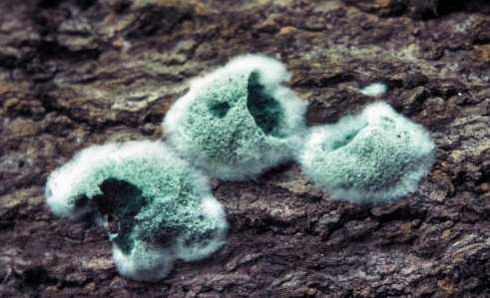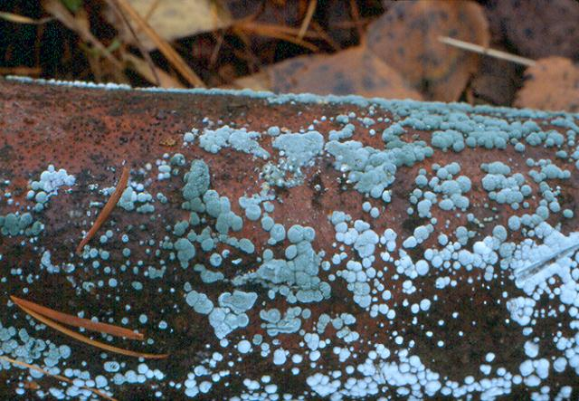

***Trichoderma viride woolly growth***

***Trichoderma*** is a [genus](http://en.wikipedia.org/wiki/Genus) of [fungi](http://en.wikipedia.org/wiki/Fungi) that is present in all soils, where they are the most prevalent [culturable](http://en.wikipedia.org/wiki/Cell_culture) fungi. Many species in this genus can be characterized as opportunistic avirulent plant symbionts.

Several strains of *Trichoderma* have been developed as biocontrol agents against fungal diseases of plants. The various mechanisms include antibiosis, myco-parasitism, inducing host-plant resistance, and competition. Most important biocontrol agent is from the species *T. viride*. The biocontrol agent generally grows in its natural habitat on the root surface, and so affects root disease in particular, but can also be effective against foliar diseases.

**Advantages**

1. **Disease Control:** Trichoderma is a potent biocontrol agent and used extensively for disease control. It has been used successfully against various pathogenic fungi belonging to various genera, viz. Fusarium, Phytopthara, Scelerotia.

2. **Plant Growth Promoter:** Trichoderma strains solubilize phosphates and micronutrients. The application of Trichoderma strains with plants such as grasses increases the number of deep roots, thereby increasing the plant's ability to resist drought.

3. **Biochemical Elicitors of Disease Resistance:** Trichoderma strains are known to induce resistance in plants. Three classes of compounds that are produced by Trichoderma and induce resistance in plants are now known. These compounds induce ethylene production, hypersensitive responses and other defence related reactions in plant cultivates.

4. **Bioremediation:** Trichoderma strains play an important role in the bioremediation of soil that are contaminated with pesticides and herbicides. They have the ability to degrade a wide range of insecticides: organochlorines, organophosphates and carbamates.

**Dose**

• Seed treatment (for one acre): 250 g / 10-15 kg seeds with light sprinkling of water.

• Soil application (for one acre): 1-2 kg (4-8 pkts)/acre is mixed with 50 kg pulverized soil or FYM or compost and broadcast. This mixture can be applied to soil near the roots of standing crop.

**Enriched Bio-organics**

Jawahar Enriched Bio-organics (Rich Organics) contains well-matured organic matter and growth promoting substances of biological origin. It contains major, minor and trace elements available in a form that facilitates its entry into the plant system in totality like chelated nutrients. It has free living nitrogen fixing and phosphate solubilizing microorganisms to benefit plants. It contains bio-stimulants that boost up plant vigour / vegetative growth, flowering, fruiting and yield of crop as targeted by the producer.

**Advantages**

1. Improves soil structure and better tilth.

2. Better soil aeration and water percolation, reducing soil erosion.

3. Increases water and nutrient holding capacity.

4. Provides reserve plant nutrients.

5. Helps in supply of growth promoting substances.

6. Contributes to better taste and flavor of produce.

7. Provides PSM, root nodule bacteria, nitrobacter, etc.

8. Prevents nutrient loss and improves fertilizer usage efficiency.

9. Minimizes the toxic effect of chemical fertilizers, while complementing the use of chemical fertilizers.

10. Serves as major food source for microbial population thus keeping the soil alive.

11. It is weed free and pathogen free.

12. Prevents micro-nutrient deficiencies in plants.

13. Better root and tiller growth, maintain plant health, vigour and green colour.

14. Increases crop yield by 20-40%, with the increase of grain yield 10-30%

15. It is unique natural organic manure.

16. The rate of application is very less 1/10th as that recommended for ordinary organic matter / compost.

17. Direct Manurial value of rich organics is about 400% better than normal cow-dung.

18. Rich organics is almost a complete balanced plant food.

**How to apply?**

* Rich Organics should be mixed well into the top 20-25 cm layer of soil. This is the area where active growth and development of roots take place.

**When to apply ?**

* Normally, it should be applied at the time of soil / land preparation.
* However, inter-row application can also be done. In case of perennials (like fruit trees), Aug, Sept. (after monsoon rains) is the best time to apply Rich Organics.
* Rich Organics creates the right kind of conditions for faster germination and establishment of the root system. Hence, the application of Rich Organics is done prior to seed sowing or raising of seedling / transplanting will have remarkably good results.
* Ideally Rich Organics is recommended to apply every year.

**How much to apply – the Dosage**

Cash crops : 0.5 to 2.0 tonnes per acre.   
Perennial plants : 5 to 10 kg per plant.   
Ornamental plants : 0.5 to 1.0 kg per plant.  
Nurseries and lawns : 2 to 3 kg per square metre.  
For Forests Plants like teak, pines, etc. : 5 - 10 kg. per plant, after rains.

However, the dosages may vary based on the fertility status of the soils. Rich Organics gives best response to light textured soils poor in organic matter and microbe content to reap rich dividends. Admix Rich Organics with adequate quantity of soil and apply before last ploughing.

**BGA culture**

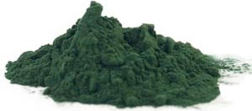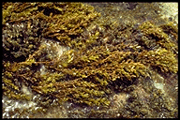

**Bloom of blue green algae flakes in pit Powdered blue green algae flakes**

Blue Green Algae, in symbiotic association with water fern belonging to Azolla species, fixes atmospheric nitrogen in the soil. Nostoc and Anabaena are the two popular species of blue green algae. It can contribute over 100 kg of nitrogen per hectare per crop like paddy under low land conditions. Hence Algae is an excellent association to supply nitrogen in low lying areas.

Blue-green algae are actually a type of **bacteria** that is known as cyanobacteria. In their aquatic habitat, cyanobacteria are equipped to use the sun's energy to manufacture their own food through **photosynthesis**. The moniker blue-green algae came about because of the colour, which was a by-product of the photosynthetic activity of the microbes, and they are found as a algal-like scum on the surface of ponds. Modern day examples of cyanobacteria include *Nostoc*, *Oscillatoria*, *Spirulina*, *Microcystis*, and *Anabaena.* **BGA culture incorporates** cyanobacteria *Anabaena* in major*.*

Cyanobacteria tend to proliferate in very slow moving or still fresh water. Large populations can result very quickly, given the appropriate conditions of temperature and nutrient availability. This explosive growth is popularly referred to as a bloom.

Cyanobacteria are one of the few microorganisms that can convert inert atmospheric nitrogen into a usable form, such as nitrate or ammonia. The production of rice has benefited from the fertilization capability of this bacterial-plant association.

A composite culture of BGA having heterocystous Nostoc, Anabaena, Aulosira etc. is cultured as primary inoculum in trays, polythene lined pots, and cemented pits. Later it is supplied for mass multiplication in the field for application as soil based flakes to the rice growing field at the rate of 10 kg/ha (4 kg/acre).

**Advantages**

1. Cheap source of nutrients, nitrogen 20-30 kg/ha.

2. Suppliers of micronutrients.

3. Supplier of organic matter.

4. Counteracting the negative impact of chemical fertilizers.

5. Secretion of growth hormones.

6. Improves soil health by increasing water holding capacity, nutrient status particularly for nitrogen, organic carbon, and micronutrients.

7. It increases crop yield by 10-20%.

**How to apply BGA culture**

1. BGA culture is applied within 7 days of paddy transplantation, as BGA grows well in presence of vegetation like paddy. The field should contain 8-10 cm of stagnant water (80-100% moisture). BGA soil based culture should be broadcasted @ 10 kg/ha (4 kg/acre).
2. Blooms of BGA flourish better when the field receives application of superphosphate at recommended dose or one third of the recommended dose.
3. After broadcasting of BGA culture, the water in the field should stagnant upto 8-10 cm without disturbance or flowing for next 10-15 days, compact soil surface is better in this context.
4. On appearance of green algae, spray 0.05% of copper sulphate solution.
5. On infestation of insects, spray malathion or nuvan (@ 1 ml/litre), accordingly.
6. To achieve better crop growth, application of one third recommended dose of nitrogen (as urea) is advised.
7. The field receives BGA culture inoculation continuously for 3-4 years, need not require BGA culture for coming years.
8. Soils highly acidic are advised to amend with lime, as GBA thrives well in condition of neutral soil reaction (around pH 7).

**Dose**

* Broadcast (for one acre): 4-8 kg (2-4 pkts)/acre
* For even application, mix the culture with 10-15 kg pulverized soil or FYM per acre area and broadcast.

**Jawahar Mycorrhiza**

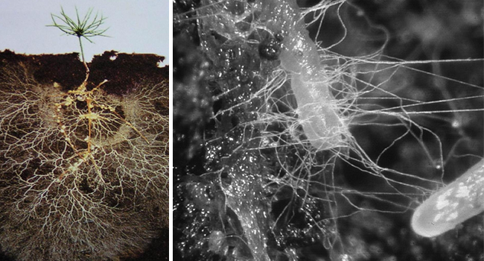

Arbuscular mycorrhizae (AM) are phytobionts correspond to approximately 80% of plant species. The increased capacity of plant roots for water and nutrients uptake from the soil when colonized by AMF is the main mechanisms proposed to explain the effect of AM in plant performance. This behaviour is particularly evident with soil nutrients that are more immobile such as phosphorus (P), Zinc (Zn), and copper (Cu).

**Doses and packing**

**A. Carrier based Jawahar Mycorrhiza culture**

**Soil application:** 12-15 kg culture mixed with 50 kg FYM for one acre and broadcast

**B. Packing**

1 kg lignite based

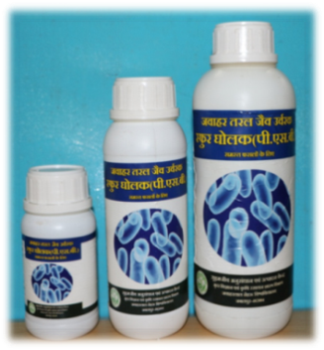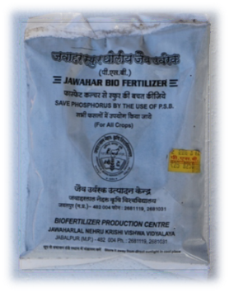**Jawaar K-Solubilizing Bacteria (KSB)**

Bacteria such as *Frateuria aurantia*are capable of mobilizing mixture of K into a usable form to the plants known as KSB, applied to all crops in association with other biofertilizers without any antagonistic effect. Jawahar KSB enhances the potash uptake in plants leading to higher productivity, helps to save up to 30% of normal potash fertilizer cost, does not disturb the ecological balance and improves the plants immune system.

**Doses and packing**

**A. Carrier based Jawahar KSB culture**

**Doses** (seed treatment): 250 g /10-12 kg seeds with light sprinkling of water

**Soil application:** 3-4 kg culture mixed with 50 kg FYM for one acre and broadcast

**B. Liquid Jawahar KSB culture**

**Dose** (seed treatment): 100 ml 10 kg-1 seeds with light sprinkling of water

**Jawahar ZSB (Zn-solubilizer)**

Zn deficiency will result in the cessation of physiological and biochemical functions of plants leading to abnormal growth and adverse effect on the yield of crops. This is actually due to low Zn content of the crops grown in Zn-deficient soils. Exogenous application of Zn as zinc sulphate to counter its deficiency in plants also gets transformed into different unavailable forms like ZnO and Zn(OH)2 at pH of 7.7 and 9.1; ZnCO3 in calcium-rich alkali soils, ZnPO4 in near-neutral to alkali soils of high P application, and gets accumulated in the soil. Though there is plenty of zinc in the soil to support crop growth, the crops exhibit deficiency due to the presence of the unavailable fractions.

Numerous bacteria like *Pseudomonas aeruginosa*, especially those associated with the rhizosphere have the ability to transform unavailable form of a metal into available form through solubilization mechanism. The secretion of organic acids appears to be the functional mechanism involved in metal solubilization. Gluconic acid is considered to be the major organic acid involved in the solubilization of insoluble minerals. Organic acids secreted by microflora increase soil Zn availability by sequestering cations and by reducing rhizospheric pH.

**Benefits**

* The Jawahar ZSB solubilizes soil unavailable Zn and the metal ion plays an essential role in the biosynthesis of IAA. Zn is required for the synthesis of tryptophan also, which in turn is the precursor for the synthesis of IAA.
* The auxin IAA plays a central regulatory role in many biological functions of plants such as cell division, elongation and differentiation to tropic responses, fruit development and senescence.
* The application of such plant growth promoting rhizobacteria will resolve Zn and the auxin deficiency in plants.

**Doses and packing**

**A. Carrier based Jawahar MSB culture**

**Doses** (seed treatment): 250 g /10-12 kg seeds with light sprinkling of water

**Soil application:** 3-4 kg culture mixed with 50 kg FYM for one acre and broadcast

**B. Liquid Jawahar MSB culture**

**Dose** (seed treatment): 100 ml 10 kg-1 seeds with light sprinkling of water

**Jawahar PGPB: Plant Growth Promoting Biofertilizer**

Certain strains of PGPR reside in the plants rhizosphere and produce a variety of secondary metabolites including antibiotics (like mupirocin) against soil borne plant pathogens. The microbes can grow on plant leaves and roots where they can contribute to plant growth. It also degrade pollutants. It is also known for its biocontrol action against Some species present biocontrol properties, protecting the seeds and roots from fungal infection against parasitic microbes such as *[Fusarium](https://en.wikipedia.org/wiki/Fusarium" \o "Fusarium),* *[Pythium](https://en.wikipedia.org/wiki/Pythium" \o "Pythium)*, *Alternaria, Sclerotium, Rhizoctonia, Macrophomina,* Curvularia as well as some phytophagous nematodes.

**Advantages**

* The bacteria might induce systemic resistance in the host plant, so it can better resist attack by a true pathogen.
* The bacteria might outcompete pathogenic soil microbes, e.g., by [siderophores](https://en.wikipedia.org/wiki/Siderophore" \o "Siderophore) (pyoverdin), giving a competitive advantage at scavenging for iron.
* Certain isolates of *P. fluorescens* produce the anti-fungal secondary metabolite [2,4-diacetyl phloroglucinol](https://en.wikipedia.org/wiki/2,4-diacetylphloroglucinol) and its derivatives phloroglucinol, phloroglucinolacaboxylic acid, responsible for anti-phytopathogenic and biocontrol properties in these strains.

**Doses and packing**

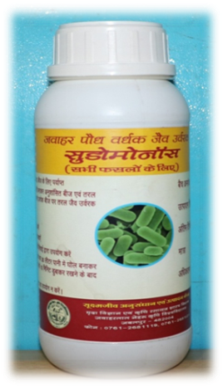**A. Carrier based Jawahar *Pseudomonas* culture**

**Doses** (seed treatment): 250 g /10-12 kg seeds with light sprinkling of water

Soil application: 3-4 kg culture mixed with 50 kg FYM for one acre and broadcast

**B. Liquid Jawahar *Pseudomonas* culture**

**Dose** (Seed treatment): 100 ml 10 kg-1 seeds with light sprinkling of water.

**Soil treatment on standing crop**:

For herbs: shrubs annual and perennial plants: 10 ml plant-1 at nursery

For trees: 50-100 ml plant-1

Standing crops through irrigation: 1-2 litre acre-1

**Jawahar Biofertisol**

Biofertisol is used as fertilizer because they are rich in nitrogen and are a source of several trace elements. Nitrogen is responsible for the vegetative growth of plants above ground and dark green foliage. Phosphorus is essential for healthy growth, strong roots, fruit and flower development, and greater resistance to disease. Potassium oxide (potash) is essential for the development of strong plants to resist diseases, protects them from the cold and protects during dry weather by preventing excessive water loss. The Jawahar biofertisol is finally a mixed product of fish hydrolysate and sea weed (rockweed). Hence, besides potential nutrient availability (total N:P:K = 4:2:3), also a source of several micronutrients, phytohormones (like cytokinins), betaines (abiotic stress tolerant) and pH controller (towards neutrality).

**Benefits from Biofertisol**

* Improves the plants ability to take up nutrients and trace elements in the soil
* A totally soluble form of plant ready nutrition
* Promotes shoot growth and root mass to increase plant health
* Improves leaf colour, flowering and fruit development
* Provides organic food for soil bacteria and worm activity
* Provides a bio-booster for stubble or compost acceleration

**Application**

* **Soil treatments:** Apply up to 5 litre per 200 litre of water acre-1. Split the application between pre-plant and side dress.
* **Foliar treatments:** 1-2 litre per 200 litre of water acre-1 every 10-14 days for row crops and small grains. Apply prior to bloom and at least once after bud set. I can also be used at all growth stages for greening.
* **Hay:** If manure has been applied use 5-10 litre acre-1 monthly.
* **Tree crops:** Apply 10-20 litre acre-1 in a minimum of 200 litre water. Apply at beginning of the season, mid-season and prior to harvest.

**Production technology**

Biofertilizers are the low cost inputs to plant nutrients, it is eco-friendly and have supplementary role with chemical fertilizers. The Biofertilizers contain bacteria, algae, fungi and actinomycetes. It may broadly be classified into three categories viz. nitrogen fixing like *Rhizobium, Azotobactor, Azospirilum*, *Acetobacter*, BGA and *Azolla*; and nutrient solubilisers / mobilisers like PSM, mycorhizae, KSB and ZSB; and another category of biofertilizers are for plant growth promoter and stimulator including PGPR and phytostimulators.

**Isolation of microbial strain**

For successful and effective biofertilizer preparation, authentic strains of desired beneficial microorganism is must to isolate from various most probable habitats viz., soil, compost, water, even plant surface, etc. for free living microorganisms, and plant root nodule, root itself, leaf, flower, fruit, etc. for endophytic microorganisms.

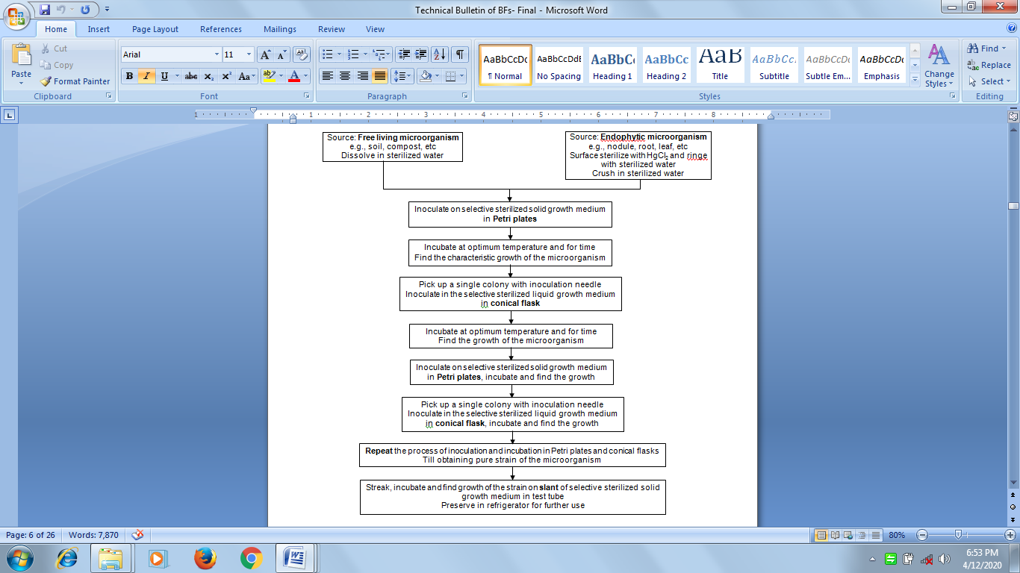

**Fig. Isolation of microbial strain**

***Note***: For maintaining purity, sub-culturing of the microorganism at every 15-20 days intervals is essential; also take necessary steps to check vertical mutation

**Characteristic growth and identification of microorganisms**

Every microorganism of a biofertilizer attains maximum population growth (up to the end of log phase) availing a suitable substrate (medium) under optimum conditions of pH, temperature and incubation period. During mass production, the growth of the mature culture exhibits characteristics colour and smell.

**Techniques of biofertilizers production**

Once the effective strain of a beneficial microorganism is isolated in pure form, this can be multiplied and mass produced in shape of biofertilizer either in powder carrier base or liquid formulation (Fig. ).

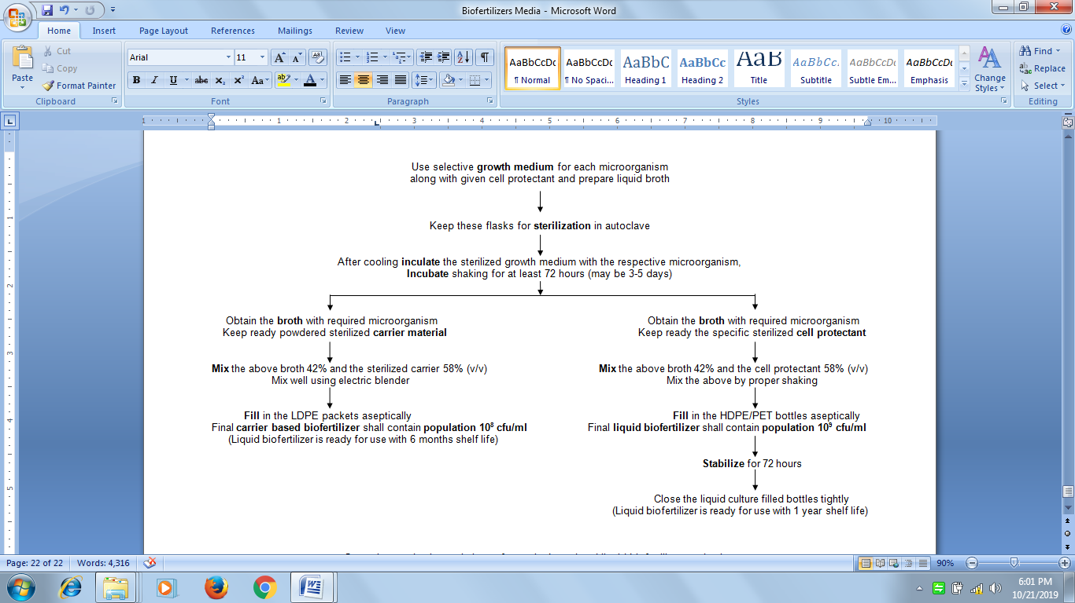

**Fig. Production techniques for carrier based and liquid biofertilizer production**

**Quality standards / specifications of biofertilizer**

Quality standards / specifications of biofertilizer differ from country to country. It may include parameters like the microbial density at the time of manufacture, microbial density at the time of expiry, the expiry period, the permissible contamination, the pH, the moisture, the microbial strain, and the carrier. Quality has also to be controlled at various stages of production (during mother culture stage, carrier selection, broth culture stage, mixing of broth and culture, packing and storage).

**Specifications of biofertilizers** [under ambit of Fertilizer (Control) Order 1985 (FCO), amended March 2006 and further amended November 2009], Schedule III [Clause 2(h) and (q), **PART - A**]

|  |  |  |  |
| --- | --- | --- | --- |
| Parameter | Requirement | | |
| *Rhizobium, Azotobacter, Azospirillum,* PSB, ZSB | | VAM |
| Base | Carrier based* in form of moist/dry powder or granules (neutralized with CaCO3 and then sterilized), or liquid based | | Fine powder/tablets/ granules/ root biomass mixed with growing substrate (soil/fly ash/ charcoal/ lignite or any other neutral material) |
| Particle size for carrier based powder formulations (BIS) | Should pass through 150 to 212 μ (72-100 mesh) IS sieve | | 90% material should pass through 250 μ IS sieve |
| Minimum viable cell count (cfu) at 25-30oC (BIS)  (solo or multi strain) | Within 15 days of mfg: Carrier based: 108 cells/g  Liquid: 109 cells/ml | Within 15 days before expiry:  Carrier based: 107 cells/g | Total viable propagules/g product: Minimum 100/g |
| Contamination level | No contamination at 105 dilution | | -- |
| pH (BIS/FCO) | ***Rhizobium:*** 6.0-7.5 ***Azotobacter:*** 6.5-7.0  ***Azospirillum:*** 7.0-8.0 | | 6.0-7.5 |
| **PSB, ZSB:**  Carrier based: 6.5-7.5  Liquid based: 5.0-7.5 | |
| Moisture per cent by weight, maximum in case of carrier based | 30-40% | | 8-12% |
| Efficiency character | ***Rhizobium:*** Should show effective nodulation (at laest >50% than control) on all the species listed on the packet | | 80 infection points in test roots/g of mycorrhizal inoculum used |
| ***Azotobacter:*** The strain should be capable of fixing at least 10 mg N / g of sucrose consumed | |
| ***Azospirillum:*** Formation of white pellicle in semisolid N-free bromothymol blue medium | |
| **PSB:**  1. The strain should have phosphate solubilizing capacity in the range of minimum 30%, when tested spectrophotometrically  2. In terms of zone formation, minimum 5 mm solubilization zone in prescribed media having at least 3 mm thickness | |
| **ZSB:** Minimum 10 mm solubilization zone in prescribed media having at least 3 mm thickness | |
|  | Carrier based- 6 months  Liquid based- 1 year | | Soil based root culture:  1 year |
| Appearance** | Powder- Brown or black  Liquid- without strange smell | | Powder- Brown or black |
| Packaging | Should be packed in  Carrier based: In 50-75 μ LDP packets  Liquid formulation: In HDPE bottles preferably polyethylene terephthalate (PET) bottles | | Should be packed in 50-75 μ LDP packets |

**Specifications of newly introduced biofertilizers**

|  |  |  |
| --- | --- | --- |
| Parameter | Specifications | |
| KSB | *Acetobacter* |
| Base | Carrier based in form of moist/dry powder or granules (neutralized with CaCO3 and then sterilized), or liquid based | Carrier based in form of moist/dry powder or granules (neutralized with CaCO3 and then sterilized), or liquid based |
| Particle size for carrier based powder formulations (BIS) | Should pass through 150 to 212 micron (72-100 mesh) IS sieve | Should pass through 150 to 212 micron (72-100 mesh) IS sieve |
| Minimum viable cell count (cfu) at 25-30oC (BIS) | Carrier based: 5x107 cells/g  Liquid: 1x108 cells/ml | Carrier based: 5x107 cells/g  Liquid: 1x108 cells/ml |
| Contamination level | No contamination at 105 dilution | No contamination at 105 dilution |
| pH (BIS/FCO) | Carrier based: pH 6.5-7.5  Liquid based: pH 5.0-7.5 | Carrier based: pH 5.5-6.0  Liquid based: pH 3.5-6.0 |
| Moisture % by weight, maximum in case of carrier based | Carrier based: 30-40% | Carrier based: 30-40% |
| Shelf-life from date of manufacture | Carrier based: 6 moths  Liquid based: 1 year | Carrier based: 6 moths  Liquid based: 1 year |
| Appearance | Carrier based (lignite): Black  Liquid: without strange smell | Carrier based (lig.): Black  Liquid: without strange smell |
| Packaging | Carrier based: LDPE pkts.  Liquid: HDPE bottles | Carrier based: LDPE pkts.  Liquid: HDPE bottles |
| **Efficiency characteristics** |  |  |
| Nodulation test | -- | -- |
| Nitrogen fixed (mg/g) of sucrose consumed | -- | -- |
| Formation of pellicle in semi solid N free media | -- | **Acetobacter**: Formulation of yellowish pellicle in semisolid N free medium |
| (a) Solubilization zone (mm) | **KSB**: Maximum 10 mm solubilization zone in prescribed medium having at least 10 mm thickness | -- |
| (b) P-phosphorus (%) spectrophotometer | -- | -- |
| Photosynthetic pigments | -- | -- |

# Metagenomics

**Metagenomics** is the study of [genetic](https://en.wikipedia.org/wiki/Genetics) material recovered directly from [environmental](https://en.wikipedia.org/wiki/Natural_environment) samples. The broad field may also be referred to as **environmental genomics, ecogenomics** or **community genomics**. While traditional [microbiology](https://en.wikipedia.org/wiki/Microbiology) and microbial [genome sequencing](https://en.wikipedia.org/wiki/Genome_sequencing)and [genomics](https://en.wikipedia.org/wiki/Genomics) rely upon cultivated [clonal](https://en.wikipedia.org/wiki/Clone_(genetics)" \o "Clone (genetics)) [cultures](https://en.wikipedia.org/wiki/Microbiological_culture), early environmental gene sequencing cloned specific genes (often the [16S rRNA](https://en.wikipedia.org/wiki/16S_ribosomal_RNA) gene) to produce a profile of diversity in a natural sample. Such work revealed that the vast majority of [microbial biodiversity](https://en.wikipedia.org/wiki/Biodiversity) had been missed by cultivation-based methods.[[1]](https://en.wikipedia.org/wiki/Metagenomics#cite_note-Hugenholz1998-1) Recent studies use either "shotgun" or PCR directed sequencing to get largely unbiased samples of all genes from all the members of the sampled communities.[[2]](https://en.wikipedia.org/wiki/Metagenomics#cite_note-Eisen2007-2) Because of its ability to reveal the previously hidden diversity of microscopic life, metagenomics offers a powerful lens for viewing the microbial world that has the potential to revolutionize understanding of the entire living world.[[3]](https://en.wikipedia.org/wiki/Metagenomics#cite_note-MarcoD2011-3) As the price of DNA sequencing continues to fall, metagenomics now allows [microbial ecology](https://en.wikipedia.org/wiki/Microbial_ecology) to be investigated at a much greater scale and detail than before.

The term "metagenomics" was first used by [Jo Handelsman](https://en.wikipedia.org/wiki/Jo_Handelsman), [Jon Clardy](https://en.wikipedia.org/wiki/Jon_Clardy), [Robert M. Goodman](https://en.wikipedia.org/wiki/Robert_M._Goodman), Sean F. Brady, and others, and first appeared in publication in 1998.[[4]](https://en.wikipedia.org/wiki/Metagenomics#cite_note-Handelsman1998-4) The term metagenome referenced the idea that a collection of genes sequenced from the environment could be analyzed in a way analogous to the study of a single [genome](https://en.wikipedia.org/wiki/Genome). Recently, Kevin Chen and [Lior Pachter](https://en.wikipedia.org/wiki/Lior_Pachter" \o "Lior Pachter) (researchers at the [University of California, Berkeley](https://en.wikipedia.org/wiki/University_of_California,_Berkeley)) defined metagenomics as "the application of modern genomics technique the need for isolation and lab cultivation of individual species".[[5]](https://en.wikipedia.org/wiki/Metagenomics#cite_note-Chen2005-5)

**Indicators of soil biomass**

|  |  |  |
| --- | --- | --- |
| End points | Soil ecosystem parameter | Microbial indicators |
| Soil ecosystem health | Soil biomass | Microbial biomass  Protozoan biomass |

The soil biomass includes bacterial, fungal and protozoan biomass. Biomass is fundamental for soil processes to occur and quantification of microbial biomass is as such a measurement at the ecosystem level (Visser and Parkinson, 1992).

**Microbial biomass**

Soil microbial biomass represents the fraction of the soil responsible for the energy and nutrient cycling and the regulation of organic matter transformation (Gregorich *et al.* 1994). A close relationship has been reported between soil microbial biomass, decomposition rate and N-mineralisation (Carter *et al.* 1999). Microbial biomass has also been shown to correlate positively with grain yield in organic, but not in conventional farming. Finally, soil microbial biomass contributes to soil structure and soil stabilisation. Soil microbial biomass has also been recommended as indicators of soil organic carbon (Carter *et al.* 1999).

Several methods have been used for the estimation of microbial biomass in soil. The methods can be divided into direct (e.g. microscopy or determinations of specific membrane phospholipid fatty acids (PLFAs) and indirect (e.g. chloroform fumigation (CFE/CFI) or substrate induced respiration (SIR).

***Direct methods (microscopy, PLFA)***

Determination of soil microbial biomass by direct methods (microscopy or PLFA analysis) gives results that very closely represent the *in situ* soil conditions. Although the methods are time-consuming, they are currently used for soil monitoring purposes (Bloem *et al.* 2002). The automation of PLFA extraction has reduced analysis time to some extent (Macnaughton *et al.* 1997).

Direct counts or bio-volume estimations using conversion factors can estimate microbial biomass. Different soil preparation methods and staining techniques in combination with epi-fluorescens microscopy are available (Bloem *et al.* 1995). Combined with automated image analysis, direct counts can be used routinely for the determination of soil microbial biomass in many samples of different origin.

The total amount of PLFAs in soil is an alternative method to microscopic counting (Zelles, 1999). PLFAs are found only in membranes of bacteria and fungi. Individual PLFAs are specific for specific subgroups of microorganisms. Using extraction of soil samples and analysis by gas chromatography, the total amount of PLFAs can be quantified. It is also possible to quantify different groups of microorganisms by this method (Zelles, 1999). PLFA analysis hereby provides information on biodiversity and the fungal-bacterial biomass ratio.

***Indirect methods (CFI, CFE, SIR)***

Indirect methods are generally cheaper, faster and easier to use than the direct methods. Results obtained by the indirect methods have been documented to be very close to the direct measurements (Carter *et al.* 1999), thus providing confidence in the utility of indirect methods.

Chloroform fumigation is the most commonly used indirect method. This method is considered to measure most of the soil microbial biomass, e.g. both dead and alive, though some microorganisms (e.g. spores) are insensitive to the fumigation process (Toyota *et al.* 1996). Determination of microbial biomass by chloroform fumigation covers two indirect methods: the chloroform fumigation incubation method (CFI) and the chloroform fumigation extraction method (CFE) (Carter *et al.* 1999). In both cases, the chloroform vapour kills the microorganisms in the soil, and subsequently the size of the killed biomass is estimated either by quantification of respired CO2 over a specified period of incubation (CFI) or by a direct extraction of the soil immediately after the fumigation followed by a quantification of extractable carbon (CFE; ISO-standard 14240-2:1997). The release of CO2 after fumigation is the result of germinating microbial spores utilising the C substrate provided by the killed microbial cells.

Another common indirect method is substrate induced respiration (SIR). This method measures only the metabolically active portion of the microbial biomass (Carter *et al.* 1999). SIR (ISO-standard 14240:1:1997) measures the initial change in the soil respiration rate as a result of adding an easily decomposable substrate (e.g. glucose). The technique has been automated and is used in soil monitoring in several countries (Höper and Kleefisch,2001). Soil microbial biomass is subsequently calculated using a conversion factor (Kaiser *et al.* 1992).

***Microbial quotient***

The amount of microbial biomass carbon (Cmicro) may be related to the total carbon (Corg) content by the microbial quotient (Cmicro/Corg). This quotient provides a measure of soil organic matter dynamics and can be used as an indicator of net C loss or accumulation. Using the quotient avoids the problems of comparing trends in soils with different organic matter content (Sparling, 1997).