UNIT- V
Preparation and preservation of farmyard manure, animal manures, rural and urban composts and vermicompost.

Composting
Composting is the controlled biological decomposition of organic matter under aerobic conditions. Organic matter decays naturally, but slowly. Composting involves human intervention to speed up the decay process by manipulating various materials and conditions.
Composting is one form of recycling. Organic, compostable material comprises 68% of MSW (Municipal Solid Waste.) Most communities can implement some form of composting in order to reduce the amount of waste going into their landfills.
Compost can be used in many ways. It can improve soil conditions and plant growth, and reduce the potential for erosion, runoff and non-point source pollution. Compost has also been found to be useful as a medium in plant disease suppression and in biofiltration. Through these uses, compost can be used to remediate or prevent the pollution of soil and groundwater systems.
With the time–temperature course, the composting process can be divided into 4 phases:
1. During the first phase a diverse population of mesophilic bacteria and fungi proliferates, degrading primarily the readily available nutrients and thereby raising the temperature to about 45°C. At this point their activities cease, the vegetative cells and hyphae die and eventually lyse, and only heat resistant spores survive.
2. After a short lag period (not always discernible) there occurs a second more or less steep rise of temperature. This second phase is characterized by the development of a thermophilic microbial population comprising some bacterial species, actinomycetes and fungi. The temperature optimum of these microor microorganisms is between 50 and 65°C, their activities terminate at 70–80°C.
3. The third phase can be regarded as a stationary period without significant changes of temperature because microbial heat production and heat dissipation balance each other. The microbial population continues to consist of thermophilic bacteria, actinomycetes, and fungi.
4. The fourth phase is characterized by a gradual temperature decline; it is best described as the maturation phase of the composting process. Mesophilic microorganisms having survived the high temperature phase or invading the cooling down material from the outside succeed the thermophilic ones and extend the degradation process as far as it is intended.

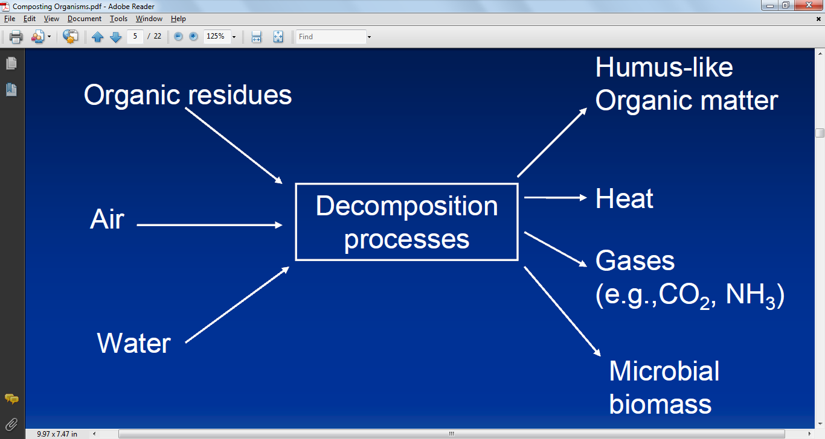
Fig. An overview of composting

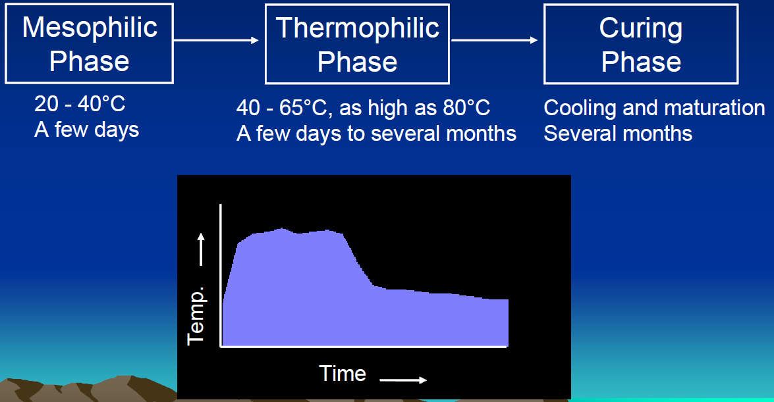

Fig. Composting process

Stage 1: Mesophilic stage:
- Bacteria and fungi are key players- Fauna and protozoa also important
- Decomposition of readily available substrates- sugars, proteins and starch
- Excess energy is released as heat, causing pile temperature to increase

Stage 2: Thermophilic stage
- Heat loving bacteria, actinomycetes and fungi are key players
- Heat interalnt organisms go dormant or are destroyed- human and plant pathogens
- High temperatures accelerate breakdown of proteins, fats, and complex polymers

Microorganisms associated with compost pile

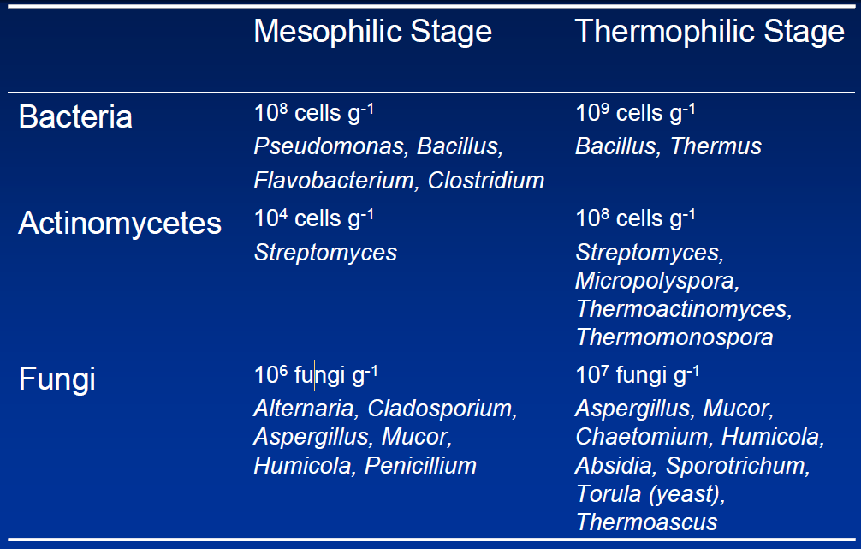

Stage 3: Curing / cooling stage
- Mesophilic bacteria, actenomycetes and fungi are key players
- Further chemical and physical changes in the compost
- Decomposition of recalcitrant polymers by actinomycetes and fungi
- Degradation of fermentation products, methane, and other organic noxious gases which accumulated earlier in anaerobic microsites
- Reduction of odours and toxic intermediates

Methods of Composting
Preparation
Before refuse may be turned into compost it must be sorted. Typically, this sorting will include receiving, sorting, magnetic separation, grinding, and the addition of water and sewage sludge. Sorting of materials allows for the reusable and larger materials to be removed by hand while the magnetic separation protects the machinery and improves the quality of the final product. Grinding reduces the size of the refuse and allows for easy handling, digestion, and mixing with other materials. For proper digestion of the compost it must have the proper moisture content ranging between 45 and 65%. Adding sewage sludge instead of pure water allows for additional organic material and a sanitary disposal of the sludge.
Digestion
For digestion to occur an environment must be created in which microorganisms will rapidly breakdown the organic portion of the refuse. Most modern composting runs of the principal of aerobic instead of anaerobic decomposition. Oxygen is introduced into systems by the use of turning or forced draft agitation. Heat is generated reaching the temperatures of 60º to 70ºC destroying the pathogenic organisms, weed, and fly larvae. The high heat causes rapid decomposition and few unpleasant odors. Aerobic decomposition takes on average 6 weeks.
If the system is not aerated it will become anaerobic causing the decomposition rate to significantly slow down and microflora to begin growing. In contrast with the relatively short decomposition rate associated with aerobic decomposition, anaerobic decomposition takes about 4 to 6 months. Anaerobic decomposition does not reach the temperature necessary to kill pathogens may create unpleasant odors.
Curing
Before compost may be applied, a curing period must occur. The curing period allows for the decomposition rate to slow to the point where it will not rob the soil of its nitrogen content. Depending upon how soon crops will be laid or the type of flora which will planted a curing period will be recommended.
Finishing
In the finishing process materials are further removed if they are objectionable to the function of the compost. This process may remove glass, plastic, waxes, or other undesirable objects through either further screening or continued grinding.
Storage
Because compost is usually in high demand during the spring and fall compost must be stored. Compost may be stored in large piles outdoors, into storage cans to further cure the compost, or placed under cover as the final product or for future finishing.
Table 1 Salient features of selected small-scale aerobic composting techniques
Method | Salient features |  |  |  |  | Duration
 | Substrate size reduction | Turnings at intervals of (days) | Added aeration provision | Microbial inoculation | Supporting microbial nutrition
Indore pit |  | +15, +30, +60 |  | Inoculum from old pit |  | 4 months
Indore heap | Shredded | +42, +84 |  |  |  | 4 months
Chinese pit |  | +30, +60, +75 |  |  | Superphosphate | 3 months
Chinese high temperature compost | Shredded | +15 | Aeration holes in heap through bamboo poles/maize stalks |  | Superphosphate | 2 months
Ecuador on-farm composting |  | +21 | Lattice of old branches/poles at heap base |  |  | 2-3 months in summer;  5-6 months in winter
Berkley rapid composting | Shredded to small size | Daily or alternate day turning |  |  |  | 2 weeks with daily turning & 3 weeks with alternate day turning
North Dakota State University hot composting | Shredded | +3 or +4 | 4-5 holes punched in centre of pile |  | 0.12 kg N per 90 cm dry matter | 4-6 weeks
EM-based quick composting |  | +14, +21 |  | EM | Molasses | 4-5 weeks
IBS rapid composting | Shredded | +7, +14, then every 2 weeks | Raised platform ground/perforated bamboo trunks | Trichoderma sp. |  | 3-7 weeks

4. Vermicomposting

The term vermicomposting means the use of earthworms (Plate 9) for composting organic residues. Earthworms can consume practically all kinds of organic matter and they can eat their own body weight per day, e.g. 1 kg of worms can consume 1 kg of residues every day. The excreta (castings) of the worms are rich in nitrate, available forms of P, K, Ca and Mg. The passage of soil through earthworms promotes the growth of bacteria and actinomycetes. Actinomycetes thrive in the presence of worms and their content in worm casts is more than six times that in the original soil.

Types of worms
A moist compost heap of 2.4 m by 1.2 m and 0.6 m high can support a population of more than 50,000 worms. The introduction of worms into a compost heap has been found to mix the materials, aerate the heap and hasten decomposition. Turning the heaps is not necessary where earthworms are present to do the mixing and aeration. The ideal environment for the worms is a shallow pit and the right sort of worm is necessary. Lumbricus rubellus (red worm) and Eisenia foetida are thermo-tolerant and so particularly useful. Field worms (Allolobophora caliginosa) and night crawlers (Lumbricus terrestris) attack organic matter from below but the latter do not thrive during active composting, being killed more easily than the others at high temperature.
European night crawlers (Dendrabaena veneta or Eisenia hortensis) are produced commercially and have been used successfully in most climates. These night crawlers grow to about 10-20 cm. The African night crawler (Eudrilus eugeniae), is a large, tropical worm species. It tolerates higher temperatures than Eisenia foetida does, provided there is ample humidity. However, it has a narrow temperature tolerance range, and it cannot survive at temperatures below 7 °C. Vermicomposting is in use in many countries. Experiences from selected countries are described as case studies.

Vermiculture in India
This approach (Jambhhekar, 2002) uses the following materials: breeder worms, a wooden bed and organic wastes. The bed should be of the desired length and about 75 cm high × 120 cm wide. Worms should be applied for every part of waste. Other steps in the process are:
- Sieving and shredding - decomposition can be accelerated by shredding raw materials into small pieces.
- Blending - carbonaceous substances such as sawdust, paper and straw can be mixed with N-rich materials such as sewage sludge, biogas slurry and fish scraps to obtain a near optimum C:N ratio. A varied mixture of substances produces good quality compost, rich in macronutrients and micronutrients.
- Half digestion - the raw materials should be kept in piles and the temperature allowed to reach 50-55 °C. The piles should remain at this temperature for seven to ten days.
- Maintaining moisture, temperature and pH - the optimum moisture level for maintaining aerobic conditions is 40-45 percent. Proper moisture and aeration can be maintained by mixing fibrous with N-rich materials. The temperature of the piles should be 28-30 °C. Higher or lower temperatures reduce the activity of microflora and earthworms. The height of the bed can help control the rise in temperature. The pH of the raw material should not exceed 6.5-7.
The compost is ready after about one month. It is black, granular, lightweight and humus-rich. In order to facilitate the separating of the worms from the compost, watering should cease two to three days before emptying the beds. This forces about 80 percent of the worms to the bottom of the bed. The remaining worms can be removed by hand. The vermicompost is then ready for application.

Enhancing vermicompost production
Vermicompost production using epigeic compost worms such as Eisenia foetida, Lumbricus rubellus and Eudrilus eugeniae can be enhanced effectively by supplementing the organic wastes used for vermicomposting with cow urine. Undiluted urine can be used for moistening organic wastes during the preliminary composting period (before the addition of worms.). After the initiation of worm activity, urine can be diluted with an equal quantity of water. No problems have been observed with daily use of diluted cow urine for moistening the vermicomposting bed. This simple technique can yield vermicompost with a higher N content. Moreover, worms have been found to become very active and vermicompost can be harvested at least 10 days early.

Integrating traditional composting and vermicomposting
Problems associated with traditional thermophilic composting relate to: long duration of the process, frequent turning of the material, material size reduction to enhance the surface area, loss of nutrients during the prolonged process, and the heterogeneous resultant product. However, the main advantage of thermophilic composting is that the temperatures reached during the process are high enough for an adequate pathogen kill.
In vermicomposting, the earthworms take over both the roles of turning and maintaining the material in an aerobic condition, thereby reducing the need for mechanical operations. In addition, the product (vermicompost) is homogenous. However, the major drawback of the vermicomposting process is that the temperature is not high enough for an acceptable pathogen kill. Whereas in traditional thermophilic composting the temperatures exceed 70 °C, the vermicomposting processes must be maintained at less than 35 °C.
A study has examined the possibility of integrating traditional thermophilic composting and vermicomposting (Ndegwa and Thompson, 2001). The work involved combining pertinent attributes from each of the two processes to enhance the overall process and improve the product qualities. The two approaches investigated in the study related to: (i) pre-composting followed by vermicomposting; and (ii) pre-vermicomposting followed by composting. The duration of each of the combined operations viz. composting and vermicomposting was four weeks. A comparison was made with vermicomposting alone (duration: 56 days). The results indicated that the combination of the two processes shortened the stabilization time and improved product quality. Furthermore, the resultant product was more stable and consistent, had less potential impact on the environment, and met pathogen reduction requirements.

Biogas

Biogas is mixture of methane (50-60%), CO₂ (30-40%), hydrogen (5-10%), H₂S and nitrogen (traces), produced from the anaerobic digestion of animal, plant wastes or any cellulose containing waste material. The digester used for biogas production is called biogas plant. A typical biogas plant (Fig.1) using cow dung as raw material consists of (a) digester and (b) gas holder. The digesters are either of batch type which are filled once, sealed and emptied when the raw materials stop producing gas or (b) continuous type, which are fed with a definite quantity of wastes at regular intervals so that gas production is continuous and regular. The nature of fermentation in the digester is anaerobic.
Biogas typically refers to a gas produced by the biological breakdown of organic matter in the absence of oxygen. Organic waste such as dead plant and animal material, animal dung, and kitchen waste can be converted into a gaseous fuel called biogas. Biogas originates from biogenic material and is a type of biofuel.
Biogas is produced by the anaerobic digestion or fermentation of biodegradable materials such as biomass, manure, sewage, municipal waste, green waste, plant material, and crops. Biogas comprises primarily methane (CH₄) and carbon dioxide (CO₂) and may have small amounts of hydrogen sulphide (H₂S), moisture and siloxanes.
The gases methane, hydrogen, and carbon monoxide (CO) can be combusted or oxidized with oxygen. This energy release allows biogas to be used as a fuel. Biogas can be used as a fuel in any country for any heating purpose, such as cooking. It can also be used in anaerobic digesters where it is typically used in a gas engine to convert the energy in the gas into electricity and heat. Biogas can be compressed, much like natural gas, and used to power motor vehicles. In the UK, for example, biogas is estimated to have the potential to replace around 17% of vehicle fuel.^{[3]} Biogas is a renewable fuel, so it qualifies for renewable energy subsidies in some parts of the world. Biogas can also be cleaned and upgraded to natural gas standards when it becomes biomethane.

Production
Biogas is practically produced as landfill gas (LFG) or digester gas. A biogas plant is the name often given to an anaerobic digester that treats farm wastes or energy crops.
Biogas can be produced utilizing anaerobic digesters. These plants can be fed with energy crops such as maize silage or biodegradable wastes including sewage sludge and food waste. During the process, an air-tight tank transforms biomass waste into methane producing renewable energy that can be used for heating, electricity, and many other operations that use any variation of an internal combustion engine, such as GE Jenbacher gas engines.^{[4]} There are two key processes: Mesophilic and Thermophilic digestion. In experimental work at University of Alaska Fairbanks, a 1000-litre digester using psychrophiles harvested from "mud from a frozen lake in Alaska" has produced 200–300 litres of methane per day, about 20–30 % of the output from digesters in warmer climates.
Landfill gas is produced by wet organic waste decomposing under anaerobic conditions in a landfill. The waste is covered and mechanically compressed by the weight of the material that is deposited from above. This material prevents oxygen exposure thus allowing anaerobic microbes to thrive. This gas builds up and is slowly released into the atmosphere if the landfill site has not been engineered to capture the gas. Landfill gas is hazardous for three key reasons. Landfill gas becomes explosive when it escapes from the landfill and mixes with oxygen. The lower explosive limit is 5% methane and the upper explosive limit is 15% methane. The methane contained within biogas is 20 times more potent as a greenhouse gas than is carbon dioxide. Therefore, uncontained landfill gas, which escapes into the atmosphere may significantly contribute to the effects of global warming. In addition, landfill gas impact in global warming, volatile organic compounds (VOCs) contained within landfill gas contribute to the formation of photochemical smog.

Composition

Typical composition of biogas
Compound | Chem | %
Methane | CH₄ | 50–75
Carbon dioxide | CO₂ | 25–50
Nitrogen | N₂ | 0–10
Hydrogen | H₂ | 0–1
Hydrogen sulfide | H₂S | 0–3
Oxygen | O₂ | 0–0

The composition of biogas varies depending upon the origin of the anaerobic digestion process. Landfill gas typically has methane concentrations around 50%. Advanced waste treatment technologies can produce biogas with 55–75% CH₄, which for reactors with free liquids can be increased to 80-90% methane using in-situ gas purification techniques. As-produced, biogas also contains water vapor. The fractional volume of water vapor is a function of biogas temperature; correction of measured gas volume for both water vapor content and thermal expansion is easily done via a simple mathematic algorithm which yields the standardized volume of dry biogas.
In some cases, biogas contains siloxanes. These siloxanes are formed from the anaerobic decomposition of materials commonly found in soaps and detergents. During combustion of biogas containing siloxanes, silicon is released and can combine with free oxygen or various other elements in the combustion gas. Deposits are formed containing mostly silica (SiO₂) or silicates (Si_{x}O_{y}) and can also contain calcium, sulfur, zinc, phosphorus. Such white mineral deposits accumulate to a surface thickness of several millimeters and must be removed by chemical or mechanical means.
Practical and cost-effective technologies to remove siloxanes and other biogas contaminants are currently available.

Benefits
When biogas is used, many advantages arise. In North America, utilization of biogas would generate enough electricity to meet up to three percent of the continent's electricity expenditure. In addition, biogas could potentially help reduce global climate change. Normally, manure that is left to decompose releases two main gases that cause global climate change: nitrous dioxide and methane. Nitrous dioxide (NO₂) warms the atmosphere 310 times more than carbon dioxide and methane 21 times more than carbon dioxide. By converting cow manure into methane biogas via anaerobic digestion, the millions of cows in the United States would be able to produce one hundred billion kilowatt hours of electricity, enough to power millions of homes across the United States. In fact, one cow can produce enough manure in one day to generate three kilowatt hours of electricity; only 2.4 kilowatt hours of electricity are needed to power a single one hundred watt light bulb for one day. Furthermore, by converting cow manure into methane biogas instead of letting it decompose, we would be able to reduce global warming gases by ninety-nine million metric tons or four percent. The 30 million rural households in China that have biogas digesters enjoy 12 benefits: saving fossil fuels, saving time collecting firewood, protecting forests, using crop residues for animal fodder instead of fuel, saving money, saving cooking time, improving hygienic conditions, producing high-quality fertilizer, enabling local mechanization and electricity production, improving the rural standard of living, and reducing air and water pollution.

Microbiology in Biogas production
At present four different bacterial groups are recognized to be involved in the anaerobic fermentation of organic matter to methane.

i. The hydrolytic bacteria which catalyze carbohydrates, proteins, lipids, other components of biomass to fatty acids, H₂ and CO₂.
ii. The hydrogen producing acetogenic bacteria which catabolize certain fatty acids and neutral end products of group one to acetate, CO₂ and H₂.
iii. The homoacetogenic bacteria which synthesize acetate using acetic acid.
iv. The methanogenic bacteria which utilize acetate, CO₂ and H₂ to produce methane.

The first three groups of bacteria include facultative as well as strict anaerobes like Cellulomonas, Clostridium, Bacillus, Bacteroides, Ruminococcus, Eubacterium, etc. while the methanogenic bacteria include Methanosarcina, Methanothrix, Methanobacterium, and Methanospirillum, the major characteristics of which are mentioned in Table 2.

Table 2. Major genera of methanogenic bacteria
Genus | Morphology | Methanogenic substrates utilized for growth
Methanobacterium | Long rods or filaments | H₂ + CO₂, formate
Methanomicrobium | Short rods | H₂ + CO₂, formate
Mehtogenium | Irregular, small cocci | H₂ + CO₂, formate
Methanococcus | Irregular, small cocci | H₂ + CO₂, formate
Mehtanobrevibacter | Lancet shaped cocci or short rods | H₂ + CO₂, formate
Methanospirillum | Short to long spiral | H₂ + CO₂, formate
Methanosarcina | Pseudosarcina | H₂ + CO₂, acetate,  methanol, methylamines

The methanogenic phase is strict anaerobic and during this phase organic carbon is converted into microbial mass, CO₂ and methane. These bacteria are sensitive to pH and optimal pH for methane production is 6.8 - 7.2. If pH drops to 6.6 or below there is an inhibition of methanogenesis.

Microbial conversion of organic matter to methane has become attractive as a method of waste treatment and resource recovery. This process is anaerobic and is carried out by action of various groups of anaerobic bacteria.
Three basic points about this process are:
i. that most of the important bacteria involved in biogas production process are anaerobes and slow growing;
ii. that a greater degree of metabolic specialization is observed in these anaerobic microorganisms; and
iii. that most of the free energy present in the substrate is found in the terminal product methane. Since less energy is available for the growth of organism, less microbial biomass is produced and, consequently, disposal of sludge after the digestion may not be a major problem.

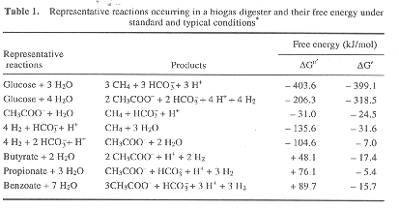
Kelkar et al. compared the activity of cellulolytic clostridia isolated from cattle dung-fed digesters and reported that C. populeti recorded higher degradation of cellulose than C. cellobioparum, and Clostridium sp. Sivakumaran et al.¹⁴ characterized the cellulase enzymes present in biogas digesters and reported that Acetivibrio sp. showed higher cellulase activity than Bacteroides sp. and Clostridium sp. isolated from biogas digesters.
Though a variety of products are formed by the action of fermentative bacteria, volatile fatty acids are the primary products of carbohydrate fermentation in biogas digesters, as they are in rumen. The partial pressure of hydrogen can influence the products of carbohydrate metabolism¹. The partial pressure of hydrogen can be maintained either by hydrogen-oxidizing methanogens or sulphate-reducing bacteria. However in biogas digesters, the action of former organisms is preferred resulting in methane as the endproduct. Under these conditions, oxidation of NADH and the conversion of hexose to acetate, H₂ and CO₂ by fermentation occurs, yielding 4 ATP molecules per hexose molecule by glycolysis or acetyl phosphate pathway (Thauer et al.⁴). But under conditions of higher partial pressure of hydrogen, formation of more reduced products results in the following order: propionate, butyrate, ethanol, and lactate. Also, the fermentation of hexose either to ethanol or lactate yields only 2 ATP per hexose molecule by glycolysis, depriving thereby methanogens of the substrate (acetate) needed for its growth and activity. Ramasamy et al.³ studied the interaction of cellulolytic bacteria, Acetivibrio sp., and methanogens, Methanosarcina sp., and Methanobacterium sp., using cellulose and cellobiose as substrate. They observed that using co-cultures, the growth of both Acetivibrio sp. and Methanosarcina sp. was higher, and that the methane content of biogas was enhanced by twenty per cent.
Though less in number, obligately hydrogen-producing acetogenic bacteria are one of the important groups in biogas digesters. These organisms oxidize the fatty acids that are longer than acetate to acetate and thereby release

Technology
Bio gas is made from organic waste matter after it is decomposed. The decomposition breaks down the organic matter, releasing various gases. The main gases released are methane, carbon dioxide, hydrogen and hydrogen sulphide. Bacteria carry out the decomposition or fermentation. The conditions for creating bio gas has to be anaerobic that is without any air and in the presence of water. The organic waste matter is generally animal or cattle dung, plant wastes, etc. These waste products contain carbohydrates, proteins and fat material that are broken down by bacteria. The waste matter is soaked in water to give the bacteria a proper medium to grow. Absence of air or oxygen is important for decomposition because bacteria then take oxygen from the waste material itself and in the process break them down.
There are two types of bio gas plants that are used in India. These plants mainly use cattle dung called “gobar” and are hence called gobar gas plant. Generally a slurry is made from cattle dung and water, which forms the starting material for these plants. The two types of bio gas plants are:
1. Floating gas-holder type
2. Fixed dome type

Floating gas holder type of plant: The diagram below shows the details of a floating gas holder type of bio gas plant.

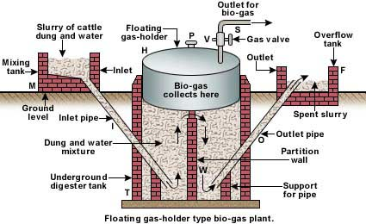

Floating gas-holder type biogas plant

A well is made out of concrete. This is called the digester tank T. It is divided into two parts. One side has the inlet, from where slurry is fed to the tank. The tank has a cylindrical dome H made of stainless steel that floats on the slurry and collects the gas generated. Hence the name given to this type of plant is floating gas holder type of bio gas plant. The slurry is made to ferment for about 50 days. As more gas is made by the bacterial fermentation, the pressure inside H increases. The gas can be taken out through outlet pipe V. The decomposed matter expands and overflows into the next chamber in tank T. This is then removed by the outlet pipe to the overflow tank and is used as manure for cultivation purposes.

Fixed dome type of plant: The diagram below shows the details of a fixed dome type of bio gas plant.
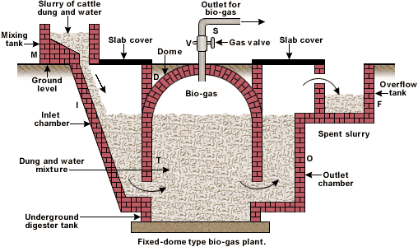

Fixed-dome type biogas plant

A well and a dome are made out of concrete. This is called the digester tank T. The dome is fixed and hence the name given to this type of plant is fixed dome type of bio gas plant. The function of the plant is similar to the floating holder type bio gas plant. The used slurry expands and overflows into the overflow tank F.

Working
- The various forms of biomass are mixed with an equal quantity of water in the mixing tank. This forms the slurry
- The slurry is fed into the digester through the inlet chamber. The temperature of the slurry must be maintained around 35 ºC. Any drop in temperature will reduce the anaerobic activity and hence the yield of biogas
- When the digester is partially filled with the slurry, the introduction of slurry is stopped and the plant is left unused for about two months
- During these two months, anaerobic bacteria present in the slurry decompose or ferment the biomass in the presence of water
- As a result of anaerobic fermentation, biogas is formed, which starts collecting in the dome of the digester
- As more and more biogas starts collecting, the pressure exerted by the biogas forces the spent slurry into the outlet chamber
- From the outlet chamber, the spent slurry overflows into the overflow tank
- The spent slurry is manually removed from the overflow tank and used as manure for plants
- The gas valve connected to a system of pipelines is opened when a supply of biogas is required
- To obtain a continuous supply of biogas, a functioning plant can be fed continuously with the prepared slurry

Advantages and disadvantages of both the bio gas plants
- In the floating gas holder type of plant, the floating chamber is made of stainless steel. This is expensive and needs continuous maintenance and supervision for non-rust. This does not arise in the fixed – holder type of bio gas plant as everything here is made of concrete.
- Fixed dome type of bio gas suffers from a disadvantage that its volume is fixed. So if the gas pressure increases inside, it may cause damage to the concrete dome. This does not happen in the floating holder type of bio gas plant.

Uses of bio gas
- Bio gas is used as cooking fuel. This is because bio gas burns without smoke, has high calorific value, can be piped into kitchens directly from a plant and is cheaper in cost.
- Bio gas can be used to run electric engines such as pumps, as they cause less air pollution.
- Bio gas can be used for street lighting as they do not cause any smoke and the illumination obtained can be made to be quite adequate.

