UNIT- IV
Biodegradation of pesticides, organic wastes and their use for production of biogas and manures; biotic factors in soil development; microbial toxins in the soil.

Biodegradation of Pesticides

Introduction
As a result of human activities, currently a large number of pollutants and waste are eliminated to the environment. Worldwide, more than one billion pounds of toxins are released into the air and water. Approximately 6x106 chemical compounds have been produced; annually 1,000 new products are synthetized and between 60,000 and 95,000 chemicals are commercially used. Among these substances are chemical pesticides, which are used extensively in most areas of crop production in order to minimize pest infestations, to protect the crop yield losses and to avoid reducing the product quality.
The pesticides belong to a category of chemicals used worldwide as herbicides, insecticides,
fungicides, rodenticides, molluscicides, nematicides, and plant growth regulators in order to control weeds, pests and diseases in crops as well as for health care of humans and animals.
Table 1 shows the most important pesticides according to their chemical composition. Some general characteristics of pesticides are shown in Table 2.

Table 1. Classification of pesticides according to their chemical composition

Table 2. General characteristics of pesticides
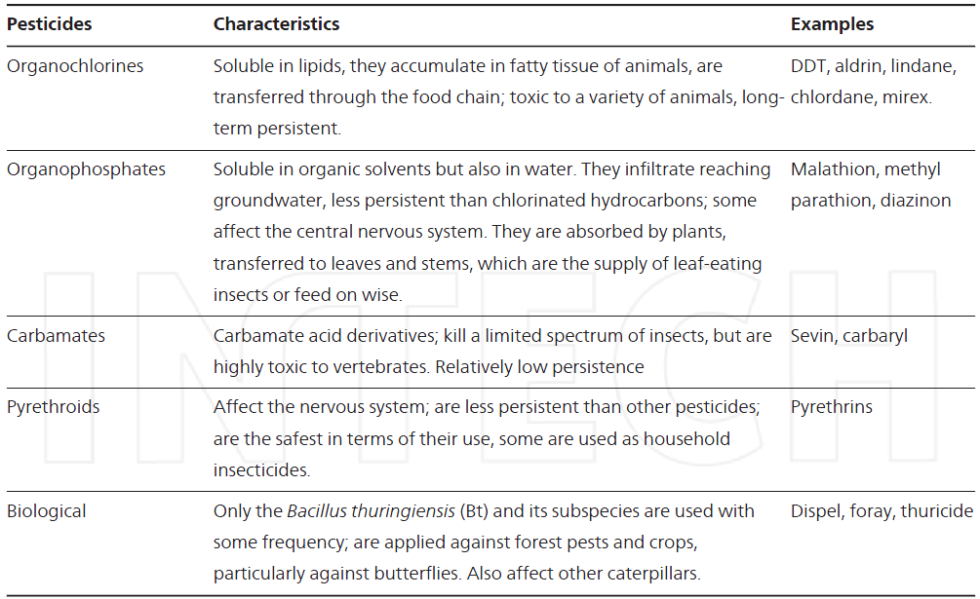

In natural environments, pesticides or their degradation products may be further transformed
or degraded by other microorganisms or eventually leading to complete degradation by the microbial consortium. However, persistent xenobiotics like pesticides and metabolic dead-end products will accumulate in the environment, become part of the soil humus, or enter the food chain leading to biomagnification (Figure 1).
The fate of pesticides in the environment is strongly related to the soil sorption processes that control not only their transfer but also their bioavailability. Contamination of soil from pesticides as a result of their bulk handling at the farmyard or following application in the field or accidental release may lead occasionally to contamination of surface and ground water. The behavior of pesticides in soils, the efficiency, persistence and potential as environmental contaminants, depend on their retention and degradation on soil constituents. In soils, several parameters influence the rate of biodegradation processes: environmental factors such as moisture and temperature, physicochemical properties of the soil, presence of other nitrogen sources or carbon, etc. can completely modify the microbial population and therefore the microbial activity.

Figure 1. Fate of pesticides in the environment

An alternative pesticides treatment with important global boom is bioremediation, which is conducted through the biodegradation of these chemical compounds. This technique relies on the ability of microorganisms to convert organic contaminants in simple and harmless compounds to the environment. Bioremediation overcomes the limitations of traditional methods for the disposal of hazardous compounds, so it has allowed the destruction of many organic contaminants at a reduced cost. Consequently, in the last years, bioremediation technology has progressed to an unknown virtual technology considered for the degradation of a wide range of pollutant compounds. Bioremediation can offer an efficient and cheap option for decontamination of polluted ecosystems and destruction of pesticides. As an efficient, economical and environmentally friendly technique, biodegradation has emerged as a potential alternative to the conventional techniques. However, the biodegradation process of many pesticides has not been fully investigated.

Microorganisms involved in the biodegradation of pesticides
Different biological systems, as microorganisms, have been used to biotransform pesticides. It has been reported that a fraction of the soil biota can quickly develop the ability to degrade certain pesticides, when they are continuously applied to the soil. These chemicals provide adequate carbon source and electron donors for certain soil microorganisms, establishing a way for the treatment of pesticide-contaminated sites.
Furthermore, the isolated microorganisms capable of degrading pesticides can be used for bioremediation of other chemical compounds to whom any microbial degradation system is known. However, the transformation of such compounds depends not only on the presence of microorganisms with appropriate degrading enzymes, but also a wide range of environmental parameters. Additionally, some physiological, ecological, biochemical and molecular aspects play an important role in the microbial transformation of pollutants.
Microbial processes that eliminate organic environmental contamination are important. Progress in the biotechnology of biodegradation relies upon the underlying sciences of environmental microbiology and analytical geochemistry. Recent key discoveries advancing knowledge of biodegradation (in general) and the aromatic-hydrocarbon biodegradation (in particular) have relied upon characterization of microorganisms: pure-culture isolates, laboratory enrichment cultures, and in contaminated field sites. New analytical and molecular
tools (ranging from sequencing the DNA of biodegrading microorganisms) have deepened our insights into the mechanisms (how), the occurrence (what), and the identity (who) of active players that effect biodegradation of organic environmental pollutants, (Figure 2).

Figure 2. Representation of the relationships between pesticides, microbial communities, and the discovery of new biodegradation processes, Omics = high throughput-based characterization of biomolecules characteristic of bioprocesses; DNA, genomics; mRNA, transcriptomics; protein, proteomics; metabolites, metabolomics.

Due to the diversity of chemistries used in pesticides, the biochemistry of pesticide bioremediation requires a wide range of catalytic mechanisms, and therefore a wide range of enzyme classes. Information for some pesticide degrading enzymes could be founded in Table 3.

Table 3. Relevant enzymes in the bioremediation of pesticides

Heavy metals: unlike organic contaminants, the metals cannot be destroyed, but must either be converted to a stable form or removed. Bioremediation of metals is achieved through biotransformation. Mechanisms by which microorganisms act on heavy metals include biosorption (metal sorption to cell surface by physicochemical mechanisms), bioleaching (heavy metal mobilization through the excretion of organic acids or methylation reactions), biomineralization (heavy metal immobilization through the formation of insoluble sulfides or polymeric complexes), intracellular accumulation, and enzyme-catalyzed transformation (redox reactions). The major microbial processes that influence the bioremediation of metals are summarized in Figure 2.

Figure 2. Microbial processes used in bioremediation technologies

Bioremediation and biodegradation
The application of bioremediation as a biotechnological process involving microorganisms has become a crescent study field in microbiology, because of its increasing potential of solving the dangers of many pollutants through biodegradation. Microorganisms might be considered excellent pollutant removal tools in soil, water, and sediments, mostly due to their advantage over other bioremediation procedures. Moreover, bioremediation using biodegradation represents a high impact strategy, but still a low cost way tool of removing pollutants, hence a very viable process to be applied. The principles of bioremediation are based on natural attenuation, bioaugmentation and biostimulation. The simplest method of bioremediation is natural attenuation, in which soils are only monitored for variations in pollution concentrations to ensure that the pollutant transformation is active. Bioaugmentation is usually applied in cases where natural active microbial communities are present in low quantities or even absent, wherein the addition of contaminant degrading organisms can accelerate the transformation rates. In such cases, the adaptation of exogenous strains that exert highly efficient activities for pollutant transformation to new environments is a key challenge in implementation. The capacity of a microbial population to degrade pollutants can be enhanced also by stimulation of the indigenous microorganisms by addition of nutrients or electron acceptors.

Factors affecting microbial degradation
Microorganisms can degrade numerous of organic pollutants owing to their metabolic machinery and to their capacity to adapt to inhospitable environments. Thus, microorganisms are major players in site remediation. However, their efficiency depends on many factors, including the chemical nature and the concentration of pollutants, their availability to microorganisms, and the physicochemical characteristics of the environment. So, factors that influence the rate of pollutants degradation by microorganisms are either related to the microorganisms and their nutritional requirements (biological factors) or associated to the environment (environmental factors).

1. Biological factors
A biotic factor is the metabolic ability of microorganisms. The biotic factors that affect the microbial degradation of organic compounds include direct inhibition of enzymatic activities and the proliferation processes of degrading microorganisms. This inhibition can occur for example if there is a competition between microorganisms for limited carbon sources, antagonistic interactions between microorganisms or the predation of microorganisms by protozoa and bacteriophages. The rate of contaminant degradation is often dependent on the concentration of the contaminant and the amount of “catalyst” present. In this context, the amount of “catalyst” represents the number of organisms able to metabolize the contaminant as well as the amount of enzymes(s) produced by each cell. Furthermore, the extent to which contaminants are metabolized is largely a function of the specific enzymes involved and their “affinity” for the contaminant and the availability of the contaminant. In addition, sufficient amounts of nutrients and oxygen must be available in a usable form and in proper proportions for unrestricted microbial growth to occur. Other factors that influence the rate of biodegradation by controlling the rates of enzyme catalyzed reactions are temperature, pH and moisture. Biological enzymes involved in the degradation pathway have an optimum temperature and will not have the same metabolic turnover for every temperature.
Indeed, the rate of biodegradation is decreased by roughly one-half for each 10°C decrease in temperature. Biodegradation can occur under a wide-range of pH; however, a pH of 6.5 to 8.5 is generally optimal for biodegradation in most aquatic and terrestrial systems. Moisture influences the rate of contaminant metabolism because it influences the kind and amount of soluble materials that are available as well as the osmotic pressure and pH of terrestrial and aquatic systems.

2. Environmental factors
Soil type and soil organic matter content affect the potential for adsorption of an organic compound to the surface of a solid. Absorption is an analogous process wherein a contaminant penetrates into the bulk mass of the soil matrix. Both adsorption and absorption reduce the availability of the contaminant to most microorganisms and the rate at which the chemical is metabolized is proportionately reduced. Variations in porosity of the unsaturated and saturated zones of the aquifer matrix may influence the movement of fluids and contaminant migration in groundwater. The ability of the matrix to transmit gases, such as oxygen, methane and carbon dioxide, is reduced in fine grained sediments and also when soils become more saturated with water. This can affect the rate and type of biodegradation taking place. The oxidation-reduction potential of a soil provides a measurement of the electron density of the system. Biological energy is obtained from the oxidation of compounds in which electrons are transferred to various more oxidized compounds referred to as electron acceptors. A low electron density (Eh greater than 50 mV) indicates oxidizing, aerobic conditions, whereas high electron density (Eh less than 50 mV) indicates reducing, anaerobic conditions.

Strategies to enhance the efficiency of pesticide degradation: Case cells immobilization
Cell immobilization has been employed for biological removal of pesticides because it confers the possibility of maintaining catalytic activity over long periods of time. Whole-cell immobilization has been shown to have remarkable advantages over conventional biological systems using free cells, such as the possibility of employing a high cell density, the avoidance of cell washout, even at high dilution rates, easy separation of cells from the reaction system, repeated use of cells, and better protection of cells from harsh environments. Previous reports have suggested that this higher productivity results from cellular or genetic modifications induced by immobilization. There is evidence indicating that immobilized cells are much more tolerant to perturbations in the reaction environment and less susceptible to toxic substances, which makes immobilized cell systems particularly attractive for the treatment of toxic substances like pesticides. In addition, the enhanced degradation capacity of immobilized cells is due primarily to the protection of the cells from inhibitory substances present in the environment. The degradation rates for repeated operations were observed to increase for successive batches, indicating that cells became better adapted to the reaction conditions over time.
There are two types of processes for cell immobilization: those based on physical retention (entrapment and inclusion membrane) and those based on chemical bonds, such as biofilm formation. In cell immobilization methods may be used various materials or substrates inorganic (clays, silicates, glass and ceramics) and organic (cellulose, starch, dextran, agarose, alginate, chitin, collagen, keratin, etc.). Entrapment in polymeric gels natural has become the preferred technique for the immobilization of cells, however, immobilized cell on supports have been used more frequently in xenobiotics biodegradation as pesticides.
In order to degrade pesticides, is important to search for materials with favorable characteristics for the immobilization of cells, including aspects such physical structure, ease of sterilization, the possibility of using it repeatedly, but above all, the support must be cheap than allow in the future apply it for pesticide degradation. Table 5 describes the main methods of immobilization. Thus, the methods can be grouped in two ways: the active that induce the capture of microorganisms in a matrix, and the passive that uses the tendency of microorganisms to attack surfaces either natural or synthetic, which form biofilms.

Table 5. Classification and description of methods of immobilization

By the other hand, a biofilm can be defined as a coherent complex structure of microorganism organized in colony and cell products such as extracellular polymers (exopolymer), which either spontaneously or in forming dense granules, grow attached to a solid surface static (static biofilm) or in a suspension bracket. The biofilm formation process is performed in several steps starting with the attack or recognition to the surface, followed by growth and utilization of various carbon and nitrogen sources for the formation of products with adhesive properties. In parallel a stratified organization dependent on oxygen gradients and other abiotic conditions takes place. This process is known as colonization.

Composting
Composting is the controlled biological decomposition of organic matter under aerobic conditions. Organic matter decays naturally, but slowly. Composting involves human intervention to speed up the decay process by manipulating various materials and conditions.
Composting is one form of recycling. Organic, compostable material comprises 68% of MSW (Municipal Solid Waste). Most communities can implement some form of composting in order to reduce the amount of waste going into their landfills.
Compost can be used in many ways. It can improve soil conditions and plant growth, and reduce the potential for erosion, runoff and non-point source pollution. Compost has also been found to be useful as a medium in plant disease suppression and in biofiltration. Through these uses, compost can be used to remediate or prevent the pollution of soil and groundwater systems.
With the time–temperature course, the composting process can be divided into 4 phases:
1. During the first phase a diverse population of mesophilic bacteria and fungi proliferates, degrading primarily the readily available nutrients and thereby raising the temperature to about 45°C. At this point their activities cease, the vegetative cells and hyphae die and eventually lyse, and only heat resistant spores survive.
2. After a short lag period (not always discernible) there occurs a second more or less steep rise of temperature. This second phase is characterized by the development of a thermophilic microbial population comprising some bacterial species, actinomycetes and fungi. The temperature optimum of these microor microorganisms is between 50 and 65°C, their activities terminate at 70–80°C.
3. The third phase can be regarded as a stationary period without significant changes of temperature because microbial heat production and heat dissipation balance each other. The microbial population continues to consist of thermophilic bacteria, actinomycetes, and fungi.
4. The fourth phase is characterized by a gradual temperature decline; it is best described as the maturation phase of the composting process. Mesophilic microorganisms having survived the high temperature phase or invading the cooling down material from the outside succeed the thermophilic ones and extend the degradation process as far as it is intended.
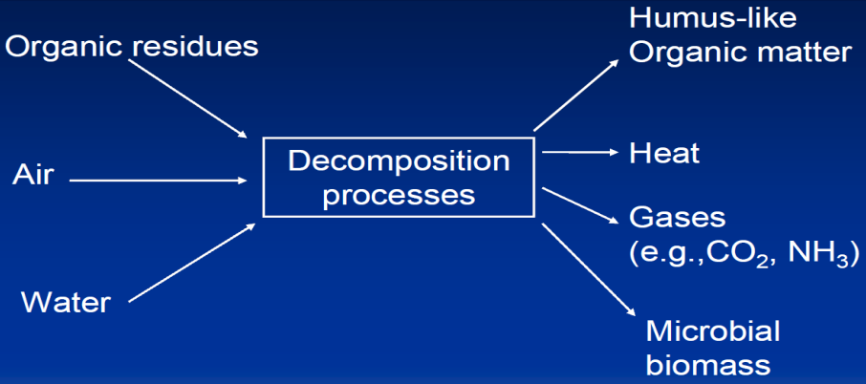

Fig. An overview of composting

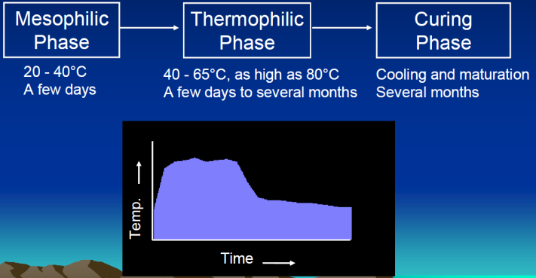

Fig. Composting process

Stage 1: Mesophilic stage:
- Bacteria and fungi are key players- Fauna and protozoa also important
- Decomposition of readily available substrates- sugars, proteins and starch
- Excess energy is released as heat, causing pile temperature to increase

Stage 2: Thermophilic stage
- Heat loving bacteria, actinomycetes and fungi are key players
- Heat interalnt organisms go dormant or are destroyed- human and plant pathogens
- High temperatures accelerate breakdown of proteins, fats, and complex polymers

Microorganisms associated with compost pile
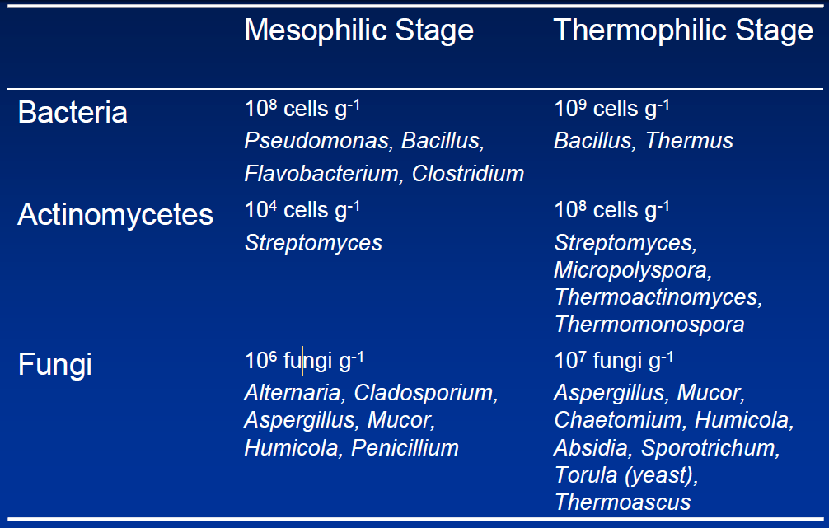

Stage 3: Curing / cooling stage
- Mesophilic bacteria, actenomycetes and fungi are key players
- Further chemical and physical changes in the compost
- Decomposition of recalcitrant polymers by actinomycetes and fungi
- Degradation of fermentation products, methane, and other organic noxious gases which accumulated earlier in anaerobic microsites
- Reduction of odours and toxic intermediates

Methods of Composting
Preparation
Before refuse may be turned into compost it must be sorted. Typically, this sorting will include receiving, sorting, magnetic separation, grinding, and the addition of water and sewage sludge. Sorting of materials allows for the reusable and larger materials to be removed by hand while the magnetic separation protects the machinery and improves the quality of the final product. Grinding reduces the size of the refuse and allows for easy handling, digestion, and mixing with other materials. For proper digestion of the compost it must have the proper moisture content ranging between 45 and 65%. Adding sewage sludge instead of pure water allows for additional organic material and a sanitary disposal of the sludge.
Digestion
For digestion to occur an environment must be created in which microorganisms will rapidly breakdown the organic portion of the refuse. Most modern composting runs of the principal of aerobic instead of anaerobic decomposition. Oxygen is introduced into systems by the use of turning or forced draft agitation. Heat is generated reaching the temperatures of 60º to 70ºC destroying the pathogenic organisms, weed, and fly larvae. The high heat causes rapid decomposition and few unpleasant odors. Aerobic decomposition takes on average 6 weeks.
If the system is not aerated it will become anaerobic causing the decomposition rate to significantly slow down and microflora to begin growing. In contrast with the relatively short decomposition rate associated with aerobic decomposition, anaerobic decomposition takes about 4 to 6 months. Anaerobic decomposition does not reach the temperature necessary to kill pathogens may create unpleasant odors.
Curing
Before compost may be applied, a curing period must occur. The curing period allows for the decomposition rate to slow to the point where it will not rob the soil of its nitrogen content. Depending upon how soon crops will be laid or the type of flora which will planted a curing period will be recommended.

Finishing
In the finishing process materials are further removed if they are objectionable to the function of the compost. This process may remove glass, plastic, waxes, or other undesirable objects through either further screening or continued grinding.
Storage
Because compost is usually in high demand during the spring and fall compost must be stored. Compost may be stored in large piles outdoors, into storage cans to further cure the compost, or placed under cover as the final product or for future finishing.

Composting process and techniques
Composting is the natural process of 'rotting' or decomposition of organic matter by microorganisms under controlled conditions. Raw organic materials such as crop residues, animal wastes, food garbage, some municipal wastes and suitable industrial wastes, enhance their suitability for application to the soil as a fertilizing resource, after having undergone composting.
Compost is a rich source of organic matter. Soil organic matter plays an important role in sustaining soil fertility, and hence in sustainable agricultural production. In addition to being a source of plant nutrient, it improves the physico-chemical and biological properties of the soil. As a result of these improvements, the soil: (i) becomes more resistant to stresses such as drought, diseases and toxicity; (ii) helps the crop in improved uptake of plant nutrients; and (iii) possesses an active nutrient cycling capacity because of vigorous microbial activity. These advantages manifest themselves in reduced cropping risks, higher yields and lower outlays on inorganic fertilizers for farmers.

Types of composting
Composting may be divided into two categories by the nature of the decomposition process. In anaerobic composting, decomposition occurs where oxygen (O) is absent or in limited supply. Under this method, anaerobic micro-organisms dominate and develop intermediate compounds including methane, organic acids, hydrogen sulphide and other substances. In the absence of O, these compounds accumulate and are not metabolized further. Many of these compounds have strong odours and some present phytotoxicity. As anaerobic composting is a low-temperature process, it leaves weed seeds and pathogens intact. Moreover, the process usually takes longer than aerobic composting. These drawbacks often offset the merits of this process, viz. little work involved and fewer nutrients lost during the process.
Aerobic composting takes place in the presence of ample O. In this process, aerobic microorganisms break down organic matter and produce carbon dioxide (CO₂), ammonia, water, heat and humus, the relatively stable organic end product. Although aerobic composting may produce intermediate compounds such as organic acids, aerobic micro-organisms decompose them further. The resultant compost, with its relatively unstable form of organic matter, has little risk of phytotoxicity. The heat generated accelerates the breakdown of proteins, fats and complex carbohydrates such as cellulose and hemi-cellulose. Hence, the processing time is shorter. Moreover, this process destroys many micro-organisms that are human or plant pathogens, as well as weed seeds, provided it undergoes sufficiently high temperature. Although more nutrients are lost from the materials by aerobic composting, it is considered more efficient and useful than anaerobic composting for agricultural production.
Composting objectives may also be achieved through the enzymatic degradation of organic materials as they pass through the digestive system of earthworms. This process is termed vermicomposting.

The aerobic composting process
The aerobic composting process starts with the formation of the pile. In many cases, the temperature rises rapidly to 70-80°C within the first couple of days. First, mesophilic organisms (optimum growth temperature range = 20-45°C) multiply rapidly on the readily available sugars and amino acids. They generate heat by their own metabolism and raise the temperature to a point where their own activities become suppressed. Then a few thermophilic fungi and several thermophilic bacteria (optimum growth temperature range = 50-70°C or more) continue the process, raising the temperature of the material to 65°C or higher. This peak heating phase is important for the quality of the compost as the heat kills pathogens and weed seeds.
The active composting stage is followed by a curing stage, and the pile temperature decreases gradually. The start of this phase is identified when turning no longer reheats the pile. At this stage, another group of thermophilic fungi starts to grow. These fungi bring about a major phase of decomposition of plant cell-wall materials such as cellulose and hemi-cellulose. Curing of the compost provides a safety net against the risks of using immature compost such as nitrogen (N) hunger, O deficiency, and toxic effects of organic acids on plants.
Eventually, the temperature declines to ambient temperature. By the time composting is completed, the pile becomes more uniform and less active biologically although mesophilic organisms recolonize the compost. The material becomes dark brown to black in colour. The particles reduce in size and become consistent and soil-like in texture. In the process, the amount of humus increases, the ratio of carbon to nitrogen (C:N) decreases, pH neutralizes, and the exchange capacity of the material increases.

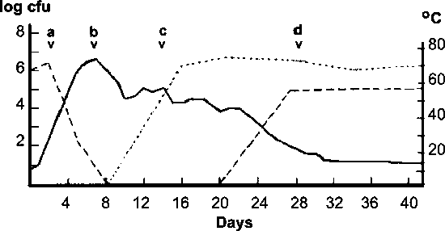

Note:
Solid line = temperature; broken line = mesophilic fungi population; dotted line = thermophilic fungi population; left y-axis = fungal populations (logarithm of colony forming units (cfu) per gram of compost plated onto agar); right y-axis = temperature in centre of compost. a, b, c and d = heating phases.

Factors affecting aerobic composting

Aeration
Aerobic composting requires large amounts of O, particularly at the initial stage. Aeration is the source of O, and, thus, indispensable for aerobic composting. Where the supply of O is not sufficient, the growth of aerobic micro-organisms is limited, resulting in slower decomposition. Moreover, aeration removes excessive heat, water vapour and other gases trapped in the pile. Heat removal is particularly important in warm climates as the risk of overheating and fire is higher. Therefore, good aeration is indispensable for efficient composting. It may be achieved by controlling the physical quality of the materials (particle size and moisture content), pile size and ventilation and by ensuring adequate frequency of turning.

Moisture
Moisture is necessary to support the metabolic activity of the micro-organisms. Composting materials should maintain a moisture content of 40-65 percent. Where the pile is too dry, composting occurs more slowly, while a moisture content in excess of 65 percent develops anaerobic conditions. In practice, it is advisable to start the pile with a moisture content of 50-60 percent, finishing at about 30 percent.

Nutrients
Micro-organisms require C, N, phosphorus (P) and potassium (K) as the primary nutrients. Of particular importance is the C:N ratio of raw materials. The optimal C:N ratio of raw materials is between 25:1 and 30:1 although ratios between 20:1 and 40:1 are also acceptable. Where the ratio is higher than 40:1, the growth of micro-organisms is limited, resulting in a longer composting time. A C:N ratio of less than 20:1 leads to underutilization of N and the excess may be lost to the atmosphere as ammonia or nitrous oxide, and odour can be a problem. The C:N ratio of the final product should be between about 10:1 and 15:1.

Temperature
The process of composting involves two temperature ranges: mesophilic and thermophilic. While the ideal temperature for the initial composting stage is 20-45 °C, at subsequent stages with the thermophilic organisms taking over, a temperature range of 50-70 °C may be ideal. High temperatures characterize the aerobic composting process and serve as signs of vigorous microbial activities. Pathogens are normally destroyed at 55 °C and above, while the critical point for elimination of weed seeds is 62 °C. Turnings and aeration can be used to regulate temperature.

Lignin content
Lignin is one of the main constituents of plant cell walls, and its complex chemical structure makes it highly resistant to microbial degradation. This nature of lignin has two implications. One is that lignin reduces the bioavailability of the other cell-wall constituents, making the actual C:N ratio (viz. ratio of biodegradable C to N) lower than the one normally cited. The other is that lignin serves as a porosity enhancer, which creates favourable conditions for aerobic composting. Therefore, while the addition of lignin-decomposing fungi may in some cases increase available C, accelerate composting and reduce N loss, in other cases it may result in a higher actual C:N ratio and poor porosity, both of which prolong composting time.

Polyphenols
Polyphenols include hydrolysable and condensed tannins. Insoluble condensed tannins bind the cell walls and proteins and make them physically or chemically less accessible to decomposers. Soluble condensed and hydrolysable tannins react with proteins and reduce their microbial degradation and thus N release. Polyphenols and lignin are attracting more attention as inhibiting factors. It is suggested that the contents of these two substances be used to classify organic materials for more efficient on-farm natural resource utilization, including composting.

pH value
Although the natural buffering effect of the composting process lends itself to accepting material with a wide range of pH, the pH level should not exceed 8. At higher pH levels, more ammonia gas is generated and may be lost to the atmosphere.

Techniques for effective aerobic composting
Simple replication of composting practices does not always give the right answer to potential composters. This is because composting takes place at various locations and under diverse climates, using different materials with dissimilar physical, chemical and biological properties. An understanding of the principles and technical options and their appropriate application may be helpful in providing the optimal environment to the compost pile.

Improved aeration
In order to obtain the end product of uniform quality, the whole of the pile should receive a sufficient amount of O so that aerobic micro-organisms flourish uniformly.
Pile size and porosity of the material
The size of the pile is of great significance and finds mention in the sections on passive composting of manure piles (Chapter 2) and turned wind-rows (Chapter 3). Where the pile or wind-row is too large, anaerobic zones occur near its centre, which slows the process in these zones. On the other hand, piles or wind-rows that are too small lose heat quickly and may not achieve a temperature high enough to evaporate moisture and kill pathogens and weed seeds. The optimal size of the piles and wind-rows should also consider such parameters as the physical property (porosity) of the materials and the way of forming the pile. While more porous materials allow bigger piles, heavy weights should not be put on top and materials should be kept as loose as possible. Climate is also a factor. With a view to minimizing heat loss, larger piles are suitable for cold weather. However, in a warmer climate, the same piles may overheat and in some extreme cases (75°C and above) catch fire.
Ventilation
Provision of ventilation complements efforts to optimize pile size. Ventilation methods are varied. The simplest method is to punch holes in the pile at several points. The high temperature compost method of Chinese rural composting (Chapter 2) involves inserting a number of bamboo poles deep into the pile and withdrawing them a day later, leaving the pile with ventilation holes. Aeration is improved by supplying more air to the base of the pile where O deficiency occurs most often. In addition to the above-mentioned vertical poles, Ecuador on-farm composting (Chapter 2) uses a lattice of old branches at the base to allow more pile surface to come into contact with the air, and the composting period is reduced to two to three months in warm seasons. This technique is also practised in the rapid composting method developed by the Institute of Biological Sciences (IBS) in the Philippines (Chapter 2), where the platform should be 30 cm above the ground. The passively aerated wind-rows method (Chapter 3) uses a more sophisticated technique. It entails embedding perforated pipes throughout the pile. As the pipe ends are open, air flow is induced and O is supplied to the pile continuously. The aerated static pile method (Chapter 3) takes this aeration system a step further; a blower generates air flow to create negative pressure (suction) in the pile and fresh air is supplied from outside.
Turning
Once the pile is formed and decomposition starts, the only technique for improving aeration is turning. As Table 1 shows, frequency of turning is crucial for composting time. While the Indian Bangalore method (Chapter 2) requires six to eight months to mature, the Indian Coimbatore method (Chapter 2) (turning once) reduces the time to four months, and the Chinese rural composting pit method (turning three times) reduces the time to three months. An extreme example is the Berkley rapid composting method (Chapter 2), which employs daily turning to complete the process in two weeks. In some cases, turning not only distributes air throughout the pile, it also prevents overheating as it kills all the microbes in the pile and terminates decomposition. However, turning too frequently might result in a lower temperature.

Inoculation
While some composters find improved aeration enough for enhanced microbial activities, others may need inoculation of microorganisms. Inoculum organisms utilized for composting are mainly fungi such as Trichoderma sp. (IBS rapid composting and composting weeds (Chapter 2)) and Pleurotus sp. (composting Coir Pith (Chapter 2) and composting weeds). This publication also features 'effective micro-organisms' (EMs) (EM-based quick compost production process (Chapter 2)). The inoculums are an affordable choice for those with access to the market and also for resource-poor farmers. The production cost could be reduced by using inoculums taken from compost pits (pit method of the Indian Indore method (Chapter 2)), by purchasing the commercial product and multiplying it on the farm (EM-based quick compost production process), and by utilizing native inoculums derived from soils or plant leaves.

Supplemental nutrition
The techniques mentioned above often need to be complemented by the provision of nutrients. One of the most common practices is to add inorganic fertilizers, particularly N, in order to modify a high C:N ratio. Similarly, P is sometimes applied as the C:P ratio of the material mix is also considered important (the ratio should be between 75:1 and 150:1). When microorganisms are inoculated, they require sugar and amino acids in order to boost their initial activities; molasses is often added for this purpose.
Table 1 Salient features of selected small-scale aerobic composting techniques
Method | Salient features |  |  |  |  | Duration
 | Substrate size reduction | Turnings at intervals of (days) | Added aeration provision | Microbial inoculation | Supporting microbial nutrition
Indore pit |  | +15, +30, +60 |  | Inoculum from old pit |  | 4 months
Indore heap | Shredded | +42, +84 |  |  |  | 4 months
Chinese pit |  | +30, +60, +75 |  |  | Superphosphate | 3 months
Chinese high temperature compost | Shredded | +15 | Aeration holes in heap through bamboo poles/maize stalks |  | Superphosphate | 2 months
Ecuador on-farm composting |  | +21 | Lattice of old branches/poles at heap base |  |  | 2-3 months in summer;  5-6 months in winter
Berkley rapid composting | Shredded to small size | Daily or alternate day turning |  |  |  | 2 weeks with daily turning & 3 weeks with alternate day turning
North Dakota State University hot composting | Shredded | +3 or +4 | 4-5 holes punched in centre of pile |  | 0.12 kg N per 90 cm dry matter | 4-6 weeks
EM-based quick composting |  | +14, +21 |  | EM | Molasses | 4-5 weeks
IBS rapid composting | Shredded | +7, +14, then every 2 weeks | Raised platform ground/perforated bamboo trunks | Trichoderma sp. |  | 3-7 weeks

Shredding
Downsizing, or chopping up the materials, is a sound and widely-practiced technique. It increases the surface area available for microbial action and provides better aeration. This technique is particularly effective and necessary for harder materials such as wood.

Other measures
An example of other measures mentioned in this publication is the practice of adding lime. Lime is thought to weaken the lignin structure of the plant materials and enhance the microbial population. However, in some cases, liming is not recommended as the pile may become too alkaline, resulting in significant N loss.

Rapid methods

Aerobic high temperature composting
Berkley rapid composting method - shredding and frequent turning
This method (Raabe, 2001) corrects some of the problems associated with the earlier methods of composting. The process can produce compost in two to three weeks. Several factors are essential to the rapid composting method:
- Material composts best when it is 1.25-3.75 cm in size. Soft, succulent tissues do not need chopping into very small pieces because they decompose rapidly. The harder or woodier the tissues, the smaller they need to be in order to decompose rapidly. Woody material should be passed through a grinder. Chopping material with a sharp shovel is effective. When pruning plants, the material should be cut into small pieces using the pruning shears. This requires a little effort but the results are worth it
- For the composting process to work most effectively, the material to be composted should have a C:N ratio of 30:1. Mixing equal volumes of green plant material with equal volumes of naturally dry plant material yields such a ratio. The green material can be grass clippings, old flowers, green prunings, weeds, fresh garbage and fruit and vegetable wastes. The dried material can be fallen leaves, dried grass, straw and woody materials from prunings.
- Materials that should not be added to a composting pile include: soil, ashes from a stove or fireplace, and manure from carnivorous animals. Manures from herbivorous animals such as rabbits, goats, cattle, horses, elephants and fowl can be used. Once a pile has been started, nothing should be added. This is because it takes a certain length of time for the material to break down and anything added has to start at the beginning, thus lengthening the decomposition time for the whole pile. Excess material should be as dry as possible during storage until a new pile is started. Moist stored materials start to decompose. If this occurs, they will not be effective in the compost pile. Nothing needs to be added to the organic materials to make them decompose. The micro-organisms active in the decomposition process are ubiquitous where plant materials are found and develop rapidly in any compost pile.
- Composting works best where the moisture content of materials in the pile is about 50 percent. Too much moisture creates a soggy mass, and decomposition will then be slow and the pile will smell. Where the organic material is too dry, decomposition is either very slow or does not occur at all.
- Heat, which is very important in rapid composting, is supplied by the respiration of the micro-organisms as they break down the organic materials. To prevent heat loss and to build up the amount of heat necessary, a minimum volume of material is essential. The pile should be at least 90 cm × 90 cm × 90 cm in size. Where the dimensions are less than 80 cm, the rapid process will not occur. Heat retention is better in bins than in open piles, so rapid composting is more effective where bins are used. In addition, the use of bins is much neater. High temperatures favour the microorganisms that are the most rapid decomposers; these microorganisms function at about 71°C and a good pile maintains itself at about that temperature.
- The compost pile needs to be turned to prevent it from overheating. If the temperature in the pile rises much above 71°C, the microorganisms will be killed, the pile will cool, and the whole process will have to start again from the beginning. Turning the pile prevents overheating and aerates the pile, both necessary conditions for keeping the most active decomposers functioning. The pile should be turned in a manner that the material is moved from the outside to the centre. In this way, all the material reaches optimal temperatures at various times. Owing to heat loss around the margins, only the central portion of the pile is at the optimal temperature. Because of the need for turning, it is desirable to have two bins so that the material can be turned from one into another. Bins with removable slats in the front facilitate the turning process. Bins with covers retain the heat better than those without. Once the decomposition process starts, the pile becomes smaller and, because the bin is no longer full, some heat will be lost at the top. This can be prevented by using a piece of polyethylene plastic slightly larger than the top area of the bin. After the compost has been turned, the plastic is placed directly on the top of the compost and is tucked in around the edges. If the material in the pile is turned every day, it will take two weeks or a little longer to compost. If turned every other day, it will take about three weeks. The longer the interval between turning, the longer it will take for the composting to finish.
- If the procedure is followed properly, a pile heats to a high temperature within 24-48 hours. If it does not do so, this means that the pile is too wet or too dry or that there is not enough green material (or N) present. If too wet, the material should be spread out to dry. If too dry, moisture should be added. If neither of these, then the N is low (a high C:N ratio), and this can be corrected by adding materials high in N (such as ammonium sulphate, grass clippings, fresh chicken manure or urine diluted 1 to 5).
- Where the C:N ratio is less than 30:1, the organic matter decomposes very rapidly but there is a loss of N. This is given off as ammonia, and where this odour is present in or around a composting pile, it means that valuable N is being lost in the air. This can be counteracted by adding sawdust to that part of the pile where there is an ammonia odour (sawdust is very high in C and low in N). Some covering for the pile may be necessary in order to keep the composting materials from becoming too wet during the rainy season.
- The rapid decomposition can be detected by a pleasant odour, by the heat produced (visible in the form of water vapour given off during the turning of the pile), by the growth of white fungi on the decomposing organic material, by a reduction of volume, and by the materials changing colour to dark brown. As composting nears completion, the temperature drops and, finally, little or no heat is produced. The compost is then ready to use. If the material was not chopped into small pieces during the preparation phase, screening the material through 2.5-cm-mesh chicken wire will hold back the large pieces. These can be added to the next pile and eventually they will decompose.
Composting organic materials with high lignin content - lime treatment
By adding organic wastes such as sawdust, wood shavings, coir pith, pine needles, and dry fallen leaves, while preparing organic waste mixtures for composting, one can ensure that the compost produced contains sufficient and long-lasting humus. However, gardeners often find that where they use lignin-rich plant materials, the compost does not ripen rapidly. A technique for making good compost from hard plant materials involves mixing lime in a ratio of 5 kg per 1,000 kg of waste material. Lime can be applied as dry powder or after mixing with a sufficient quantity of water. Treatment with lime enhances the process of decomposition of hard materials. Liming can enhance the humification process in plant residues by enhancing microbial population and activity and by weakening lignin structure. It also improves the humus quality by changing the ratio of humic to fulvic acids and decreases the amount of bitumen, which interferes with the decomposition process. Instead of lime, powdered phosphate rock can be used in a ratio of 20 kg per 1,000 kg of organic waste. Phosphate rock contains a lot of lime. The phosphates and micronutrients contained in phosphate rock make composts rich in plant nutrients.

Aerobic high temperature composting with inoculation
EM-based quick composting
Effective micro-organisms (EM) consist of common and food-grade aerobic and anaerobic microorganisms: photosynthetic bacteria, lactobacillus, streptomyces, actinomycetes, yeast, etc. The strains of the microorganisms are commonly available from microbe banks or from the environment. There are no genetically engineered strains that are in use. Since 1999, seven small-scale organic fertilizer units have been using the EM-based quick production process in Myanmar (FAO, 2002). They are owned and operated by women's income generation groups. A unit consists of nine pits measuring about 180 cm (length) × 120 cm (width) × 90 cm (depth), enclosed by low walls and covered with a roof (Plate 2).
Raw materials
The raw materials for organic fertilizer production are:
- cow dung - 2 portions;
- rice husk - 1 portion;
- rice husk-charcoal - 1 portion;
- rice bran, milled - 1 portion;
- accelerator - 33 litres of EM solution or Trichoderma solution per pit.
EM-based quick composting in Myanmar
Preparation of EM solution (accelerator)
One litre of 'instant solution' is made by mixing 10 ml of EM, 40 ml of molasses and 950 ml of water and leaving it for five to seven days, depending on temperature. The solution is then added to 1 litre of molasses and 98 litres of water to obtain 100 litres of ready-to-use EM solution. This amount is enough for three pits. The EM solution functioning as accelerator reduces the composting period from three months to one month.
Procedure
All the ingredients are mixed together, except accelerator. A 15 cm layer of mixture is spread in the pit and accelerator is sprinkled on it. This procedure is repeated until the pit is full. The pit is covered with a plastic sheet (Plate 3). Two or three weeks later, the whole pit is mixed in order to boost aerobic decomposition. The compost is ready to use a couple of weeks later. A pit produces 900 kg of final product per batch. The product is usually packed in 30-kg plastic bags. Assuming that it takes 30 days on average to produce a batch and that only eight pits may be used for technical reasons, the annual potential production capacity is 86.4 tonnes (0.9 tonnes × 8 pits × 12 months).
The IBS rapid composting technology (Virginia, 1997) involves inoculating the plant substrates used for composting with cultures of Trichoderma harzianum, a cellulose decomposer fungus. The fungus, grown in a medium of sawdust mixed with the leaves of a leguminous tree called ipil ipil (Leucaena leucocephala), is termed compost fungus activator (CFA).
The CFA is broadcast onto the substrates during piling. The amount of activator used is usually 1 percent of the total weight of the substrates (i.e. about 1 kg compost activator per 100 kg substrate). Decomposition is faster where the activator is mixed thoroughly with the substrate. A larger amount of activator can be used should faster decomposition be desired.
Composting organic materials with high lignin content - coir pith
Coir pith is a waste from the coir industry (TNAU, 1999). This is a major industry that produces coconuts on a large scale. During the process of separating fibre from the coconut husk, a large volume of pith is collected. The pith, containing about 30 percent lignin and 26 percent cellulose, does not degrade rapidly, posing a major disposal problem. However, it can be composted by using the fungus Pleurotus sp. and urea. To compost 1 tonne of coir pith, the materials required are: five spawn bottles (250 g) of Pleurotus sp. and 5 kg of urea.
Composting weeds
This method has been developed for composting weeds such as parthenium, water hyacinth (Eichornia crassipes), cyperus (Cyperus rotundus) and cynodon (Cynodon dactylon). The materials required are: 250 g of Trichoderma viride and Pleurotus sajor-caju consortia, and 5 kg of urea. An elevated shaded place is selected, or a thatched shed is erected. An area of 500 cm × 150 cm is marked out. The material to be composted is cut to 10-15 cm in size. About 100 kg of cut material is spread over the marked area. About 50 g of microbial consortia is sprinkled over this layer. About 100 kg of weeds are spread on this layer. One kilogram of urea is sprinkled uniformly over the layer. This process is repeated until the level rises to 1 m. Water is sprinkled as necessary to maintain a moisture level of 50-60 percent. Thereafter, the surface of the heap is covered with a thin layer of soil. The pile requires a thorough turning on the twenty-first day. The compost is ready in about 40 days.

Compost enrichment
Farm compost is poor in P content (0.4-0.8 percent). Addition of P makes the compost more balanced, and supplies nutrient to micro-organisms for their multiplication and faster decomposition. The addition of P also reduces N losses. Compost can be enriched by:
- Application of superphosphate, bonemeal or phosphate rock (Ramasami, 1975): 1 kg of superphosphate or bonemeal is applied over each layer of animal dung. Low-grade phosphate rock can also be used for this purpose.
- Use of animal bones: these can be broken into small pieces, boiled with wood ash leachate or lime water and drained, and the residue applied to the pits. This procedure of boiling bones facilitates their disintegration. Even the addition of raw bones, broken into small pieces and added to the pit, improves the nutrient value of compost significantly.
- Wood ash waste can also be added to increase the K content of compost.
- Addition of N-fixing and P-solubilizing cultures (IARI, 1989): The quality of compost can be further improved by the secondary inoculation of Azotobacter, Azospirillum lipoferum, and Azospirillum brasilence (N-fixers); and Bacillus megaterium or Pseudomonas sp. (P solubilizers). These organisms, in the form of culture broth or water suspension of biofertilizer products, can be sprinkled when the decomposing material is turned after one month. By this time, the temperature of the compost has also stabilized at about 35 °C. As a result of this inoculation, the N content of straw compost can be increased by up to 2 percent. In addition to improving N content and the availability of other plant nutrients, these additions help to reduce the composting time considerably.

4. Vermicomposting

The term vermicomposting means the use of earthworms (Plate 9) for composting organic residues. Earthworms can consume practically all kinds of organic matter and they can eat their own body weight per day, e.g. 1 kg of worms can consume 1 kg of residues every day. The excreta (castings) of the worms are rich in nitrate, available forms of P, K, Ca and Mg. The passage of soil through earthworms promotes the growth of bacteria and actinomycetes. Actinomycetes thrive in the presence of worms and their content in worm casts is more than six times that in the original soil.

Types of worms
A moist compost heap of 2.4 m by 1.2 m and 0.6 m high can support a population of more than 50,000 worms. The introduction of worms into a compost heap has been found to mix the materials, aerate the heap and hasten decomposition. Turning the heaps is not necessary where earthworms are present to do the mixing and aeration. The ideal environment for the worms is a shallow pit and the right sort of worm is necessary. Lumbricus rubellus (red worm) and Eisenia foetida are thermo-tolerant and so particularly useful. Field worms (Allolobophora caliginosa) and night crawlers (Lumbricus terrestris) attack organic matter from below but the latter do not thrive during active composting, being killed more easily than the others at high temperature.
European night crawlers (Dendrabaena veneta or Eisenia hortensis) are produced commercially and have been used successfully in most climates. These night crawlers grow to about 10-20 cm. The African night crawler (Eudrilus eugeniae), is a large, tropical worm species. It tolerates higher temperatures than Eisenia foetida does, provided there is ample humidity. However, it has a narrow temperature tolerance range, and it cannot survive at temperatures below 7 °C. Vermicomposting is in use in many countries. Experiences from selected countries are described as case studies.

Vermiculture in India
This approach (Jambhhekar, 2002) uses the following materials: breeder worms, a wooden bed and organic wastes. The bed should be of the desired length and about 75 cm high × 120 cm wide. Worms should be applied for every part of waste. Other steps in the process are:
- Sieving and shredding - decomposition can be accelerated by shredding raw materials into small pieces.
- Blending - carbonaceous substances such as sawdust, paper and straw can be mixed with N-rich materials such as sewage sludge, biogas slurry and fish scraps to obtain a near optimum C:N ratio. A varied mixture of substances produces good quality compost, rich in macronutrients and micronutrients.
- Half digestion - the raw materials should be kept in piles and the temperature allowed to reach 50-55 °C. The piles should remain at this temperature for seven to ten days.
- Maintaining moisture, temperature and pH - the optimum moisture level for maintaining aerobic conditions is 40-45 percent. Proper moisture and aeration can be maintained by mixing fibrous with N-rich materials. The temperature of the piles should be 28-30 °C. Higher or lower temperatures reduce the activity of microflora and earthworms. The height of the bed can help control the rise in temperature. The pH of the raw material should not exceed 6.5-7.
The compost is ready after about one month. It is black, granular, lightweight and humus-rich. In order to facilitate the separating of the worms from the compost, watering should cease two to three days before emptying the beds. This forces about 80 percent of the worms to the bottom of the bed. The remaining worms can be removed by hand. The vermicompost is then ready for application.

Enhancing vermicompost production
Vermicompost production using epigeic compost worms such as Eisenia foetida, Lumbricus rubellus and Eudrilus eugeniae can be enhanced effectively by supplementing the organic wastes used for vermicomposting with cow urine. Undiluted urine can be used for moistening organic wastes during the preliminary composting period (before the addition of worms.). After the initiation of worm activity, urine can be diluted with an equal quantity of water. No problems have been observed with daily use of diluted cow urine for moistening the vermicomposting bed. This simple technique can yield vermicompost with a higher N content. Moreover, worms have been found to become very active and vermicompost can be harvested at least 10 days early.

Integrating traditional composting and vermicomposting
Problems associated with traditional thermophilic composting relate to: long duration of the process, frequent turning of the material, material size reduction to enhance the surface area, loss of nutrients during the prolonged process, and the heterogeneous resultant product. However, the main advantage of thermophilic composting is that the temperatures reached during the process are high enough for an adequate pathogen kill.
In vermicomposting, the earthworms take over both the roles of turning and maintaining the material in an aerobic condition, thereby reducing the need for mechanical operations. In addition, the product (vermicompost) is homogenous. However, the major drawback of the vermicomposting process is that the temperature is not high enough for an acceptable pathogen kill. Whereas in traditional thermophilic composting the temperatures exceed 70 °C, the vermicomposting processes must be maintained at less than 35 °C.

A study has examined the possibility of integrating traditional thermophilic composting and vermicomposting (Ndegwa and Thompson, 2001). The work involved combining pertinent attributes from each of the two processes to enhance the overall process and improve the product qualities. The two approaches investigated in the study related to: (i) pre-composting followed by vermicomposting; and (ii) pre-vermicomposting followed by composting. The duration of each of the combined operations viz. composting and vermicomposting was four weeks. A comparison was made with vermicomposting alone (duration: 56 days). The results indicated that the combination of the two processes shortened the stabilization time and improved product quality. Furthermore, the resultant product was more stable and consistent, had less potential impact on the environment, and met pathogen reduction requirements.

Biogas

Biogas is mixture of methane (50-60%), CO₂ (30-40%), hydrogen (5-10%), H₂S and nitrogen (traces), produced from the anaerobic digestion of animal, plant wastes or any cellulose containing waste material. The digester used for biogas production is called biogas plant. A typical biogas plant (Fig.1) using cow dung as raw material consists of (a) digester and (b) gas holder. The digesters are either of batch type which are filled once, sealed and emptied when the raw materials stop producing gas or (b) continuous type, which are fed with a definite quantity of wastes at regular intervals so that gas production is continuous and regular. The nature of fermentation in the digester is anaerobic.
Biogas typically refers to a gas produced by the biological breakdown of organic matter in the absence of oxygen. Organic waste such as dead plant and animal material, animal dung, and kitchen waste can be converted into a gaseous fuel called biogas. Biogas originates from biogenic material and is a type of biofuel.
Biogas is produced by the anaerobic digestion or fermentation of biodegradable materials such as biomass, manure, sewage, municipal waste, green waste, plant material, and crops. Biogas comprises primarily methane (CH₄) and carbon dioxide (CO₂) and may have small amounts of hydrogen sulphide (H₂S), moisture and siloxanes.
The gases methane, hydrogen, and carbon monoxide (CO) can be combusted or oxidized with oxygen. This energy release allows biogas to be used as a fuel. Biogas can be used as a fuel in any country for any heating purpose, such as cooking. It can also be used in anaerobic digesters where it is typically used in a gas engine to convert the energy in the gas into electricity and heat. Biogas can be compressed, much like natural gas, and used to power motor vehicles. In the UK, for example, biogas is estimated to have the potential to replace around 17% of vehicle fuel.^{[3]} Biogas is a renewable fuel, so it qualifies for renewable energy subsidies in some parts of the world. Biogas can also be cleaned and upgraded to natural gas standards when it becomes biomethane.

Production
Biogas is practically produced as landfill gas (LFG) or digester gas. A biogas plant is the name often given to an anaerobic digester that treats farm wastes or energy crops.
Biogas can be produced utilizing anaerobic digesters. These plants can be fed with energy crops such as maize silage or biodegradable wastes including sewage sludge and food waste. During the process, an air-tight tank transforms biomass waste into methane producing renewable energy that can be used for heating, electricity, and many other operations that use any variation of an internal combustion engine, such as GE Jenbacher gas engines.^{[4]} There are two key processes: Mesophilic and Thermophilic digestion. In experimental work at University of Alaska Fairbanks, a 1000-litre digester using psychrophiles harvested from "mud from a frozen lake in Alaska" has produced 200–300 litres of methane per day, about 20–30 % of the output from digesters in warmer climates.
Landfill gas is produced by wet organic waste decomposing under anaerobic conditions in a landfill. The waste is covered and mechanically compressed by the weight of the material that is deposited from above. This material prevents oxygen exposure thus allowing anaerobic microbes to thrive. This gas builds up and is slowly released into the atmosphere if the landfill site has not been engineered to capture the gas. Landfill gas is hazardous for three key reasons. Landfill gas becomes explosive when it escapes from the landfill and mixes with oxygen. The lower explosive limit is 5% methane and the upper explosive limit is 15% methane. The methane contained within biogas is 20 times more potent as a greenhouse gas than is carbon dioxide. Therefore, uncontained landfill gas, which escapes into the atmosphere may significantly contribute to the effects of global warming. In addition, landfill gas impact in global warming, volatile organic compounds (VOCs) contained within landfill gas contribute to the formation of photochemical smog.

Composition

Typical composition of biogas
Compound | Chem | %
Methane | CH₄ | 50–75
Carbon dioxide | CO₂ | 25–50
Nitrogen | N₂ | 0–10
Hydrogen | H₂ | 0–1
Hydrogen sulfide | H₂S | 0–3
Oxygen | O₂ | 0–0

The composition of biogas varies depending upon the origin of the anaerobic digestion process. Landfill gas typically has methane concentrations around 50%. Advanced waste treatment technologies can produce biogas with 55–75% CH₄, which for reactors with free liquids can be increased to 80-90% methane using in-situ gas purification techniques. As-produced, biogas also contains water vapor. The fractional volume of water vapor is a function of biogas temperature; correction of measured gas volume for both water vapor content and thermal expansion is easily done via a simple mathematic algorithm^{[13]} which yields the standardized volume of dry biogas.
In some cases, biogas contains siloxanes. These siloxanes are formed from the anaerobic decomposition of materials commonly found in soaps and detergents. During combustion of biogas containing siloxanes, silicon is released and can combine with free oxygen or various other elements in the combustion gas. Deposits are formed containing mostly silica (SiO₂) or silicates (Si_{x}O_{y}) and can also contain calcium, sulfur, zinc, phosphorus. Such white mineral deposits accumulate to a surface thickness of several millimeters and must be removed by chemical or mechanical means.
Practical and cost-effective technologies to remove siloxanes and other biogas contaminants are currently available.

Benefits
When biogas is used, many advantages arise. In North America, utilization of biogas would generate enough electricity to meet up to three percent of the continent's electricity expenditure. In addition, biogas could potentially help reduce global climate change. Normally, manure that is left to decompose releases two main gases that cause global climate change: nitrous dioxide and methane. Nitrous dioxide (NO₂) warms the atmosphere 310 times more than carbon dioxide and methane 21 times more than carbon dioxide. By converting cow manure into methane biogas via anaerobic digestion, the millions of cows in the United States would be able to produce one hundred billion kilowatt hours of electricity, enough to power millions of homes across the United States. In fact, one cow can produce enough manure in one day to generate three kilowatt hours of electricity; only 2.4 kilowatt hours of electricity are needed to power a single one hundred watt light bulb for one day.^{[15]} Furthermore, by converting cow manure into methane biogas instead of letting it decompose, we would be able to reduce global warming gases by ninety-nine million metric tons or four percent.
The 30 million rural households in China that have biogas digesters enjoy 12 benefits: saving fossil fuels, saving time collecting firewood, protecting forests, using crop residues for animal fodder instead of fuel, saving money, saving cooking time, improving hygienic conditions, producing high-quality fertilizer, enabling local mechanization and electricity production, improving the rural standard of living, and reducing air and water pollution.^{[17]}

Microbiology in Biogas production
At present four different bacterial groups are recognized to be involved in the anaerobic fermentation of organic matter to methane.

i. The hydrolytic bacteria which catalyze carbohydrates, proteins, lipids, other components of biomass to fatty acids, H₂ and CO₂.
ii. The hydrogen producing acetogenic bacteria which catabolize certain fatty acids and neutral end products of group one to acetate, CO₂ and H₂.
iii. The homoacetogenic bacteria which synthesize acetate using acetic acid.
iv. The methanogenic bacteria which utilize acetate, CO₂ and H₂ to produce methane.

The first three groups of bacteria include facultative as well as strict anaerobes like Cellulomonas, Clostridium, Bacillus, Bacteroides, Ruminococcus, Eubacterium, etc. while the methanogenic bacteria include Methanosarcina, Methanothrix, Methanobacterium, and Methanospirillum, the major characteristics of which are mentioned in Table 2.

Table 2. Major genera of methanogenic bacteria
Genus | Morphology | Methanogenic substrates utilized for growth
Methanobacterium | Long rods or filaments | H₂ + CO₂, formate
Methanomicrobium | Short rods | H₂ + CO₂, formate
Mehtogenium | Irregular, small cocci | H₂ + CO₂, formate
Methanococcus | Irregular, small cocci | H₂ + CO₂, formate
Mehtanobrevibacter | Lancet shaped cocci or short rods | H₂ + CO₂, formate
Methanospirillum | Short to long spiral | H₂ + CO₂, formate
Methanosarcina | Pseudosarcina | H₂ + CO₂, acetate,  methanol, methylamines

The methanogenic phase is strict anaerobic and during this phase organic carbon is converted into microbial mass, CO₂ and methane. These bacteria are sensitive to pH and optimal pH for methane production is 6.8 - 7.2. If pH drops to 6.6 or below there is an inhibition of methanogenesis.

Microbial conversion of organic matter to methane has become attractive as a method of waste treatment and resource recovery. This process is anaerobic and is carried out by action of various groups of anaerobic bacteria.
Three basic points about this process are:
i. that most of the important bacteria involved in biogas production process are anaerobes and slow growing;
ii. that a greater degree of metabolic specialization is observed in these anaerobic microorganisms; and
iii. that most of the free energy present in the substrate is found in the terminal product methane. Since less energy is available for the growth of organism, less microbial biomass is produced and, consequently, disposal of sludge after the digestion may not be a major problem.

Complex polymers are broken down to soluble products by enzymes produced by fermentative bacteria (Figure 1, Group 1) which ferment the substrate to short-chain fatty acids, hydrogen and carbon dioxide. Fatty acids longer than acetate are metabolized to acetate by obligate hydrogen-producing acetogenic bacteria (Figure 1, Group 2). The major products after digestion of the substrate by these two groups are hydrogen, carbon dioxide, and acetate. Hydrogen and carbon dioxide can be converted to acetate by hydrogen-oxidizing acetogens (Figure 1, Group 3) or methane by carbon-dioxide-reducing, hydrogen-oxidizing methanogens (Figure 1, Group 4). Acetate is also converted to methane by aceticlastic methanogens (Figure 1, Group 5). Nearly 70% of methane from biogas digesters fed with cattle dung is derived from acetate. Representative reactions occurring in biogas digester and their free energy under standard and typical conditions are given in Table 1.
Interactions between the various microbial groups
Microbial diversity in biogas digesters is as great as that of rumen⁵ wherein seventeen fermentative bacterial species have been reported to play important role⁶ for production of biogas. Furthermore, it is the nature of the substrate that determines the type and extent of the fermentative bacteria present in the digester⁷. Ramasamy et al.³ reported higher presence of proteolytic organisms in cow dung-fed digesters and other animals waste-fed digesters. However, Preeti Rao et al.⁸ observed that while cow dung-fed digesters supported higher amylolytic microorganisms, poultry waste-fed digesters showed higher proteolytic population. Among fermentative organisms, Bacteroides succinogens, Butyrivibrio fibrisolvens Clostridium cellobioparum, Ruminococcus albus and Clostridium sp. were predominant⁹. Ramasamy et al.⁵ observed that a clear differentiation existed in the type of cellulolytic bacterial distribution in rumen and biogas digester. Whereas in rumen, Ruminococcus sp. alone accounted for 60 per cent of the total population, in the biogas digester the predominant species belonged to the genera Bacteroides and Clostridium rather than the genus Ruminococcus. Later Ramasamy¹⁰ reported that Ruminococcus flavefaciens, Eubacterium cellulosolvens, Clostridium cellulosolvens, Clostridium cellulovorans, Clostridium thermocellum, Bacteroides cellulosolvens and Acetivibrio cellulolyticus were some of the other predominant fermentative bacteria present in cattle dung-fed digesters.

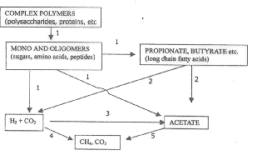

Most of these bacteria adhere to the substrate prior to extensive hydrolysis. Ramasamy¹¹ showed that while the digester slurry contained higher cellulolytic population, the outlet of the digester recorded the least cellulolytic population. Furthermore, Ramasamy et al.³ reported that the particulate-bound cellulolytic bacteria were the predominant group in the slurry of the digester. It was observed that out of the total cellulolytic population of 42 × 10⁴ ml^{–1} of slurry, the particulate-bound bacteria accounted for 34 × 10⁴ ml^{–1} of slurry. Furthermore, the particulate-bound bacteria predominated up to 20th day of initiation of biogas digester. It is also known that the particulate-bound bacteria showed direct relation to the biogas yield from the digester¹⁰ (Figure 2). In a recent review, Salom Gnana Thanga and Ramasamy¹² elaborated the need for adherence of anaerobic bacteria in cellulose hydrolysis.
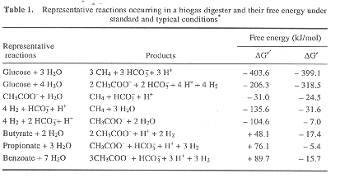
Kelkar et al.¹³ compared the activity of cellulolytic clostridia isolated from cattle dung-fed digesters and reported that C. populeti recorded higher degradation of cellulose than C. cellobioparum, and Clostridium sp. Sivakumaran et al.¹⁴ characterized the cellulase enzymes present in biogas digesters and reported that Acetivibrio sp. showed higher cellulase activity than Bacteroides sp. and Clostridium sp. isolated from biogas digesters.
Though a variety of products are formed by the action of fermentative bacteria, volatile fatty acids are the primary products of carbohydrate fermentation in biogas digesters, as they are in rumen. The partial pressure of hydrogen can influence the products of carbohydrate metabolism¹. The partial pressure of hydrogen can be maintained either by hydrogen-oxidizing methanogens or sulphate-reducing bacteria. However in biogas digesters, the action of former organisms is preferred resulting in methane as the endproduct. Under these conditions, oxidation of NADH and the conversion of hexose to acetate, H₂ and CO₂ by fermentation occurs, yielding 4 ATP molecules per hexose molecule by glycolysis or acetyl phosphate pathway (Thauer et al.⁴). But under conditions of higher partial pressure of hydrogen, formation of more reduced products results in the following order: propionate, butyrate, ethanol, and lactate. Also, the fermentation of hexose either to ethanol or lactate yields only 2 ATP per hexose molecule by glycolysis¹, depriving thereby methanogens of the substrate (acetate) needed for its growth and activity¹⁵. Ramasamy et al.³ studied the interaction of cellulolytic bacteria, Acetivibrio sp., and methanogens, Methanosarcina sp., and Methanobacterium sp., using cellulose and cellobiose as substrate. They observed that using co-cultures, the growth of both Acetivibrio sp. and Methanosarcina sp. was higher, and that the methane content of biogas was enhanced by twenty per cent.
Though less in number, obligately hydrogen-producing acetogenic bacteria are one of the important groups in biogas digesters. These organisms oxidize the fatty acids that are longer than acetate to acetate and thereby release energy from the substrate in the form of methane. Boone and Bryant¹⁶ isolated Syntrophobacter wolinii which beta-oxidized propionate to acetate, and later McInerney et al.¹⁷ isolated Syntrophomonas wolfei which beta-oxidized C₄ to C₇ fatty acids. But these reactions are favourable only if the hydrogen partial pressure is below 10^{– 3} atmosphere. However, for propionate oxidation the partial pressure has to be still lower¹⁷. Nagamani et al.¹⁸ reported that accumulation of propionic acid and lauric acid resulted in acidification of digester which inhibited further methane formation in castor-oil-cake-fed digesters. Furthermore, they reported¹⁹ that propionate is toxic to methanogens even at a concentration of 8 mM. Subsequently, Nagamani et al.²⁰ developed a consortia comprised of syntrophic co-cultures in association with hydrogen-utilizing methanogens, which stabilized methane production from castor-oil-cake-fed digester. Earlier, Meher and Ranade²¹ isolated a propionate-degrading bacterium in association with M. formicicum from cattle dung-fed digesters. Meher et al.²² also reported the presence of butyrate-degrading syntrophic co-culture in biogas digesters fed with cattle dung. Though these organisms occurred at a pH < 6.0 and below 45ºC, methanogenesis was observed at pH > 6.5 and above 40ºC.

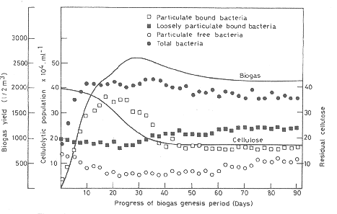

Reductive halogenation of various halogenated aliphatic and aromatic compounds is the next important process by fermentative group of organisms. Thauer et al.⁴ observed that these reactions are thermodynamically feasible and can support growth. Anaerobic degradation of aromatic compounds also depend on hydrogen-consuming bacteria⁷. Mountford and Bryant²³ isolated a bacterium which oxidized benzoate to acetate in obligate co-culture with methanogens or sulphate-reducing bacteria. Doraisamy et al.²⁴ showed that phenol at 1000 ppm concentration inhibited the gas production up to six weeks, which increased with prolonged incubation. However, a mixed culture consortia enriched with phenol utilized the phenol immediately, showing an increase in gas production without any lag phase. Earlier, Doraisamy et al.²⁵ studied the anaerobic degradation of aromatic compounds and observed that benzoic acid was the major intermediary product, which was further metabolized to acetate and butyrate. Kalaichelvan²⁶ screened various anaerobic bacteria for their potential for degradation of aromatic compounds. He reported that out of the 17 compounds tested, 14 were amenable for anaerobic degradation and more than 50 per cent of the concentration of these compounds disappeared in 14 days.
Hydrogen-consuming acetogenic bacteria are the minor groups involved in fermentative reactions in biogas digesters. Mackie and Bryant²⁷ reported that their activity in the formation of acetate by reduction of CO₂ in cattle dung-fed digesters accounted for less than 5 per cent of the total acetate formed. However, a substantial activity by these group of organisms should definitely increase methane formation, as acetate is the preferred substrate for Methanosarcina barkeri, the predominant methanogen in biogas digester in cattle waste-fed digester³. However, Ranade et al.²⁸ reported that Methanobacterium formicicum was the predominant methanogenic bacteria in cattle dung-fed digesters, followed by Mb. ruminantium.
Methanogens possess very limited metabolic repertoire, using only acetate or C₁ compounds (H₂ and CO₂, formate, methanol, methylamines or CO), with methane being the endproduct of the reaction. Of the methanogenic genera, Methanosarcina sp. and Methanosaeta sp. form methane by aceticlastic reaction. Whereas the apparent K_{m} for methane formation from acetate for Methanosaeta sp. was under 1 mM, for Methanosarcina sp. it was 3–5 mM (ref. 8). Therefore, while faster-growing Methanosarcina sp. are predominant in high-rate, shorter-retention digesters wherein acetate concentration is higher, Methanosaeta sp. are predominant in low-rate, slow-turnover digesters. Pathway of methane formation by Methanobacterium thermoautotrophicum is given in Figure 3.
Both carbon-dioxide-reducing and aceticlastic-methanogens play an important role in maintaining stability of the digester. The failure in a biogas digester can occur if carbon dioxide-reducing methanogens fail to keep pace with hydrogen production. Whereas apparent K_{m} for hydrogen consumption in methanogenic environments is near 10^{– 2} atmosphere²⁹, hydrogen consumption must be below 10^{– 3} atmosphere for oxidation of fatty acid to acetate, and thus the carbon dioxide-reducing methanogens in a biogas digester are greatly undersaturated for hydrogen³⁰. Despite this, hydrogen in biogas digester can build up rapidly to levels inhibitory to methanogenesis due to failure of the activity of hydrogen-scavenging organisms, shifting the fermentation products away from acetate. Moreover, failure of aceticlastic methanogens to keep up with acetic acid production results in the accumulation of fatty acids, resulting thereby in failure of the digester. Maheswari et al.³¹ developed a simple test kit that can be used at field level to detect the problems of microbiological process during anaerobic digestion of organic wastes to methane.

Technology
Bio gas is made from organic waste matter after it is decomposed. The decomposition breaks down the organic matter, releasing various gases. The main gases released are methane, carbon dioxide, hydrogen and hydrogen sulphide. Bacteria carry out the decomposition or fermentation. The conditions for creating bio gas has to be anaerobic that is without any air and in the presence of water. The organic waste matter is generally animal or cattle dung, plant wastes, etc. These waste products contain carbohydrates, proteins and fat material that are broken down by bacteria. The waste matter is soaked in water to give the bacteria a proper medium to grow. Absence of air or oxygen is important for decomposition because bacteria then take oxygen from the waste material itself and in the process break them down.
There are two types of bio gas plants that are used in India. These plants mainly use cattle dung called “gobar” and are hence called gobar gas plant. Generally a slurry is made from cattle dung and water, which forms the starting material for these plants. The two types of bio gas plants are:
1. Floating gas-holder type
2. Fixed dome type

Floating gas holder type of plant: The diagram below shows the details of a floating gas holder type of bio gas plant.

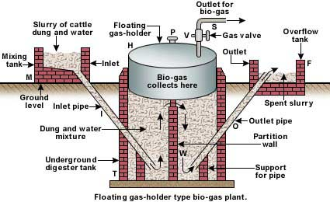

A well is made out of concrete. This is called the digester tank T. It is divided into two parts. One side has the inlet, from where slurry is fed to the tank. The tank has a cylindrical dome H made of stainless steel that floats on the slurry and collects the gas generated. Hence the name given to this type of plant is floating gas holder type of bio gas plant. The slurry is made to ferment for about 50 days. As more gas is made by the bacterial fermentation, the pressure inside H increases. The gas can be taken out through outlet pipe V. The decomposed matter expands and overflows into the next chamber in tank T. This is then removed by the outlet pipe to the overflow tank and is used as manure for cultivation purposes.

Fixed dome type of plant: The diagram below shows the details of a fixed dome type of bio gas plant.
A well and a dome are made out of concrete. This is called the digester tank T. The dome is fixed and hence the name given to this type of plant is fixed dome type of bio gas plant. The function of the plant is similar to the floating holder type bio gas plant. The used slurry expands and overflows into the overflow tank F.

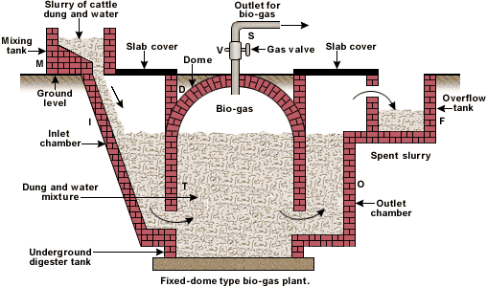

Working
- The various forms of biomass are mixed with an equal quantity of water in the mixing tank. This forms the slurry
- The slurry is fed into the digester through the inlet chamber. The temperature of the slurry must be maintained around 35 ºC. Any drop in temperature will reduce the anaerobic activity and hence the yield of biogas
- When the digester is partially filled with the slurry, the introduction of slurry is stopped and the plant is left unused for about two months
- During these two months, anaerobic bacteria present in the slurry decompose or ferment the biomass in the presence of water
- As a result of anaerobic fermentation, biogas is formed, which starts collecting in the dome of the digester
- As more and more biogas starts collecting, the pressure exerted by the biogas forces the spent slurry into the outlet chamber
- From the outlet chamber, the spent slurry overflows into the overflow tank
- The spent slurry is manually removed from the overflow tank and used as manure for plants
- The gas valve connected to a system of pipelines is opened when a supply of biogas is required
- To obtain a continuous supply of biogas, a functioning plant can be fed continuously with the prepared slurry

Advantages and disadvantages of both the bio gas plants
- In the floating gas holder type of plant, the floating chamber is made of stainless steel. This is expensive and needs continuous maintenance and supervision for non-rust. This does not arise in the fixed – holder type of bio gas plant as everything here is made of concrete.
- Fixed dome type of bio gas suffers from a disadvantage that its volume is fixed. So if the gas pressure increases inside, it may cause damage to the concrete dome. This does not happen in the floating holder type of bio gas plant.

Uses of bio gas
- Bio gas is used as cooking fuel. This is because bio gas burns without smoke, has high calorific value, can be piped into kitchens directly from a plant and is cheaper in cost.
- Bio gas can be used to run electric engines such as pumps, as they cause less air pollution.
- Bio gas can be used for street lighting as they do not cause any smoke and the illumination obtained can be made to be quite adequate.

Soil contamination or Soil Toxins

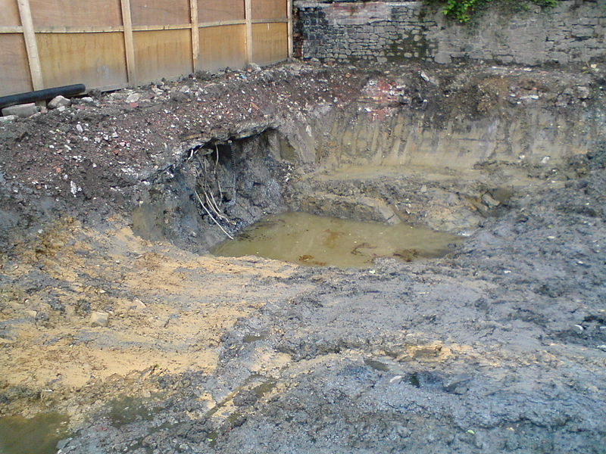

Excavation showing soil contamination at a disused gasworks
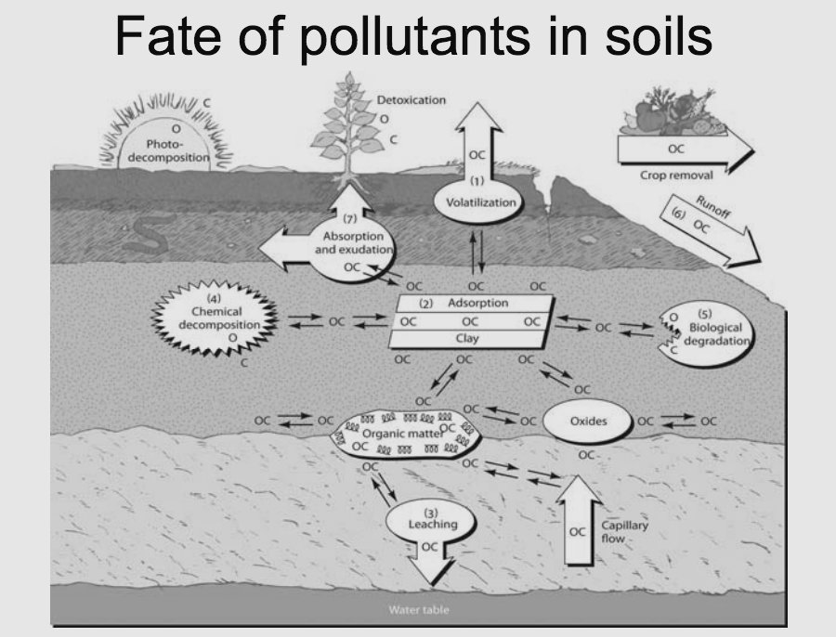

Naturally occurring fate of pollutants in soils
Soil contamination or soil pollution is caused by the presence of xenobiotic (human-made) chemicals or other alteration in the natural soil environment. It is typically caused by industrial activity, agricultural chemicals, or improper disposal of waste. The most common chemicals involved are petroleum hydrocarbons, polynuclear aromatic hydrocarbons (such as naphthalene and benzo(a)pyrene), solvents, pesticides, lead, and other heavy metals. Contamination is correlated with the degree of industrialization and intensity of chemical usage.
The concern over soil contamination stems primarily from health risks, from direct contact with the contaminated soil, vapors from the contaminants, and from secondary contamination of water supplies within and underlying the soil. Mapping of contaminated soil sites and the resulting cleanup are time consuming and expensive tasks, requiring extensive amounts of geology, hydrology, chemistry, computer modelling skills, and GIS in Environmental Contamination, as well as an appreciation of the history of industrial chemistry.
In North America and Western Europe the extent of contaminated land is best known, with many of countries in these areas having a legal framework to identify and deal with this environmental problem. Developing countries tend to be less tightly regulated despite some of them having undergone significant industrialization.

Causes
Soil pollution can be caused by the following
- Drilling of oil refineries
- Accidental spills
- Acid rain (which is caused by air pollution)
- Intensive farming
- Deforestation
- Genetically modified plants
- Nuclear wastes
- Industrial accidents
- Landfill and illegal dumping
- Land erosion
- Agricultural practices, such as application of pesticides, herbicides and fertilizers
- Mining and other industries
- Oil and fuel dumping
- Buried wastes
- Disposal of coal ash
- Disposal of ammunitions and agents of war.
- Drainage of contaminated surface water into the soil
- Electronic waste
- The most common chemicals involved are petroleum hydrocarbons, solvents, pesticides, lead, and other heavy metals.

Historical deposition of coal ash used for residential, commercial, and industrial heating, as well as for industrial processes such as ore smelting, were a common source of contamination in areas that were industrialized before about 1960. Coal naturally concentrates lead and zinc during its formation, as well as other heavy metals to a lesser degree. When the coal is burned, most of these metals become concentrated in the ash (the principal exception being mercury). Coal ash and slag may contain sufficient lead to qualify as a "characteristic hazardous waste", defined in the USA as containing more than 5 mg/L of extractable lead using the TCLP procedure. In addition to lead, coal ash typically contains variable but significant concentrations of polynuclear aromatic hydrocarbons (PAHs; e.g., benzo(a)anthracene, benzo(b)fluoranthene, benzo(k)fluoranthene, benzo(a)pyrene, indeno(cd)pyrene, phenanthrene, anthracene, and others). These PAHs are known human carcinogens and the acceptable concentrations of them in soil are typically around 1 mg/kg. Coal ash and slag can be recognised by the presence of off-white grains in soil, gray heterogeneous soil, or (coal slag) bubbly, vesicular pebble-sized grains.
Treated sewage sludge, known in the industry as biosolids, has become controversial as a fertilizer to the land. As it is the by-product of sewage treatment, it generally contains more contaminants such as organisms, pesticides, and heavy metals than other soil.
In the European Union, the Urban Waste Water Treatment Directive allows sewage sludge to be sprayed onto land. The volume is expected to double to 185,000 tons of dry solids in 2005. This has good agricultural properties due to the high nitrogen and phosphate content. In 1990/1991, 13% wet weight was sprayed onto 0.13% of the land; however, this is expected to rise 15 fold by 2005. Advocates[ say there is a need to control this so that pathogenic microorganisms do not get into water courses and to ensure that there is no accumulation of heavy metals in the top soil.
Pesticides and herbicides
A pesticide is a substance or mixture of substances used to kill a pest. A pesticide may be a chemical substance, biological agent (such as a virus or bacteria), antimicrobial, disinfectant or device used against any pest. Pests include insects, plant pathogens, weeds, mollusks, birds, mammals, fish, nematodes (roundworms) and microbes that compete with humans for food, destroy property, spread or are a vector for disease or cause a nuisance. Although there are benefits to the use of pesticides, there are also drawbacks, such as potential toxicity to humans and other organisms.
Herbicides are used to kill weeds, especially on pavements and railways. They are similar to auxins and most are biodegradable by soil bacteria. However, one group derived from trinitrotoluene (2:4 D and 2:4:5 T) have the impurity dioxin, which is very toxic and causes fatality even in low concentrations. Another herbicide is Paraquat. It is highly toxic but it rapidly degrades in soil due to the action of bacteria and does not kill soil fauna.
Insecticides are used to rid farms of pests which damage crops. The insects damage not only standing crops but also stored ones and in the tropics it is reckoned that one third of the total production is lost during food storage. As with fungicides, the first insecticides used in the nineteenth century were inorganic e.g. Paris Green and other compounds of arsenic. Nicotine has also been used since the late eighteenth century.

Agents of war
The disposal of munitions, and a lack of care in manufacture of munitions caused by the urgency of production, can contaminate soil for extended periods. There is little published evidence on this type of contamination largely because of restrictions placed by Governments of many countries on the publication of material related to war effort. However, mustard gas stored during World War II has contaminated some sites for up to 50 years and the testing of Anthrax as a potential biological weapon contaminated the whole island of Gruinard^{[6]}

Health effects
Contaminated or polluted soil directly affects human health through direct contact with soil or via inhalation of soil contaminants which have vaporized; potentially greater threats are posed by the infiltration of soil contamination into groundwater aquifers used for human consumption, sometimes in areas apparently far removed from any apparent source of above ground contamination.
Health consequences from exposure to soil contamination vary greatly depending on pollutant type, pathway of attack and vulnerability of the exposed population. Chronic exposure to chromium, lead and other metals, petroleum, solvents, and many pesticide and herbicide formulations can be carcinogenic, can cause congenital disorders, or can cause other chronic health conditions. Industrial or man-made concentrations of naturally occurring substances, such as nitrate and ammonia associated with livestock manure from agricultural operations, have also been identified as health hazards in soil and groundwater.^{[7]}
Chronic exposure to benzene at sufficient concentrations is known to be associated with higher incidence of leukemia. Mercury and cyclodienes are known to induce higher incidences of kidney damage and some irreversible diseases. PCBs and cyclodienes are linked to liver toxicity. Organophosphates and carbomates can induce a chain of responses leading to neuromuscular blockage. Many chlorinated solvents induce liver changes, kidney changes and depression of the central nervous system. There is an entire spectrum of further health effects such as headache, nausea, fatigue, eye irritation and skin rash for the above cited and other chemicals. At sufficient dosages a large number of soil contaminants can cause death by exposure via direct contact, inhalation or ingestion of contaminants in groundwater contaminated through soil.^{[8]}
The Scottish Government has commissioned the Institute of Occupational Medicine to undertake a review of methods to assess risk to human health from contaminated land. The overall aim of the project is to work up guidance that should be useful to Scottish Local Authorities in assessing whether sites represent a significant possibility of significant harm (SPOSH) to human health. It is envisaged that the output of the project will be a short document providing high level guidance on health risk assessment with reference to existing published guidance and methodologies that have been identified as being particularly relevant and helpful. The project will examine how policy guidelines have been developed for determining the acceptability of risks to human health and propose an approach for assessing what constitutes unacceptable risk in line with the criteria for SPOSH as defined in the legislation and the Scottish Statutory Guidance.

Ecosystem effects
Not unexpectedly, soil contaminants can have significant deleterious consequences for ecosystems. There are radical soil chemistry changes which can arise from the presence of many hazardous chemicals even at low concentration of the contaminant species. These changes can manifest in the alteration of metabolism of endemic microorganisms and arthropods resident in a given soil environment. The result can be virtual eradication of some of the primary food chain, which in turn could have major consequences for predator or consumer species. Even if the chemical effect on lower life forms is small, the lower pyramid levels of the food chain may ingest alien chemicals, which normally become more concentrated for each consuming rung of the food chain. Many of these effects are now well known, such as the concentration of persistent DDT materials for avian consumers, leading to weakening of egg shells, increased chick mortality and potential extinction of species.
Effects occur to agricultural lands which have certain types of soil contamination. Contaminants typically alter plant metabolism, often causing a reduction in crop yields. This has a secondary effect upon soil conservation, since the languishing crops cannot shield the Earth's soil from erosion. Some of these chemical contaminants have long half-lives and in other cases derivative chemicals are formed from decay of primary soil contaminants.^{[citation needed]}

Cleanup options
Cleanup or environmental remediation is analyzed by environmental scientists who utilize field measurement of soil chemicals and also apply computer models (GIS in Environmental Contamination) for analyzing transport and fate of soil chemicals. Various technologies have been developed for remediation of oil-contaminated soil/ sediments. There are several principal strategies for remediation:
- Excavate soil and take it to a disposal site away from ready pathways for human or sensitive ecosystem contact. This technique also applies to dredging of bay muds containing toxins.
- Aeration of soils at the contaminated site (with attendant risk of creating air pollution)
- Thermal remediation by introduction of heat to raise subsurface temperatures sufficiently high to volatize chemical contaminants out of the soil for vapour extraction. Technologies include ISTD, electrical resistance heating (ERH), and ET-DSP.
- Bioremediation, involving microbial digestion of certain organic chemicals. Techniques used in bioremediation include land farming, biostimulation and bioaugmentating soil biota with commercially available microflora.
- Extraction of groundwater or soil vapor with an active electromechanical system, with subsequent stripping of the contaminants from the extract.
- Containment of the soil contaminants (such as by capping or paving over in place).
- Phytoremediation, or using plants (such as willow) to extract heavy metals
- Mycoremediation, or using fungus to metabolize contaminants and accumulate heavy metals.

By country
Various national standards for concentrations of particular contaminants include the United States EPA Region 9 Preliminary Remediation Goals (U.S. PRGs), the U.S. EPA Region 3 Risk Based Concentrations (U.S. EPA RBCs) and National Environment Protection Council of Australia Guideline on Investigation Levels in Soil and Groundwater.

India
In March 2009, the issue of Uranium poisoning in Punjab attracted press coverage. It was alleged to be caused by fly ash ponds of thermal power stations, which reportedly lead to severe birth defects in children in the Faridkot and Bhatinda districts of Punjab. The news reports claimed the uranium levels were more than 60 times the maximum safe limit. In 2012, the Government of India confirmed that the ground water in Malwa belt of Punjab has uranium metal that is 50% above the trace limits set by the United Nations' World Health Organization. Scientific studies, based on over 1000 samples from various sampling points, could not trace the source to fly ash and any sources from thermal power plants or industry as originally alleged. The study also revealed that the uranium concentration in ground water of Malwa district is not 60 times the WHO limits, but only 50% above the WHO limit in 3 locations. This highest concentration found in samples was less than those found naturally in ground waters currently used for human purposes elsewhere, such as Finland. Research is underway to identify natural or other sources for the uranium.

