Topic: Detection of Genetically Modified Crops
Lecture 1
Detection of Genetically Modified Crops
After commercial release of transgenic variety, its seed can be marketed in the country as per Seed Act. After commercial release of a transgenic plant variety, its performance in the field is monitored for 3 to 5 years by the Ministry of Agriculture and State Department of Agriculture. Packages carrying transgenic seed/ Planting material should have a label depicting their transgenic nature. Transgenic varieties can be protected under the PVP legislation in the same manner as non-transgenic varieties after their release for commercial cultivation. The need for Identification and detection of genetically modified (GM) seeds has increased with the rapid expansion of the cultivation of GM crops and involvement of cost. The objectives of GM certification are as follows:
- To confirm the producers claims regarding the genetic status of the product.
- To ensure the varietal purity of GM seeds with respect to the expression of the inserted transgene and varietal characterisitics of the particular variety.
- To detect and quantify the contaminations of GM seeds in non-GM seed lots
- To prevent the entry of unapproved transgene event into the country along with the imported seed/ food material.
- To certify that the seed used in organic farming are free from GM seeds or its contamination.
- To enforce the proper labeling of GM products and food materials
- To ensure and document compliance with GMO-related regulations.
Therefore, the establishment of relevant, reliable and economical methodology for detection, identification and quantification of GM seed is a great challenge. It is detected by
- Protein Based methods/ Immunoassays
- DNA based methods

Protein Based Methods/ Immunoassays
- Enzyme-Linked Immunosorbent Assay (ELISA)
- Lateral flow strip metgod

Enzyme-Linked Immunosorbent Assay (ELISA) Method
It is a protein based test method that uses antibodies specific to the protein of interest.. ELISA detects and quantifies the amount of specific protein (antigen) in a sample in the presence of other proteins. The antigen is the substance or the protein to be measured. In this technique the antigen is immobilised onto a solid phase, either into the reaction vessel or a bead. Immobilization is achieved by the use of a coating antibody which actively traps antigen to the solid phase. A second antibody which is labeled with a reporter enzymes allowed to bind to the immobilized antigen. This second antibody is antigen specific or specific to protein to be identified.
The enzyme substrate is then added to the antigen antibody/enzyme complex and a positive reaction usually involve a colour change is seen. If a protein to be identified is present in sample, than antibody-antigen complex being formed and the presence of it being confirmed by the reactions of the reporter enzyme. Without antigen, the antibody enzyme conjugate cannot be bound to the solid phase and no signal can be generated. If a sample contain protein specific to the transgene then the Genetically modified contaminants will be detected through positive signal.
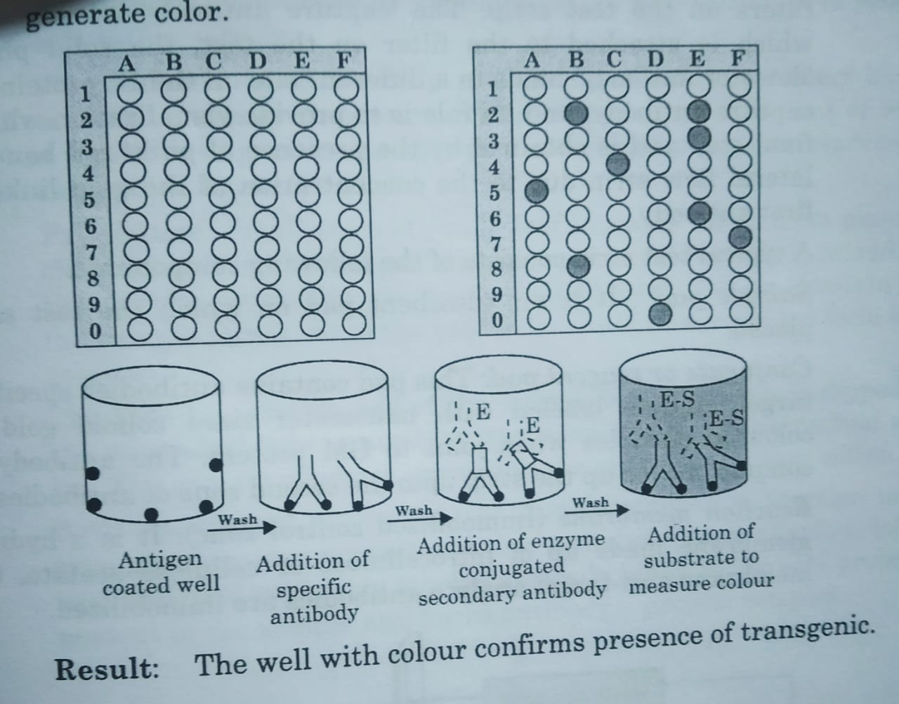

DNA based methods
It is based on the detection of the specific sequence of transgenic DNA genetically engineered into the crop. Presence of transgene is tested by polymerase chain Reaction technology based on million or billion fold amlipfication of specific target DNA of transgene with synthetic oligonucleotide primers. An event specific presence of a DNA sequence is unique for detection of GM. Generally it is present in between transgene and the organisms original DNA.
Procedure: The polymerase chain reaction (PCR0 is a technique to isolate and amplify a fragment of DNA, via enzymatic replication. It makes milions of copies of the target genetic sequence (DNA). The targeted genetic sequence pairs with primers i.e., custom designed complementary part of DNA and trigger a chain of reaction. In PCR, the first step in a cycle involves separation of the two strands of the original DNA molecule. The second step involves binding of the two primers to their oligonucleotide primers. The third step involves making two perfect copies of the original double stranded DNA molecule by adding the right nucleotides to the end of each primer, using the strands as templates. Once the cycle is completed, it can be repeated, and for each cycle the number of copies is doubled, resulting in an exponential amplification. The amplified fragment can be detected by running it in a agarose gel elrectrophoresis and observe under UV light in the presence of dye.
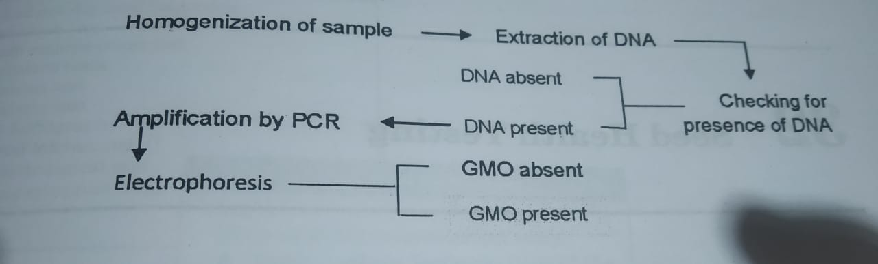
Plate 2. Procedure of DNA based PCR method for detection of GM crops.

