Course: Fundamentals of Genetics
Class: - IInd Year, IInd Semester
Title of topic: - Techniques for detecting genetically modified crops and products
Prepared by- Vinod Kumar, Assistant Professor, (PB & G)
College of Agriculture, Powarkheda
Techniques for detecting genetically modified crops and products
The cultivation of genetically modified crops is becoming increasingly important; more traits are emerging and more acres than ever before are being planted with GM varieties. The release of GM crops and products in the markets worldwide has increased the regulatory need to monitor and verify the presence and the amount of GM varieties in crops and products. GM crops and their products can be identified by detecting either the inserted genetic material at DNA level, the resulting protein or phenotype.
INTRODUCTION
A genetically modified (GM) crop is a plant into which one or more genes have been artificially inserted instead of the plant acquiring them under natural conditions of cross-breeding or natural recombination. The inserted gene sequence, known as the transgene, may be from same species, a different species within the same kingdom or even from a different kingdom (e.g. genetically modified Bt corn, which produces the natural insecticide, contains a gene from a bacterium).
GENETIC TRANSFORMATION FOR PRODUCTION OF GM CROPS
The process of genetic transformation involves several distinct steps, namely identification of useful gene, the cloning of the gene into a suitable plasmid vector, delivery of the vector into plant cell (insertion and integration) followed by expression and inheritance of the foreign DNA encoding a polypeptide.
A gene construct consists typically of three elements: 1) The promoter functions as an on/off switch for when and where the inserted/modified gene is active in the recipient plant; 2) The transgene encodes a specifically selected trait, 3) The terminator functions as a stop signal for transcribing the inserted/altered gene. In addition marker genes for distinguishing GM from non- GM varieties during crop development may be present.
Methods of gene insertion in plants can be achieved by direct gene transfer like microprojectile bombardment or through biological vectors like a disarmed Ti (tumour inducing)-plasmid of A. tumefaciens.
GLOBAL STATUS OF GENETICALLY MODIFIED PLANTS
The global area of GM crops increased 47 fold, from 1.7 million hectares in 1996 to 81 million hectares in 2004, with an increasing proportion grown by developing countries (James, 2004). Almost one-third (30%) of the global transgenic crop area, was grown in developing countries where growth continued to be strong. The main GM crops which are being commercialized include soybean (60%), corn (23%), cotton (12%), canola (5%) and potato (~1%). The traits for which GM varieties have been produced are herbicide tolerance (71%), insect resistance (28%) and quality traits (1%). However, research efforts are being made to genetically modify most plants with a high economic value such as cereals, fruits, vegetables, floriculture and horticulture species. Recently, it has been reported that there are fourteen countries growing about 50,000 hectares or more of GM crops (James, 2004). These includes 9 developing countries and 5 developed countries; they are, in order of hectarage, USA, Argentina, Canada, Brazil, China, Paraguay, India, South Africa, Uruguay, Australia, Romania, Mexico, Spain and the Philippines.
THE POTENTIAL CONTRIBUTION OF GM CROPS
. The GM crops can offer a range of benefits by contributing to:
1. Increasing crop productivity by production of GM crop resistant to biotic (disease and pest) and abiotic (like drought, frost, acid or salty soil) stresses, and thus contribute to global food security.
2. Conserving biodiversity, as a land-saving technology for higher productivity.
3. Improving the nutritional quality of foods through GM crop varieties containing additional nutrients that are lacking from the diets of many people in develop developing countries, thus contributing to human health.
4. More sustainable agriculture and environment, reduction in use of pesticides and other chemicals; and
5. Improvement of economy and poverty alleviation in developing countries through increasing income of farmers.
DETECTION OF GM CROPS AND PRODUCTS
In general the procedure consists of three distinct steps:
1) Detection: The objective is to determine whether a product is GM or not. For this purpose, a general screening method can be used. The result is a positive/negative statement. The screening methods are usually based on the PCR, immunoassays or bioassays. Analytical methods for detection must be sensitive and reliable enough to obtain accurate and precise results.
2) Identification: The purpose of identification is to find out which GM crop or product are present and whether they are authorized or not in the country.
3) Quantification: If a crop or its product has been shown to contain GM varieties, then it become necessary to assess compliance with the threshold regulation by the determination of the amount of each of the GM variety present. Normally, quantification is performed using Real- time PCR.
METHODS FOR DETECTING GM CROPS AND PRODUCTS
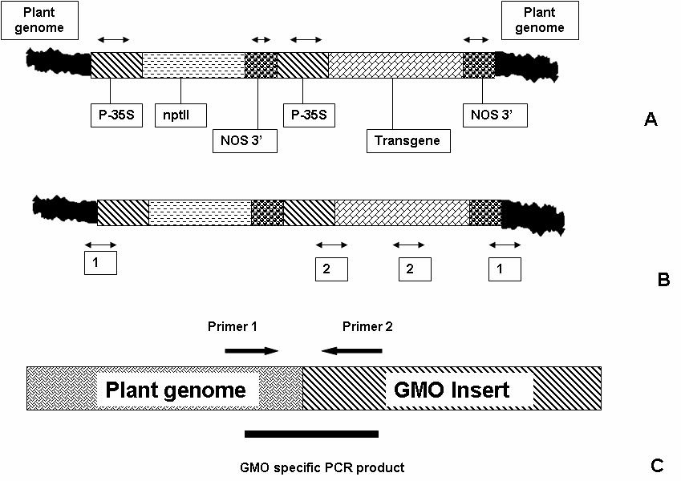
Figure 1. Primer selection for detection of GM crop by PCR analysis: A. primer selection for general screening purposes; B. primer selection for identification of GM crop, 1-event specific, 2-construct specific; and C. primer selection for detecting a specific transformation event.
DNA-based methods
DNA based methods are based on detection of the specific genes, or DNA genetically engineered into the crop. Although, there are several DNA based methodologies, the most commercial testing is conducted using PCR technology. The PCR technique is based on multiplying a specific target DNA allowing the million or billion fold amplification by two synthetic oligonucleotide primers. In PCR, the first step in a cycle involves separation of the two strands of the original DNA molecule. The second step involves binding of the two primers to their oligonucleotide primers. The third step involves making two perfect copies of the original double stranded DNA molecule by adding the right nucleotides to the end of each primer, using the strands as templates. Once the cycle is completed, it can be repeated, and for each cycle the number of copies is doubled, resulting in an exponential amplification. The amplified fragment can be detected by gel electrophoresis or hybridization techniques.
The process consists of extraction and purification of DNA, amplification of the inserted DNA by PCR and confirmation of the amplified PCR product. In principle, PCR can detect a single target molecule in a complex DNA mixture.
Protein based methods
Immunoassay is the current method for detection and quantification of new (foreign) proteins introduced through genetic transformation of plants. Immunoassay is based on the specific binding between an antigen and an antibody. Thus, the availability of antibodies with the desired affinity and specificity is the most important factor for setting up immunoassay systems. Immunoassays can be highly specific and samples often need only a simple preparation before being analysed. Moreover, immunoas- says can be used qualitatively or quantitatively over a wide range of concentrations. Western blot, ELISA (Enzyme-Linked Immunosorbent Assay) and lateral flow sticks are typical protein-based test methods.
The antibodies can be polyclonal, raised in animals, or monoclonal, produced by cell cultures. Commercially available polyclonal antiserum is often produced in rabbits, goats or sheep. Monoclonal antibodies offer some advantages over polyclonal antibodies because they express uniform affinity and specificity against a single epitope or antigenic determinant and can be produced in vast quantities. Both polyclonal and monoclonal antibodies may require further purification steps to enhance the sensitivity and reduce backgrounds in assays. The specificity of the antibodies must be checked carefully to elucidate any cross-reactivity with similar substances, which might cause false positive results.
Phenotypic characterisation (herbicide bioassays)
Phenotypic characterisation allows detection of the presence or absence of a specific trait. So far only tests for traits as herbicides tolerance are available. Such methods can be used to test for presence or absence of herbicide resistant GM varieties and is termed herbicide bioassays. They consist of conducting germination tests on solid germination media in the presence of a specific herbicide, where non-GM and GM seeds show distinct characteristics. The detection level is dependent on germination of the seed and the germination methods should ensure that all viable seeds of the tested sample germinate. Seeds tested positive should be exposed to subsequent tests for confirmation. The herbicide bioassay tests are claimed to be accurate, inexpensive, and useful as a preventative test primarily for seed companies. Companies are using the herbicide bioassays to check individual shipments as a quality assurance program. Negative trait and positive trait seeds should be included as controls with every sample testing. At the moment herbicide bioassays are available for Roundup Ready soybean, maize, cotton and oilseed rape, and Liberty Link maize. In the future bioassays for insect-resistant or other GM varieties may be developed.
Comparison of the different methods
The comparison of various detection methods is summarized in Table 1. At present, only PCR offers a way for performing a general screening for GM varieties and detection of particular "events". Phenotypic characterisation and immunoassays detect particular traits that may be present in several GM crops (e.g. the Cry1a protein and genes, conferring insecticide resistance, are present in a range of different GM Maize: MON80100, MON801, MON802, MON809, 176, BT11).
One of the major considerations in analytical testing of almost any GM crop or its product is the sampling procedure. The sample analysed must be representative of the material from which it is taken otherwise the testing regime is flawed. Sample preparation for both DNA- based and protein-based methods is critical for detection and/or quantification. It is important to know the limitations of each procedure as well as the purpose of detection. Both the sample size and sampling procedures dramatically impact the conclusions that may be drawn from any of these testing methods.

